Practice Session
Modifying Charts

Aim
- To modify Charts using the Chart Editor

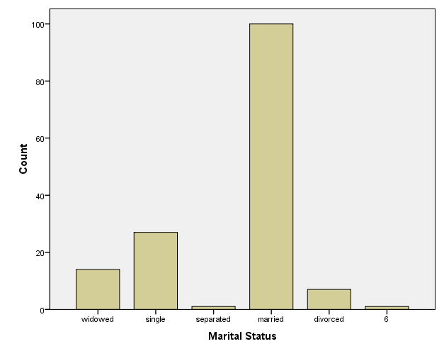
Open the file SOTONEX.SAV
Create a Bar chart for Marital Status recoded (MSTATREC) using the Chart Builder (or you could use legacy dialogs). In the Chart Builder click on Options and under Break Variables click Include. This will include missing values on the bar chart.

Now try to modify this chart using the Chart Editor to look similar to the diagram below.
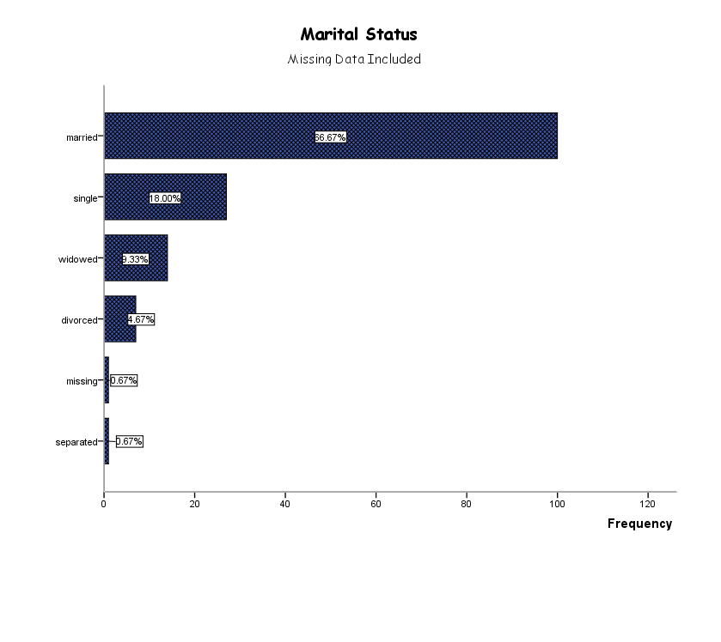Items that have been changed are listed on the next page

Insert title | Swap axes
Insert sub-title as text box – font size 10pt  Note there is no option to add a sub-title in the Editor. | Bar colour changed to blue and a pattern used
Category axis title removed | Chart area changed from grey to white
Scale axis scale (maximum 120) changed | Plot border removed (change colour to white)
Scale axis title changed to Frequency | Order of category axis labels modified (sort categories by Statistic- Ascending)
Fonts changed (Comic Sans MS) | Data labels (counts) added to the bars as percentages
“missing” label changed

The following chart shows a scatter plot of AGE by WEIGHT, with the SEX of the respondents identified by different symbols.

In the Chart Builder:
Drag weight onto the Y axis
Drag sex onto the X axis
Distinguish between points for males and females
Plot the graph and modify it to create the following diagram, using the chart editor menu.

Use Chart Editor to select File | Save Chart Template.
Now create a scatter plot of Weight by Height by Sex using this. The new chart should look similar to the chart above, rather than the default display.

Create a boxplot of WEIGHT by SEX.
Hide the “67” data label.
Give it a title of “Weight by Sex”.
Make the box part of the boxplot blue.
Change the Major Increment on the y-axis so that it appears every 10 kg.
Add a y-axis reference line at 66kg.
Add a footnote that says “A boxplot shows the minimum value, the lower quartile, the median, upper quartile, the maximum value and any outliers.”
Ensure that all of the writing in the footnote is visible
Change the font size of the “Female” and “Male” labels on the x-axis to 10.

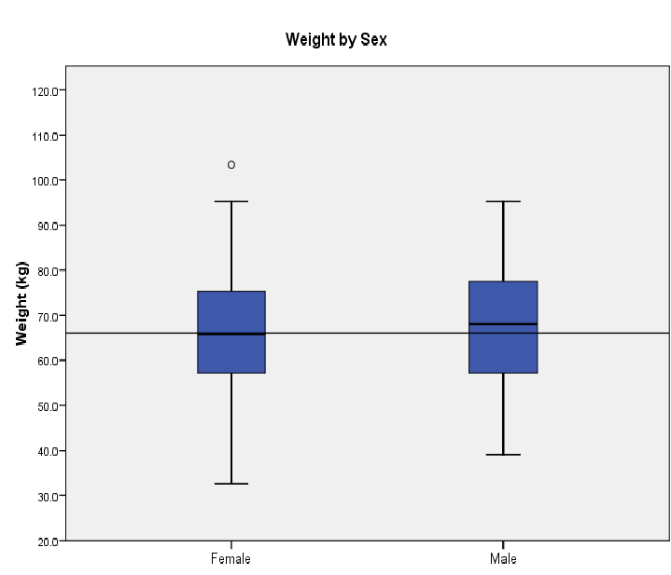

Optional extras…

If you are unsure of any of the terms used in the footnote then find out what they are by looking on the internet, using Statistics for the Terrified or a statistical textbook.
If you are unsure of any other terms used in today’s lecture then find out what they are.

