Introduction to SPSS

Dates: 2-4 Feb 2009
RDS, School of Medicine, University of Southampton

8 Charts

Teaching staff Mr Joe Maskell
Date 3 Feb 2008
Time Lecture: 11:45 – 12:30
Practice: 13:30 – 14:00

Charts

In this description of the charting facilities in SPSS we will be using the data file Health4.sav.

From the menus select Graphs | Chart Builder

You will see the Chart Builder dialog box. This is an interactive window that can be used to preview how a chart will look as you build it.

Note the canvas and the x-axis and y-axis drop zones labelled in the picture below. Also note the Variables in the top left of the Chart Builder and the Gallery and Title/Footnotes tabs that are ringed in the picture below. We will be using all of these.

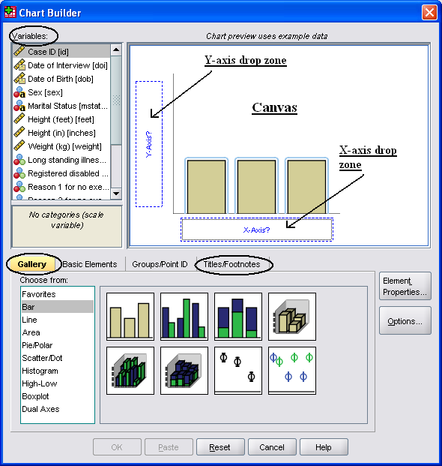

Select the Gallery tab.

Here you can see that you can choose from many different chart types: bar, line etc.

We are going to look at bar charts, scatter plots and box plots.

Bar charts

Simple Bar Charts

Click Bar.

You can see icons that represent the different bar charts.

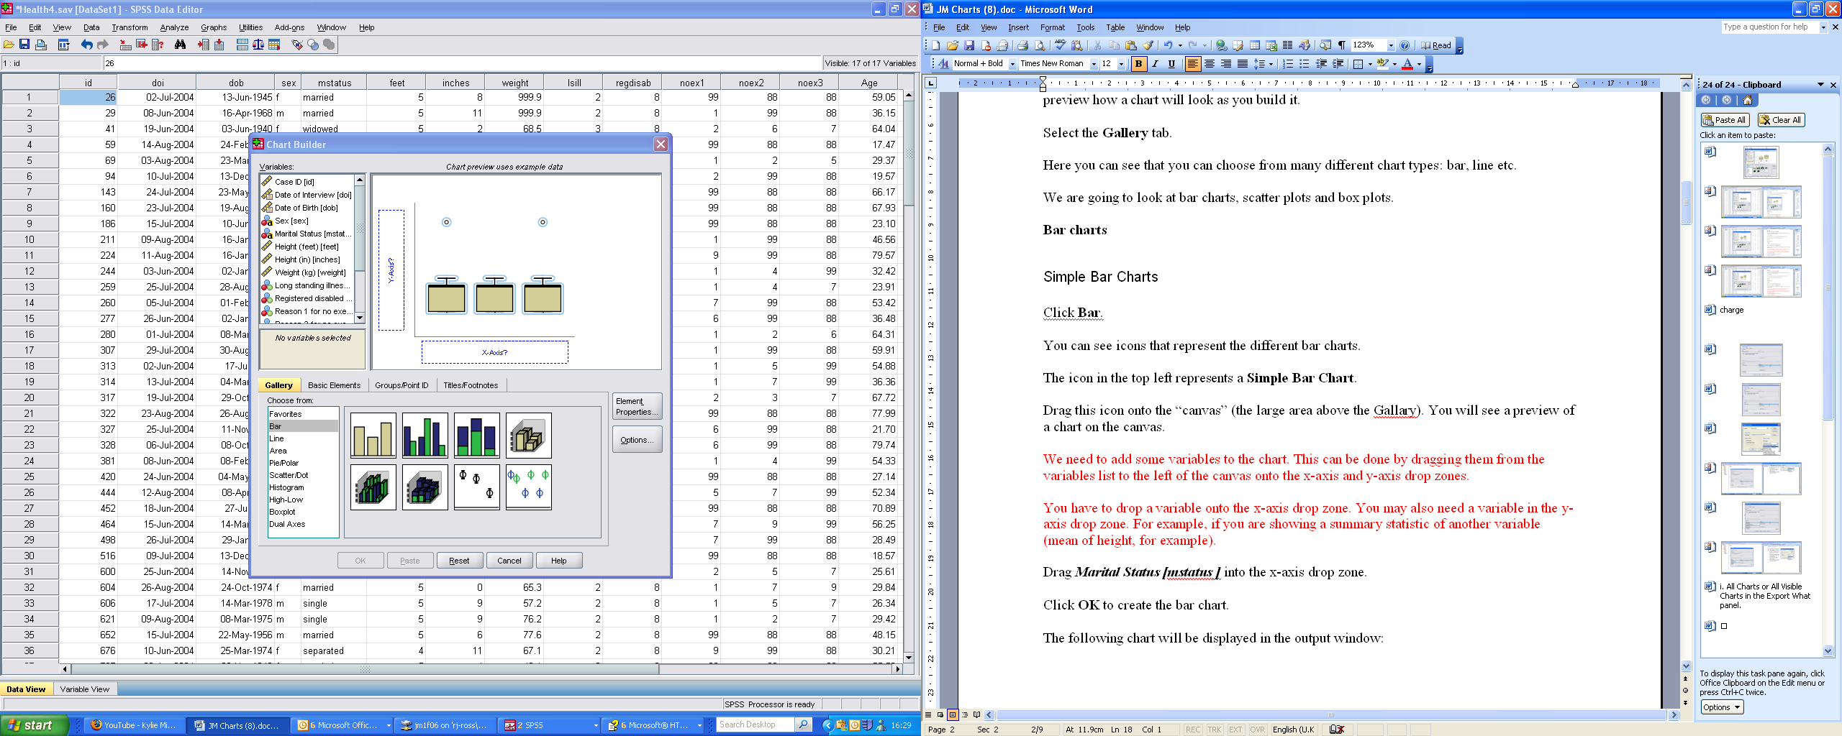 This icon represents a Simple Bar Chart.

Drag this icon onto the canvas.

You will see a preview of a chart on the canvas. Notice that the y-axis and x-axis drop zones have appeared.

Drag Marital Status [mstatus ] into the x-axis drop zone.

Click OK to create the bar chart.

The following chart will be displayed in the output window:

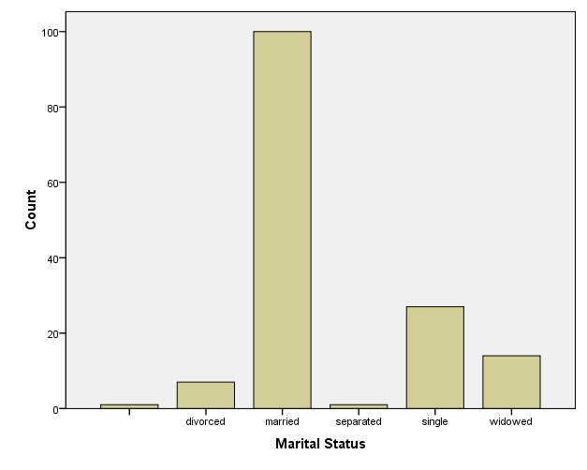

Clustered bar chart

A clustered bar chart is the diagrammatic equivalent of a cross tabulation. Suppose we want a chart of Marital Status by Sex.

Select Graphs | Chart Builder.

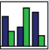 This icon represents a Clustered Bar Chart.

Drag this icon onto the canvas.

Notice the Cluster on X: set color drop zone appears.

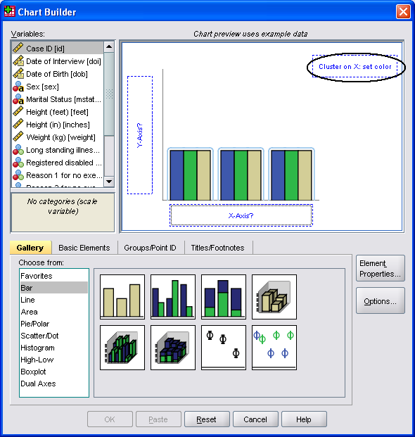

If it isn’t already there then drag Marital Status [mstatus] onto the x-axis drop zone.

We want to cluster by sex. In other words we want to have separate bars for each sex within each category of marital status.

Drag the Sex [sex] variable onto the Cluster on X: set colour drop zone.

Click OK to create the following bar chart.

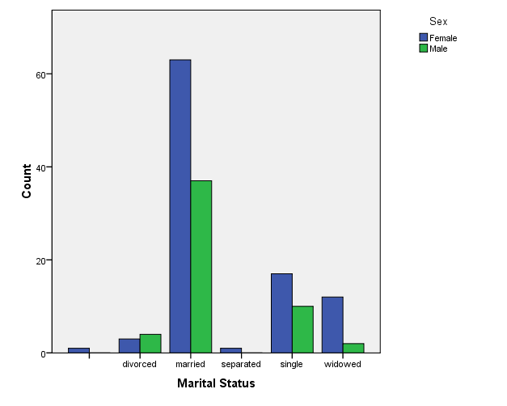
You can move through the Output Viewer to view charts previously created.

Scatterplots - XY graphs

Simple Scatterplot charts

To create a Scatterplot chart select Graphs | Chart Builder.

In Gallery click on Scatter/Dot

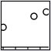 This icon represents a Simple Scatterplot.

Drag this icon onto the canvas.

To plot Age against Weight, drag the variable Weight (kg) [weight] onto the y-axis drop zone and the variable Age onto the x-axis drop zone.

To add a title to the graph click on the Titles/Footnotes tab.

Click on the tick box by Title 1.

If the Element Properties box isn’t on your screen then press the Element Properties button (ringed below).

In the Element Properties box, notice the Edit Properties of: and the Content: boxes (all ringed below).

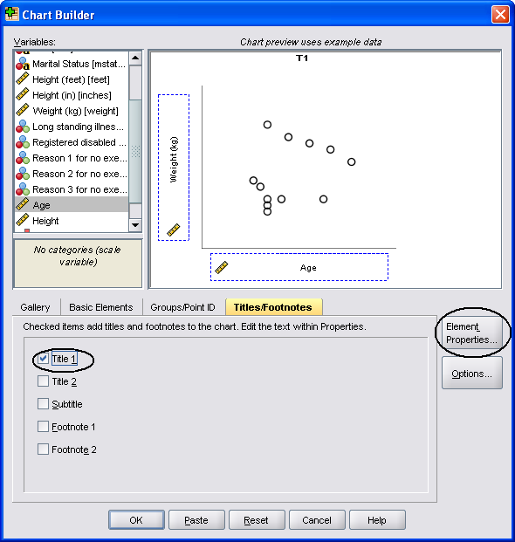 | 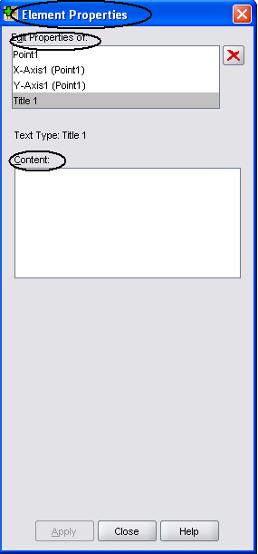

In the Element Properties box make sure that Title 1 is highlighted in the Edit Properties of: box.

Type “Age by Weight” in the Content: box.

Click Apply at the bottom of the Element Properties box.

Click OK to get the following plot.

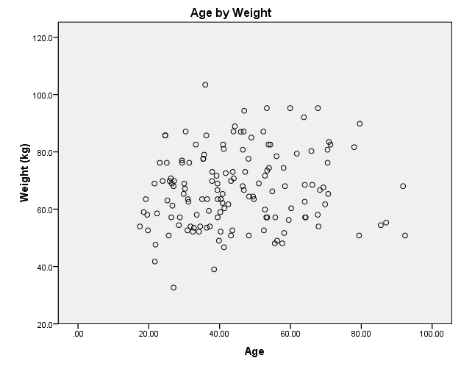
Note: To remove the decimal places on the axes, double click on the plot to bring up the Chart Editor. Then double click on an axis to bring up the Properties box. Select the Number Format tab and then change the Decimal Places: to 0 and click Apply. Repeat for the other axis then close the Chart Editor.

You may want to identify males and female in the above plot.

To do this select Graphs | Chart Builder.

Right-click on the canvas.

Click on Add Grouping Zone.

Notice that the set color drop zone has appeared in the top right of the canvas.

Drag Sex [sex] onto the Set color drop zone.

Click OK.

This will plot female and male data points as blue and green open circles.

Note: If you want to remove the colours then in the Chart Builder right-click in the Set colour drop-zone and click on Delete Grouping Zone.

Boxplots

Boxplots can help you visualise distributions and dispersion. They show the actual distribution of the data.

Simple boxplot

To create a boxplot chart select Graphs | Chart Builder.

In gallery click on Boxplot.

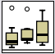 This icon represents a Simple Boxplot.

Drag this icon onto the canvas.

To plot Age characterised by Sex, drag the variable Age onto the y-axis drop zone and the variable Sex onto the x-axis drop zone.

Click OK to get the following plot:

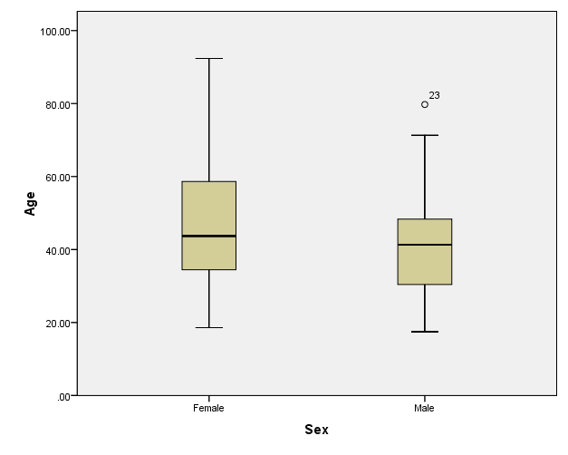

Note: The circle with a 23 represents an outlier. The 23rd observation is an outlier. You can see this if you look in the data.

Printing charts

To print a chart click on the chart that you want to print in the Output Viewer and then click on print preview . If everything is in order then click Print.

Don’t print things unnecessarily. Keep things on the screen if you can and print double-sided if you need to print.

Saving Charts
To save your charts so that you may print/edit during a later SPSS session select File  Save As, and enter the filename and location. This saves everything in the output window. The chart(s) may be retrieved by selecting File  Open  Output.

You may also export SPSS charts so that they can be included as objects in other windows software (e.g. PowerPoint) by:

To save the chart(s), select the chart in the Output Viewer by clicking on it. Select File  Export from the menu.
- In Objects to Export select All, All visible or Selected depending on which graphs you want to export.
- Select None (Graphics only) in the Type: drop down list in the Document section.
- Select JPEG file (*.jpg) in the Type: drop down list in the Graphics section.
- Click on Browse in the Graphics section to specify the file name and folder to save it in.
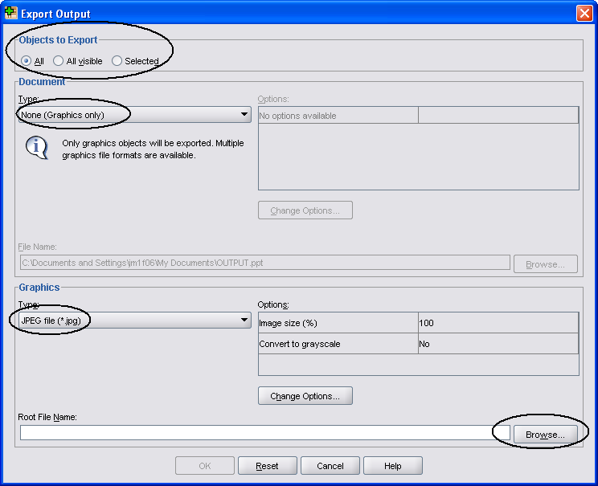

Incorporating SPSS charts into other Windows applications
(such as Word and PowerPoint)

Note: Make all the modifications/changes to your chart before transferring it to another application. Although Word and PowerPoint have some editing capability, they can introduce unwanted changes!
There are two options:

- From the SPSS Viewer window select the chart, select Edit  Copy. Move to the other application (such as Word or PowerPoint) and select Edit Paste.
- Export the SPSS chart (using File  Export) as a JPEG type file .In Word / PowerPoint select Insert  Picture  From file…to insert the JPEG image of the SPSS chart.

Saving a file as an image removes your ability to edit the chart again using SPSS. If you think that you might wish to edit the chart again then save the contents of the Output window. This will include the chart, but note that Output files can get very large, so delete any unwanted output in the Viewer window before saving.

Resizing a Chart in a Word / PowerPoint document
In Word / PowerPoint right click over the image and select Format Picture. Choose the Size tab and in the Scale section, check that the Lock aspect ratio is selected. Then modify the Height setting percentage; the Width will be automatically adjusted and so the image will not become stretched in one dimension.

