<!doctype html public "-//w3c//dtd html 4.0 transitional//en">Faculty of Mathematical Studies
MA101 Calculus - Outline Notes: Inverse Functions

This topic is discussed in section 3.1 of Adams.

The equation $y=f(x)$ gives y in terms of x. To solve it for x we need to rearrange it to find x in terms of y. This occurs in many situations where we need to change the subject of a formula, often with more than two variables. For example
$$\begin{aligned}V={πr}^{2}h⇒h=\frac{V}{{πr}^{2}}; \\ E=\text{IR}⇒R=\frac{E}{I}; \\ \frac{1}{f}=\frac{1}{u}+\frac{1}{v}⇒v=\frac{f\text{.}u}{u−f}\text{.}\end{aligned}$$
In each of these there is a unique solution. With $y=x^{2}$ there are two possibilities for x in terms of y (when y is positive), so the equation does not determine x as a function of y. However with $y=x^{3}$ a given value of y does determine a unique value of x, i.e., $x=\sqrt[3]{y}\text{.}$ It is this distinction we shall be exploring.
So let y be a function of x given by $y=f(x)\text{.}$ If each value of y in the range is associated with a unique value of x in the domain the function is said to be one-to-one (1-1). The equation then determines x as a function of y, called the inverse function, denoted by $f^{−1}\text{.}$ You need to be aware of the confusing notation, because the exponent $−1$ is also used to denote reciprocal. You need to use and interpret this notation according to the context.

Section 3.1 gives a symbolic definition of a 1-1 function and gives lots of properties and examples. We shall discuss some of them here.

Example 1
Let $y=x^{3}\text{.}$ Then $x=\sqrt[3]{y}\text{.}$ Using the notations above, let $f(x)=x^{3}\text{.}$ Then $x=\sqrt[3]{y}$ is equivalent to $f^{−1}(y)=\sqrt[3]{y}\text{.}$ If we want to represent a function and its inverse on the same graph we would write $f^{−1}(x)=\sqrt[3]{x}\text{.}$ This is all illustrated on the graphs below.

It is important to notice that the graphs of a function and its inverse are reflections of one another in the line $y=x\text{.}$

Notice also in this example that $f^{−1}\left(f\left(x\right)\right)=\sqrt[3]{x^{3}}=x\text{ and }f\left(f^{−1}(x)\right)={\left(\sqrt[3]{x}\right)}^{3}=x\text{.}$ this is a general property - the inverse simply takes you back to where you started from.
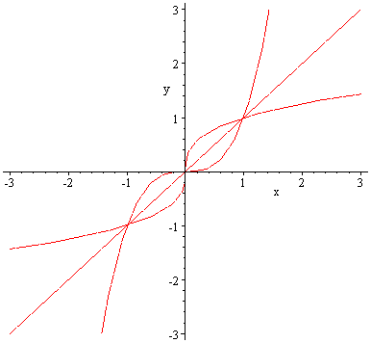
$$x=y^{3}; y=\sqrt[3]{x}$$
Example 2
$$y=x^{3}; x=\sqrt[3]{y}$$

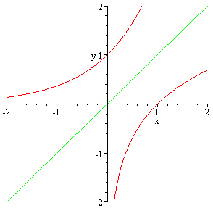
The exponential and logarithmic functions are inverses.
$$y=e^{x}; x=\text{ln}y$$
$$y=\text{ln}x; x=e^{y}$$

Numerical relationships also illustrate the inverse properties, for example

$$e^{0}=1$$ | $$\text{ln}1=0$$
$$e^{1}=e$$ | $$\text{ln}e=1$$
$$e^{−1}=\frac{1}{e}$$ | $$\text{ln}\left(\frac{1}{e}\right)=−1$$
$$e^{−2}=\frac{1}{e^{2}}$$ | $$\text{ln}\left(\frac{1}{e^{2}}\right)=−2$$

On many calculators the INVERSE button acts to pair together inverse functions, for example

$$e^{x}$$ | $${\text{10}}^{x}$$ | $$x^{y}$$
$$\text{ln}x$$ | $$\text{log}x$$ | $$x^{1y}$$

Quadratic functions do not have inverses unless the domain is restricted. If you think about the $x^{2}$ and buttons on your calculator with negative numbers you will find that $\sqrt{(−3)^{2}}≠−3,$ so squaring and then square rooting does not always take you back to where you started. They are not true inverse operations. We shall consider the problems of restricting the domain in the following example.

Example 3

Let $y=x^{2}+2x=(x+1)^{2}−1\text{.}$ this is not a 1-1 function if the domain is the whole of R. however if we restrict the domain we can obtain 1-1 functions. So the two functions
$$\begin{aligned}f(x)=x^{2}+2x; x≤−1 \\ g(x)=x^{2}+2x; x≥−1\end{aligned}$$
are both 1-1 functions. The following graph illustrates this

$$y=f(x)$$
$$y=g(x)$$
$$y=g^{−1}(x)$$
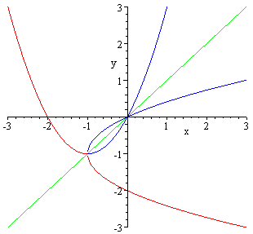
$$y=f^{−1}(x)$$

Now if $y=(x+1)^{2}−1$ then $x=−1±\sqrt{y+1}\text{.}$ To find the formulae for the inverses we must choose the correct square root. The easiest method is to look at the graph, and this tells us that $f^{−1}(x)=−1−\sqrt{x+1}\text{ and }g^{−1}(x)=−1+\sqrt{x+1}\text{.}$

