<!doctype html public "-//w3c//dtd html 4.0 transitional//en">Faculty of Mathematical Studies
MA101 Calculus - Outline Notes: Integration - The Logarithmic Integral

Example 6 on page 327 of Adams discusses briefly the integral $\int{\frac{\text{dx}}{x}}=\text{ln}\left|x\right|$ and points out the problem about $x=0\text{.}$ We shall consider this integral in more detail here.

One approach is to consider graphs.
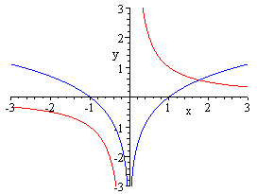

For $x>0$ we know that $\frac{d}{\text{dx}}\text{ln}x=\frac{1}{x},$ and this is shown on the right hand side of the graphs above. Now $\frac{1}{x}$ is an odd function, so its slope at $−x$ will be the negative of the slope at x. This means that for x negative $\frac{1}{x}$ is the gradient for the logarithmic function with x replaced by $−x,$ i.e. $\text{ln}(−x)\text{.}$The modulus function is defined by $\left|x\right|=\begin{aligned}\left\{x (x>0) | \right.\end{aligned}$ hence the use of $\text{ln}\left|x\right|\text{.}$ In addition to this we need to consider the constant of integration, and in fact the most general function whose derivative is $\frac{1}{x}$ is $F(x)=\begin{aligned}\left\{\text{ln}(x)+C (x>0) | \right.\end{aligned}$ Because of the discontinuity at zero there is no reason to suppose that C and D should be the same; we cannot join up the two halves of the graphs.

As a check we can differentiate using the chain rule to give
$$\frac{d}{\text{dx}}\text{ln}(−x)=\frac{1}{−x}×\frac{d}{\text{dx}}(−x)=\frac{1}{−x}×−1=\frac{1}{x}\text{.}$$

Challenge
Can you prove that the derivative of an even function is always odd, and that the derivative of an odd function is always even.

