<!doctype html public "-//w3c//dtd html 4.0 transitional//en">Faculty of Mathematical Studies
MA101 Calculus - Outline Notes: Functions

This is the first topic in the course. There are some useful sections in the Preliminaries chapter of Adams.

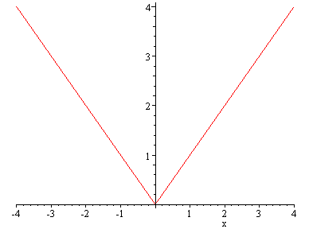
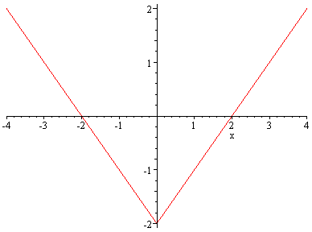
Section P1 deals with real numbers and their representation on the real line. In particular there is some discussion of the absolute value or modulus function $f(x)=\left|x\right| \text{.}$ This is important in many areas of mathematics and you need to be familiar with its graph, and with manipulating equations and inequalities involving the modulus function. Here are a few graphs involving the modulus function.
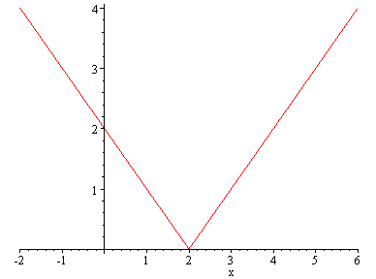
$$y=\left|x\right|$$ | $$y=\left|x−2\right|$$ | $$y=\left|x\right|−2$$

On the number line the modulus of a number represents its distance from zero, measured without regard to direction, so it is always a non-negative number. The quantity $\left|x−a\right|$ measures the distance of x from the number a, again without regard to direction. So we can solve equations and inequalities involving the modulus function and this geometrical interpretation is helpful in that regard.

Example 1 Solve the equation $\left|x+5\right|=2\text{.}$
Solution: $\left|x+5\right|=2$ means that $x+5=±2,$ so the equation has two solutions, $x=−3$ and $x=−7\text{.}$ We can relate these solutions to the geometrical interpretation above. In this example $a=−5$ so that we are looking for values of x which are at distance 2 from the number $−5,$ and these are exactly the solutions we found algebraically. Note that we have to be very careful in thinking about minus signs when we use this geometrical interpretation.

Example 2 Solve the equation $\left|x^{2}−2x−5\right|=3\text{.}$
Solution: $\left|x^{2}−2x−5\right|=3$ means that $x^{2}−2x−5=±3\text{.}$ This gives the two separate equations $x^{2}−2x−5=3; x^{2}−2x−5=−3\text{.}$ The solutions are therefore $−2, 4, 1+\sqrt{3}, 1−\sqrt{3}\text{.}$

The following graph illustrates the fact that there are four solutions.
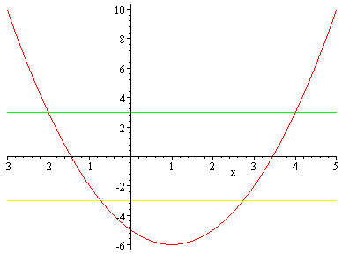

Example 3 Solve the inequality $\left|x−5\right|≤2\text{.}$
Solution: Geometrically we would say that this means that x is within distance 2 of the number 5, so that x lies between 3 and 7.
Algebraically we say that $\left|x−5\right|≤2$ is equivalent to $−2≤x−5≤2,$ so adding 5 throughout this inequality gives $3≤x≤7\text{.}$

There are more worked examples and exercises in Adams, pages 10-12

Functions: Definitions
On pages 26-28 in Adams there is a discussion about what a function is, and what distinguishes a function from other kinds of relationships between variables. Particularly important is the
Domain of a Function
When we have an algebraic expression we often find that there are some values for which the expression can't be evaluated. We might get an error message on a calculator. A simple example is $f(x)=\frac{1}{x},$ where we cannot substitute $x=0\text{.}$
In describing a function we should strictly speaking specify the set of values of the independent variable we are considering, as well as the rule or formula which determines the function. This is particularly important in applications, where a solution may only be valid for a restricted set of values because of physical or other restrictions.
Informally therefore a function from a set A to a set B is a rule or a formula which assigns a unique member of the set B to every member of A. The set A is called the domain of the function.
In practice we often adopt the convention that if the domain is unspecified then we take it to be the set of all possible values which can legitimately be substituted into the rule or formula which describes the function. This convention is explained with a couple of examples on page 28, and some exercises to try on page 34.

Range of a Function
If a function is given by the formula $y=f(x),$ with domain A, then the range of the function is defined to be the set of all possible y values obtained as x ranges over the domain A.

The Square Root Function
All the function buttons on a calculator follow the definition of a function discussed above. You will not find a button which gives alternative possibilities. This is true in particular of the square root button, which always returns a non-negative number. This is exactly the convention which we shall follow with respect to the square root symbol. So if we consider the real-valued function given by the formula $f(x)=\sqrt{x},$ the maximal domain is $\left\{x:x≥0\right\}\text{.}$
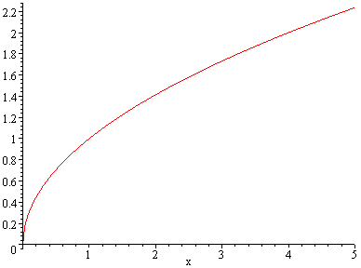
The graph of this function is as follows:

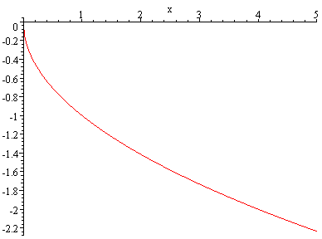
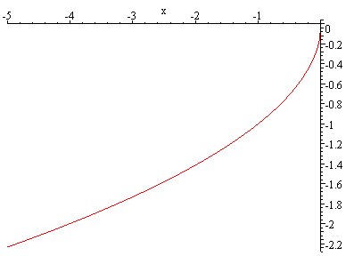
Some related graphs involving the square root function are
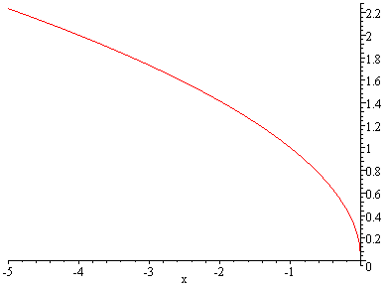
$$y=\sqrt{−x}$$ | $$y=−\sqrt{x}$$ | $$y=−\sqrt{−x}$$

Example 4
What is the largest possible domain for a function given by the formula $f(x)=\text{ln}(\text{cos}x)?$
Solution: We know that $\text{ln}t$ is defined only for $t>0\text{.}$ Therefore $\text{ln}(\text{cos}x)$ is defined only when $\text{cos}x>0\text{.}$ The best way to approach this is through a graph of the cosine function. From the graph of cosine we can see that cosine is positive when
$−\frac{5π}{2}<x<−\frac{3π}{2}; −\frac{π}{2}<x<\frac{π}{2}; \frac{3π}{2}<x<\frac{5π}{2};$ etc. There are of course infinitely many such intervals, and we can write them together in the general form
$$2nπ−\frac{π}{2}<x<2nπ+\frac{π}{2}; n=0, ±1, ±2, ⋯$$
There are various notations used for this kind of set in mathematics, including the notation for intervals on page 5. In interval notation the domain for $\text{ln}(\text{cos}x)$ is
$$\left\{\left(2nπ−\frac{π}{2}, 2nπ+\frac{π}{2}\right) : n∈Z\right\}\text{.}$$
NOTE: You are expected to know what basic trigonometric graphs (pages 46-49 figures P74, P75, P77) look like. You should also learn some other basic graphs on pages 29-30; specifically those in figures P37, P38, P39, P40, P41, P42, P43, P44, P46, and page 187 figure 3.13.
Example 5
Formula | Maximal Domain | Range
$$f(x)=\text{sin}x$$ | All real x; R | $$[−1,1]$$
$$g(x)=\text{ln}x$$ | $$\left\{x:x>0\right\}$$ | R
$h(x)=\frac{2−x}{x−1}$ (P48 on pg. 30) | $$\left\{x:x≠1\right\}$$ | $$\left\{y:y≠−1\right\}$$
$$y=\sqrt{x}$$ | $$\left\{x:x≥0\right\}$$ | $$\left\{y:y≥0\right\}$$
$$y=−\sqrt{x}$$ | $$\left\{x:x≥0\right\}$$ | $$\left\{y:y≤0\right\}$$
$$y=\sqrt{−x}$$ | $$\left\{x:x≤0\right\}$$ | $$\left\{y:y≥0\right\}$$
$$y=−\sqrt{−x}$$ | $$\left\{x:x≤0\right\}$$ | $$\left\{y:y≤0\right\}$$
(The last four are illustrated on graphs above)

Odd and Even Functions (pages 31 - 32)
A function is said to be even if its graph has reflective symmetry in the y-axis, i.e. the picture is unaltered under this reflection. This reflection is performed by the transformation $x→−x\text{.}$ So algebraically if x is replaced by $−x$ the formula should be unaltered, giving the equation $f(−x)=f(x)$ as a definition of an even function. A standard example is $\text{cos}x\text{.}$
A function is said to be odd if its graph is unaltered after reflection in the x-axis followed by reflection in the y-axis. This reflection is performed by the transformation $x→−x$ and $y→−y\text{.}$ So algebraically if x is replaced by $−x$ and if y is replaced by $−y$ the formula should be unaltered. So if $y=f(x)$ then $−y=f(−x),$ giving $f(−x)=−f(x)$ as a definition of an odd function. A standard example is $\text{sin}x\text{.}$

There are a couple of interesting properties given in exercises in Adams
Page 41 No. 34 asks you to show that if a function is both even and odd then it must be zero at every point of its domain.
Page 41 No. 35 asks you to show that any function can be expressed uniquely as a sum of an even function and an odd function. The question gives formulae, so that it $f(x)$is the function then the even and odd parts of the decomposition are given respectively by
$$E(x)=\frac{f(x)+f(−x)}{2}; O(x)=\frac{f(x)−f(−x)}{2}\text{.}$$
Let's illustrate this with an example. Take $f(x)=x^{2}−2x−5\text{.}$ This is neither even nor odd, as the graph below shows. We shall work out both $E(x)$ and $O(x)$ from the formulae. So
$E(x)=\frac{(x^{2}−2x−5)+((−x)^{2}−2(−x)−5)}{2}=x^{2}−5,$
and $O(x)=\frac{(x^{2}−2x−5)−((−x)^{2}−2(−x)−5)}{2}=−2x\text{.}$
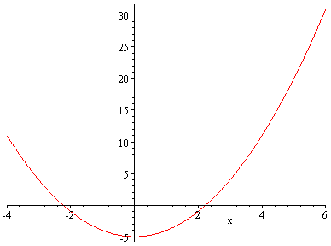
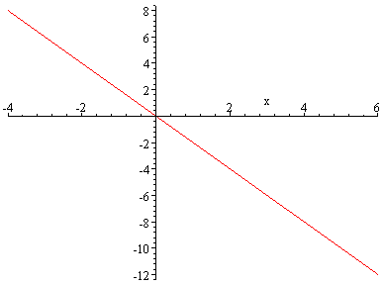
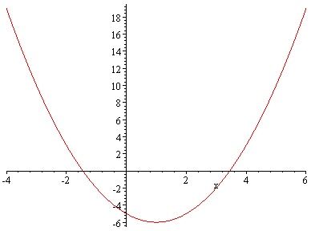
$$y=f(x) y=E(x) y=O(x)$$
Increasing and Decreasing Functions
If we know that a function is increasing or decreasing over a certain interval this makes it easier to sketch that part of the graph. It also helps when we are drawing graphs of functions involving reciprocals. If a function is increasing its reciprocal is decreasing, and vice versa, apart from consideration of changes of sign. This follows from properties of inequalities, namely
If $0<a<b$ then $0<\frac{1}{b}<\frac{1}{a}\text{.}$
If $a<b<0$ then $\frac{1}{b}<\frac{1}{a}<0\text{.}$
If $a<0<b$ then $\frac{1}{a}<0<\frac{1}{b}\text{.}$
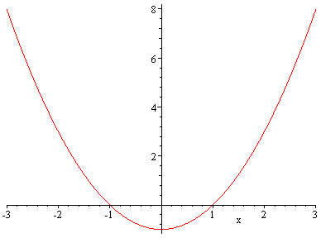
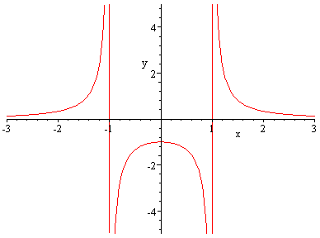
This is illustrated in the following graphs which show $y=x^{2}−1$ and $y=\frac{1}{x^{2}−1}\text{.}$
increasing
decreasing
decreasing
decreasing
increasing
increasing

