<!doctype html public "-//w3c//dtd html 4.0 transitional//en">Faculty of Mathematical Studies
MA101 Calculus - Outline Notes: Composite Functions

Composite functions are discussed in Adams on pages 37-38

Many functions are built up in stages, as with $\text{ln}(\text{cos}x)$which we discussed earlier. You would work out $\text{ln}(\text{cos}x)$on your calculator by entering x and then using the cos button followed by the ln button, in that order. We use the following notation:
If $f(x)=\text{ln}x$ and $g(x)=\text{cos}x$ then $f∘g(x)=f(g(x))=\text{ln}(\text{cos}(x))\text{.}$
Note that $g∘f(x)=(f(x))=\text{cos}(\text{ln}(x)),$ so that $f∘g$ and $g∘f$ are different. The formulae are different and the domains are also different. We found the domain for $f∘g$ earlier. The domain for $g∘f$ is the set of positive real numbers: $\left\{x:x>0\right\}\text{.}$
We can use composition in solving equations:

Example 1 To solve $\text{cos}(\text{ln}x)=0$ we consider $\text{cos}t=0,$ where $t=\text{ln}x\text{.}$
We know that $\text{cos}t=0$ for $t=⋯−\frac{3π}{2},−\frac{π}{2},\frac{π}{2},\frac{3π}{2},\frac{5π}{2}⋯$ Now if $t=\text{ln}x$ then $x=e^{t}\text{.}$
So $\text{cos}(\text{ln}x)=0$ when $\begin{aligned}x=⋯e^{−\frac{3π}{2}},e^{−\frac{π}{2}},e^{\frac{π}{2}},e^{\frac{3π}{2}},e^{\frac{5π}{2}},⋯ \\ ⋯0\text{.}\text{009}, 0\text{.}\text{208}, 4\text{.}\text{810}, \text{111}\text{.}\text{318}, \text{2575}\text{.}\text{970},⋯\end{aligned}$

We can also use composition in drawing graphs, as in the following two examples, where we construct the graph in stages corresponding to the stages in the composition.
Example 2 Let $y=\frac{x+1}{x−2}=1+\frac{3}{x−2}\text{.}$ We get from x to y in several stages, corresponding to the steps you would use on a calculator, as follows

$$\begin{aligned}f_{1}(x)=x−2 \\ f_{2}(x)=\frac{1}{x} \\ f_{3}(x)=3x \\ f_{4}(x)=1+x\end{aligned}$$
So we have $y=f_{4}(f_{3}(f_{2}(f_{1}(x))))\text{.}$ We can represent the process diagrammatically
$$x \underset{\text{subtract 2}}{→} \underset{\text{reciprocal}}{→} \underset{\text{multiply by 3}}{→} \underset{\text{add 1}}{→} y$$

The corresponding sequence of graphs is shown on the next page.
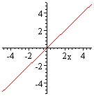
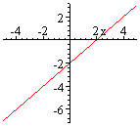
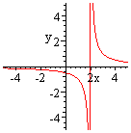
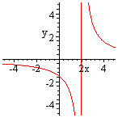
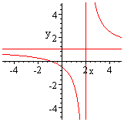
Subtract 2
reciprocal
Multiply by 3
Add1
Example 3 Use composition to construct the graph of $y=\text{ln}(\text{cos}x)\text{.}$

Again we decompose the function: $y=\text{ln}t; t=\text{cos}x\text{.}$ The graphs are as follows. Since ln is an increasing function it follows that $\text{ln}(\text{cos}x)$is increasing where $\text{cos}x$ is increasing and decreasing where $\text{cos}x$ is decreasing.

