<!doctype html public "-//w3c//dtd html 4.0 transitional//en">Faculty of Mathematical Studies
MA101 Calculus - Outline Notes: Approximation - Newton's Method

We want to find a root of the equation $f(x)=0\text{.}$ We are assuming that the function is such that we can't find an exact root, so we look for an approximation. A first approximation can be found sometimes by numerical guesswork, and sometimes by plotting a graph. Newton's method is based on the latter.

In the diagram below, we can see that if $x_{0}$ is a first approximation then if we draw the tangent to the curve at the point $\left(x_{0},f\left(x_{0}\right)\right)$ then the point $x_{1}$ where it meets the x-axis is nearer to the root than the first approximation.
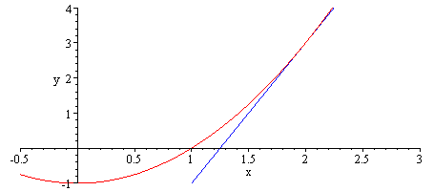
$$x_{0}$$
$$\left(x_{0},f\left(x_{0}\right)\right)$$
$$x_{1}$$

If you work out the equation of the tangent at the point $\left(x_{0},f\left(x_{0}\right)\right)$ and then work out where that line meets the x-axis you should be able to verify that
$x_{1}=x_{0}−\frac{f\left(x_{0}\right)}{f^{'}\left(x_{0}\right)},$ provided $f^{'}\left(x_{0}\right)≠0\text{.}$

We then repeat this process, producing a sequence of approximations which in many cases will get successively nearer to the root we are seeking. We should note that this does not always happen, and the condition about a non-zero derivative above suggests that if we are near to a point where the derivative is zero then things might go wrong.

So we generalise the equation above to produce the following iterative relationship for the sequence of approximations.
$x_{n+1}=x_{n}−\frac{f\left(x_{n}\right)}{f^{'}\left(x_{n}\right)},$ provided $f^{'}\left(x_{n}\right)≠0\text{.}$

This equation lends itself to implementation on a spreadsheet provided we can work out a formula for the derivative. We shall use spreadsheets in the following examples.

Example 1
Find a sequence of approximations to the roots of the equation $x−2\text{sin}x=0$.

If we draw a graph it reminds us of the obvious root at zero. It also reminds us that $x−2\text{sin}x$
is an odd function, so that we need only consider the positive root, which appears to be just under 2, so an initial guess of 2 would be reasonable.
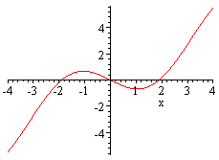

We can easily work out the relevant derivative, so that the equation for the implementation of Newton's method is $x_{n+1}=x_{n}−\frac{x_{n}−2\text{sin}\left(x_{n}\right)}{1−2\text{cos}\left(x_{n}\right)}\text{.}$ The following spreadsheet output takes the initial approximation to be 2.

x - 2sinx = 0 | x₀ = | 2
n | x_{n} | x_{n+1}
0 | 2 | 1.900995594
1 | 1.900995594 | 1.895511645
2 | 1.895511645 | 1.895494267
3 | 1.895494267 | 1.895494267
4 | 1.895494267 | 1.895494267
5 | 1.895494267 | 1.895494267
6 | 1.895494267 | 1.895494267
7 | 1.895494267 | 1.895494267
8 | 1.895494267 | 1.895494267
9 | 1.895494267 | 1.895494267
10 | 1.895494267 | 1.895494267

You will see how quickly this sequence converges. It only takes three iterations before we reach an accuracy of 9 decimal places.

Example 2
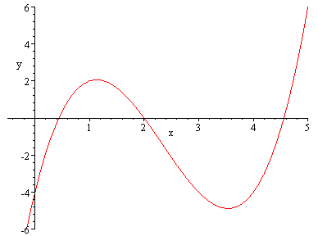
Find approximations to the roots of $x^{3}−7x^{2}+\text{12}x−4=0\text{.}$

From the graph we can see that there are three roots. In fact we could solve this equation exactly because the graph enables us to guess that 2 is a root, which we can verify algebraically. The remaining roots are then found from a quadratic. However we shall use Newton's method to show how changing the initial guess changes the root to which the approximations converge. The equation for Newton's method in this case is
$$x_{n+1}=x_{n}−\frac{x_{n}^{3}−7x_{n}^{2}+\text{12}x_{n}−4}{3x_{n}^{2}−\text{14}x_{n}+\text{12}}\text{.}$$

x₀ = | 0.5
n | x_{n} | x_{n+1}
0 | 0.5 | 0.434782609
1 | 0.434782609 | 0.438435391
2 | 0.438435391 | 0.438447187
3 | 0.438447187 | 0.438447187
4 | 0.438447187 | 0.438447187
x₀ = | 1.8
N | x_{n} | x_{n+1}
0 | 1.8 | 2.016091954
1 | 2.016091954 | 2.000062166
2 | 2.000062166 | 2.000000001
3 | 2.000000001 | 2
4 | 2 | 2
x₀ = | 4.1
N | x_{n} | x_{n+1}
0 | 4.1 | 4.8055666
1 | 4.8055666 | 4.59205322
2 | 4.59205322 | 4.562124746
3 | 4.562124746 | 4.56155302
4 | 4.56155302 | 4.561552813
5 | 4.561552813 | 4.561552813

