<!doctype html public "-//w3c//dtd html 4.0 transitional//en">Faculty of Mathematical Studies
MA101 Calculus - Outline Notes: Approximating Functions

How does your calculator work out values of the trigonometric functions, or any of the other functions on the various buttons? The circuitry can do addition, and therefore multiplication, which is really just repeated addition. It can do subtraction, and therefore division, which can be though of as repeated subtraction.
It can therefore work out things like $3−x+2x+4x^{3}−2\text{.}7x^{4}$ for numerical values of x. What we therefore need is to be able to find polynomials which approximate the standard functions, and these can then be programmed onto the circuits in a calculator. Clearly this exercise should include an analysis of the greatest possible errors arising in such approximations if the digits in the output display are to be accurate. We start with a simple case.

Linear Approximations
There are many lines which provide approximations over a part of the graph of $y=f(x),$ as the diagram shows.

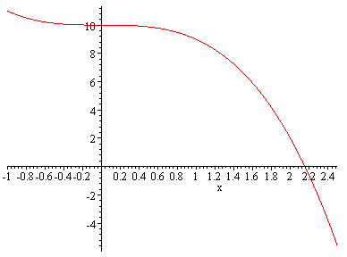
a
x

The red line shown a linear approximation which passes through two specified points. The black line is parallel to the red line and its maximum deviation from the curve is less than that of the red line. The blue line is the tangent line. We shall develop approximations based on the tangent line in this course.
The slope of the tangent line is $f^{'}(a)$ and it passes through the point $\left(a,f(a)\right)\text{.}$ So its equation is $y=f(a)+f^{'}(a)(x−a)\text{.}$ We can see from the diagram that the error increases quite quickly as x moves away from a, so the tangent line is only a good approximation near to $x=a\text{.}$

Quadratic Approximations
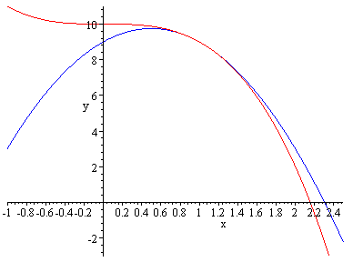
We shall now choose to approximate a curve near to the point a be a quadratic which passes through the point $\left(a,f(a)\right)$ and has the same first and second derivatives as the curve at that point.
a
The red curve is that of $y=f(x)$ and the blue curve is the approximating quadratic. The diagram shows that the approximation does not deviate from the curve so rapidly as the linear approximation. We can work out the equation of the parabola as follows.
Suppose its equation is $y={\text{px}}^{2}+\text{qx}+r\text{.}$ It must pass through the point $\left(a,f(a)\right)$ and its first and second derivatives at a must be the same as those of f at a. This gives equations
$$\begin{aligned}f^{''}(a)=2p⇒p=\frac{f^{''}(a)}{2} \\ f^{'}(a)=2\text{pa}+q⇒q=f^{'}(a)−a\text{.}f^{''}(a) \\ f(a)={\text{pa}}^{2}+\text{qa}+r\end{aligned}$$
If we substitute for p and q in the last equation and then rearrange it we obtain
$$r=f(a)−a\text{.}f^{'}(a)+\frac{a^{2}}{2}f^{''}(a)\text{.}$$
We have therefore found the coefficients for the approximating parabola, and they can be substituted and the equation rearranged in the form
$$y=f(a)+f^{'}(a)(x−a)+\frac{f^{''}(a)}{2}(x−a)^{2}\text{.}$$

In fact simpler even than a linear or quadratic approximation is approximation by the constant function $f(a)\text{.}$ We shall discuss the error involved in this case using

The Mean Value Theorem (discussed in Adams pages 130-132)

If f is a function which is continuous and differentiable in appropriate intervals then $\frac{f(x)−f(a)}{x−a}=f^{'}(c)$ for some value of c between x and a.

Note that the conditions for the Mean Value Theorem are important. They are discussed at length with lots of diagrams in Adams, and you should study pages 130-132. We can rearrange the equation from the statement of the theorem in the form $f(x)−f(a)=f^{'}(c)(x−a)\text{.}$This means that the approximation error is approximately proportional to the difference between x and a, with the scale factor of proportionality depending on the size of the derivative. This makes sense, as the larger the size of the derivative the more quickly the value of the function moves away from $f(a)$ as x moves away from a.
So a constant approximation has an error which is related to f'.
A linear approximation has an error which is related to f''.
A quadratic approximation has an error which is related to f'''.

We have not justified these last two statements. Instead we shall generalise to approximations by polynomials of degree n in the next section.

