<!doctype html public "-//w3c//dtd html 4.0 transitional//en">Faculty of Mathematical Studies
MA101 Calculus - Outline Notes: Approximation - Fixed Point Iteration

This topic is discussed on pages 270-272 of Adams

Sometimes when we are solving equations it is convenient to arrange them in the form $x=F(x)\text{.}$ If a is a root of this equation then it satisfies $a=F(a)\text{.}$ a is therefore referred to as a fixed point for the function F. If we can find a good first approximation $x_{0}$ for the root, then substituting it into F will sometimes give a better approximation. We can repeat the procedure to generate a sequence of approximations given by $x_{n+1}=F\left(x_{n}\right)\text{.}$ Like Newton's method, fixed point iteration can also be represented graphically, and this is shown on page 271 of Adams. Graphs there illustrate situations where the sequence converges, and also where it fails to converge. In the Numerical Analysis course in year 2 you will see that the sequence will converge if $\left|F^{'}(x)\right|<1$ in the neighbourhood of the root of the equation, and diverges if $\left|F^{'}(x)\right|>1$ in the neighbourhood of the root. The graphs on page 271 are consistent with these conditions.

Example 1
We shall use the same equation as in Example 1 for Newton's method. We can arrange it in the form $x=\text{sin}x,$ so $F(x)=\text{sin}x\text{.}$
We can implement the iteration on a spreadsheet, and the result is shown below. It is clear that this method needs many more iterations that Newton's method to achieve the same degree of accuracy. This is also explored in the second year Numerical Analysis course.

x₀ = | 1.9
n | x_{n} | x_{n+1} | n | x_{n} | x_{n+1}
0 | 1.9 | 1.892600175 | 20 | 1.895494833 | 1.895493906
1 | 1.892600175 | 1.897332887 | 21 | 1.895493906 | 1.895494497
2 | 1.897332887 | 1.894317941 | 22 | 1.895494497 | 1.89549412
3 | 1.894317941 | 1.896243504 | 23 | 1.89549412 | 1.895494361
4 | 1.896243504 | 1.895015688 | 24 | 1.895494361 | 1.895494207
5 | 1.895015688 | 1.895799405 | 25 | 1.895494207 | 1.895494305
6 | 1.895799405 | 1.895299487 | 26 | 1.895494305 | 1.895494243
7 | 1.895299487 | 1.895618509 | 27 | 1.895494243 | 1.895494283
8 | 1.895618509 | 1.89541498 | 28 | 1.895494283 | 1.895494257
9 | 1.89541498 | 1.89554485 | 29 | 1.895494257 | 1.895494273
10 | 1.89554485 | 1.895461991 | 30 | 1.895494273 | 1.895494263
11 | 1.895461991 | 1.89551486 | 31 | 1.895494263 | 1.89549427
12 | 1.89551486 | 1.895481127 | 32 | 1.89549427 | 1.895494265
13 | 1.895481127 | 1.895502651 | 33 | 1.895494265 | 1.895494268
14 | 1.895502651 | 1.895488918 | 34 | 1.895494268 | 1.895494266
15 | 1.895488918 | 1.89549768 | 35 | 1.895494266 | 1.895494267
16 | 1.89549768 | 1.895492089 | 36 | 1.895494267 | 1.895494267
17 | 1.895492089 | 1.895495656 | 37 | 1.895494267 | 1.895494267
18 | 1.895495656 | 1.895493381 | 38 | 1.895494267 | 1.895494267
19 | 1.895493381 | 1.895494833 | 39 | 1.895494267 | 1.895494267
A graph illustrating the process is shown below. This is the type of graph shown on page 271.
It shows that we solve $x=F(x)$ by using the intersection of the two graphs $y=F(x); y=x\text{.}$

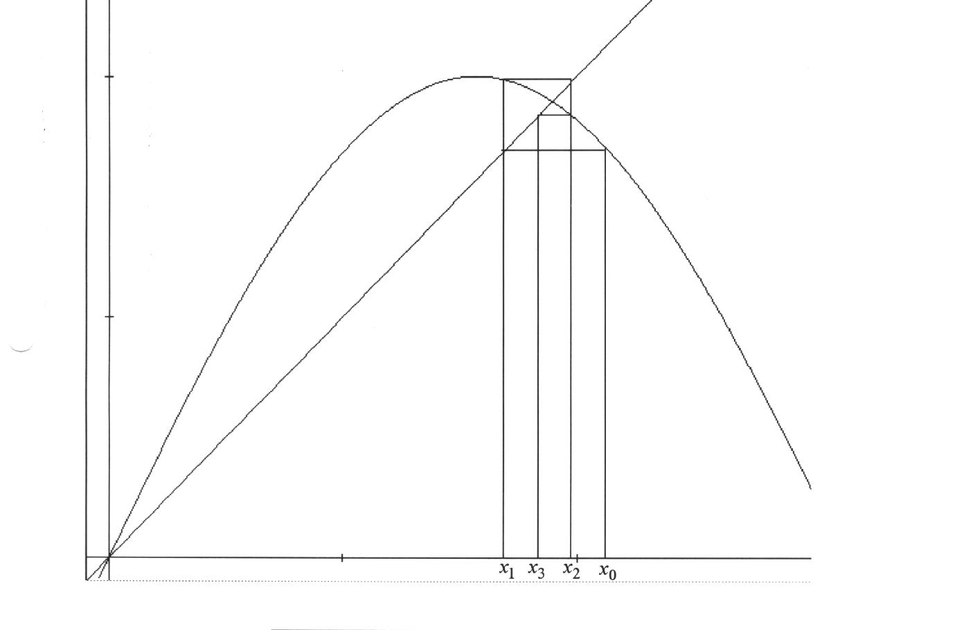
$$y=2\text{sin}x$$
$$y=x$$

