Supplementary information

Contents of this document
SUPP_1: Modifications to practical scripts relating to the inclusion of PSPs
SUPP_2: The PSP template
SUPP_3: Examples of Quickmark comments used to provide feedback in Turnitin
SUPP_4: Example of Rubric used for rapid marking in Turnitin
SUPP_5: Case study 2 self-assessment survey questions
SUPP_6: Example of self-assessment pro forma used in place of an online survey.
SUPP_7: Qualitative data collected in evaluation of case study 1.
SUPP_8: Qualitative data collected in evaluation of case study 2.
SUPP_9: Feedback statements accompanying marks (%) for the reflective self-
assessed organic mechanisms activity

SUPP_1: Modifications to practical scripts relating to the inclusion of PSPs
Note that the practical scripts for Science Foundation Year chemistry practicals can be downloaded here: http://edshare.soton.ac.uk/19405/
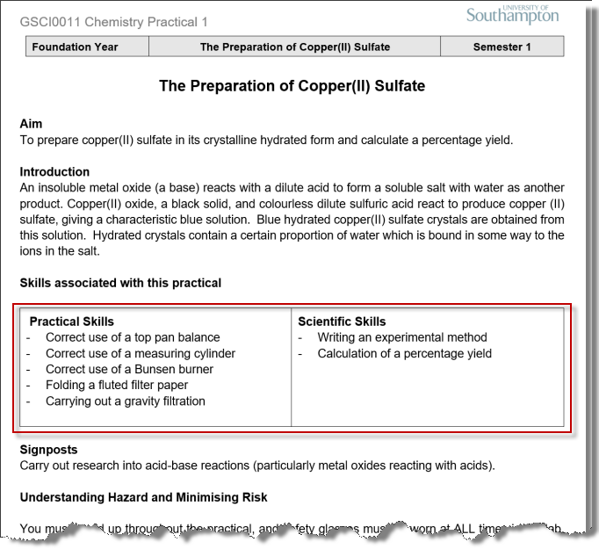 | The skills associated with the practical are listed under the introduction on the script, emphasising their importance to the students. In many cases, practical techniques are supported by videos outlining the correct procedure that students watch as part of their prelab preparatory work. Each prelab includes a quiz featuring questions relating to the material covered, which may include aspects of techniques and skills included in these videos. This means that students have some familiarity with the techniques and skills they are working with prior to arrival in the lab.
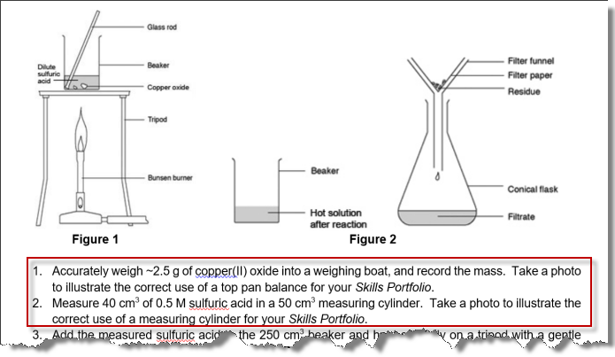 | The script includes prompts where students are performing techniques/skills that require photographs (and subsequent reflection) for inclusion in the PSP. Students are advised that their lab partner should take the photograph. Note that phones can be placed in re-sealable plastic bags while retaining their touchscreen functionality to protect them from chemicals in the lab.

SUPP_2: The PSP template
Note that the PSP templates associated with Science Foundation Year chemistry practicals can be downloaded here: http://edshare.soton.ac.uk/19405/
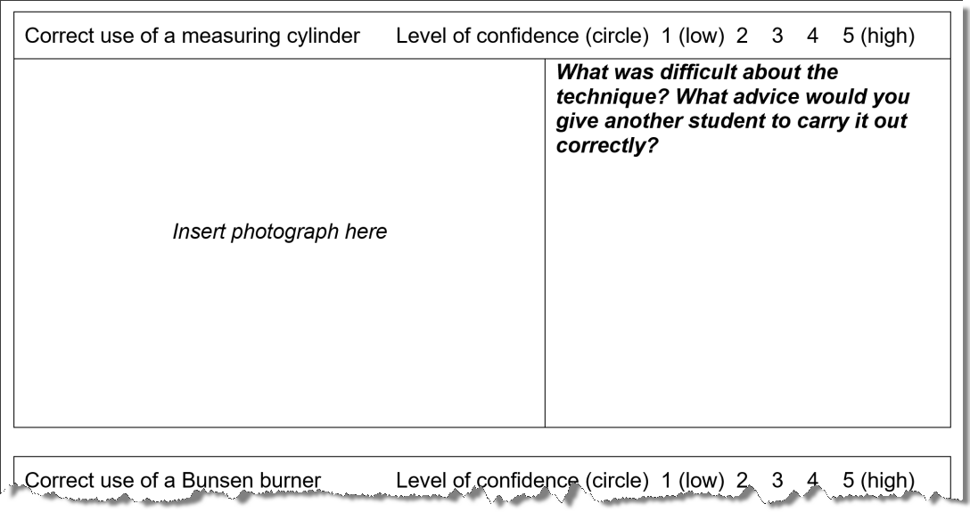 | For each technique of interest, a table is created with space for a photo/photos and accompanying reflection. Students are advised in class that photos should be taken by their lab partner, clearing showing them performing the technique correctly, and their response to the reflective prompt should ideally include 3 aspects of a practical technique on which they will reflect and provide advice to other students, with some discussion of issues which should be considered when performing the skill/technique.
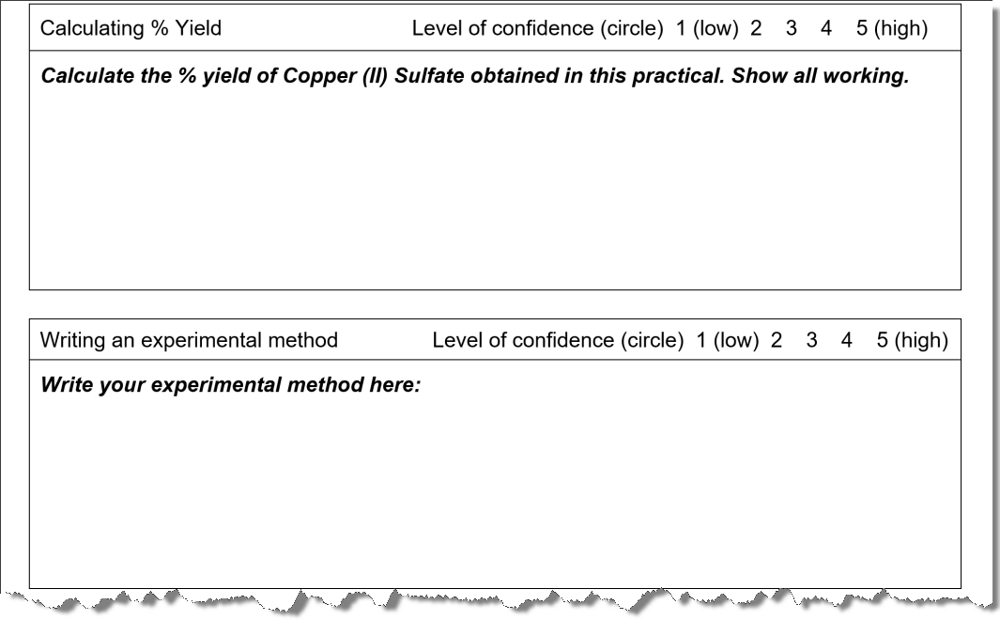 | To support students in developing skills they will need later on for writing full lab reports, they are given the opportunity to write different sections of a lab report (e.g. experimental method) as they work through the PSPs associated with the practical programme. This permits the provision of feedback that will assist them when writing lab reports in future.

SUPP_3: Examples of Quickmark comments used to provide feedback in Turnitin
The table lists some examples of Turnitin Quickmark comments associated with the PSP for practical 2. This is not the complete list, but does give a sense of the nature of comments provided.
Label | Quickmark comment
Apparatus? | What apparatus did you use?
Calc gd label | This calculation is good, but you could've labelled the steps more clearly.
Calc lab | It would be helpful if every step in the working were labelled to show what you were doing at each stage.
Calc. O | Did you use the molar mass of oxygen molecules (O₂) or oxygen atoms (O)?
Calc. rounding | Don't round the values until you get to your final answer.
Calc. units | It can be helpful to include the units of each value in your calculations.
Colour? | What colour was the solution?
Convention | This is not the correct convention to use.
CuO portions | Copper(II) oxide was added gradually, in portions.
Detail unnec | Unnecessary detail here. State what you did with reference the the technique - no need to add further detail unless you modified the standard procedure for the technique.
Exp clearer | This needs to be explained more clearly I.e. so somebody else can repeat exactly what you did.
It? | What's 'it'?
molar mass | This is the molar mass (it has units of g mol⁻¹).
Past tense | This should be written in the past tense.
Photo ex | This is an excellent photo which shows you clearly performing the technique in a correct manner. Well done!
Photo heating | This photo should show the apparatus used for heating the crucible - here the crucible is not above the Bunsen burner.
Photo incorrect | This photo shows incorrect technique. In future, make sure you are performing the technique correctly.
Photo not you | The photos are good, but you've lost marks because they don't show you completing the technique.
Prose | The method should be written in continuous prose i.e. paragraphs of text, not a list of sentences or bullet points.
Ratio | You have performed the calculations correctly but your description is a bit confused. The word "ratio" should be used to refer to the relative amounts of two or more things, here these are magnesium and oxygen.
Ratio wrong way | You have calculated the ratio the wrong way around.
Ref gd | This shows a good level of reflection indicating that you have thought about the difficulties of the technique, and you have provided some advice for other students in performing it. For a better mark, aim to identify at least 3 aspects of the technique which are key to performing it effectively.
Ref imp | You are giving some good advice to other students, but to get a better mark you need to discuss more aspects (aim for 3) of the techniques and explain more clearly why you are giving that specific advice.
Sig fig | Make sure you give your answer to the correct number of significant figures.
Sub and sup | Make sure all your chemical formulae and units have the numbers in subscript or superscript, as appropriate.
SUPP_4: Example of Rubric used for rapid marking in Turnitin
The image below shows part of a Turnitin marking rubric, taken as a screenshot from the Turnitin iPad app which is used to support the rapid marking required by the SFY programme schedule. Additional text is present in each box in the grid, but this is not shown for simplicity. Individual criteria are weighted (% values on the left), with numerical marks awarded against each criterion (0-5) by touching the box, with final mark awarded automatically and uploaded to the Blackboard Grade Centre by selecting ‘Apply % to Grade’.
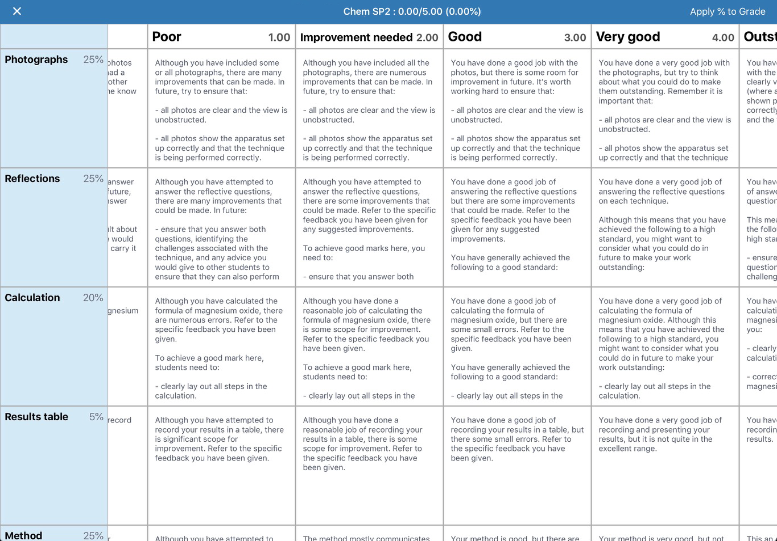

SUPP_5(1): Case study 2 self-assessment survey questions

A) SELF-ASSESSMENT ITEMS – students were prompted to enter marks for each sub-question.
B) FURTHER QUESTIONS
1) The exam-style questions and talking mark schemes have helped me to develop my understanding of organic reaction mechanisms. (5 pt Likert)
2) I found it easy to use the talking mark schemes. (5 pt Likert)
3) I am now more confident about tackling some questions that I may meet in my exams. (5 pt Likert)
4) The talking mark schemes have been more helpful than the alternative of looking at the published mark scheme. (5 pt Likert)
5) Doing the exam-style questions and using the talking mark schemes has helped me identify where I need to do more work/revision. (5 pt Likert)
6) The talking mark schemes enabled me to focus in on those questions where I needed greater explanation. (5 pt Likert)
7) Having now answered the exam-style questions and marked your responses using the talking mark schemes, what do you understand by the term 'curly arrow'? (open text)
8) Choose the option that best describes how you feel about your performance in this exercise.
- I am happy with my performance
- I thought my performance was OK
- I am unhappy with my performance
9) Having self-assessed your work, please comment on what you are think your strengths and weaknesses regarding organic reaction mechanisms.
10) What did you find most useful about the talking mark schemes?
- Ability to control pace
- The explanations
- Seeing the thought processes in how to answer a question
- Use of pen drawing/annotations
- Useful hints and tips in answering exam questions
11) Do you have any further comments on what was useful about the talking mark schemes? (Open text)
12) To what extent has your confidence in answering organic reaction mechanism questions changed as a result of doing this exercise?
- I am much more confident than before.
- I am slightly more confident than before.
- My confidence hasn’t changed.
- I am slightly less confident than before.
- I am much less confident than before.
SUPP_5(2): Case study 2 self-assessment survey questions

13) Please explain what has caused your confidence to change, if indeed it did change as a result of this exercise. (Open text)
14) Would you like access to talking mark schemes in the future?
- Yes
- I don’t mind
- No
15) Briefly explain your answer to the question above. (Open text)
16) What will you do to ensure that you can improve your performance in organic chemistry, and prepare for your upcoming exams? Be specific in your response (e.g. rather than saying 'revise', state exactly how you will revise the topic). (Open text)
17) If you have any comments you would like to add, please add them below. (Open text)

These are the core questions that contribute the data considered in the case study in this book chapter. Additional demographic and background questions were included for the purposes of Stephen Barnes’ Master’s project, which are not considered here.
When the resources were repurposed for use by teachers of students aged 16-18, the survey was replaced with a paper pro forma that could be completed by students as they completed self-assessment of their work and then submitted to the teacher. This was intended as a less cumbersome approach in comparison with setting up a survey. An example pro forma is included on the next page.

SUPP_6(1): Example of self-assessment pro forma used in place of an online survey.

Organic reaction mechanisms self-assessment pro forma Name: …………………...
We have created talking mark schemes, hosted on YouTube, which you can watch to assist you in marking your own work. An expert explains the answers to the questions and the thought processes behind them. The idea is to help you to ‘think like an expert’ when you approach organic reaction mechanisms in the future. Our research has shown that it’s important for you to reflect on your performance as you self-assess your work, and as such you should complete all the reflective questions as well as recording your marks so you can devise strategies for future success in this area. Unsure what this is about? Watch this video first: https://youtu.be/haEL4F3cwf8

Question 1 For the talking mark scheme on You Tube, go to: http://tinyurl.com/z4r2pkb

Question | 1 (a) (i) | 1 (a) (ii) | 1 (b) (i) | 1 (b) (ii) | Total mark
Your marks | … / 2 | … / 2 | … / 1 | … / 3 | … / 8

Question 2 For the talking mark scheme on You Tube, go to: http://tinyurl.com/jchkxat

Question | 2
Your mark | … / 5

Question 3 For the talking mark scheme on You Tube, go to: http://tinyurl.com/j3xnpy4

Question | 3 (a) | 3 (b) (i) | 3 (b) (ii) | 3 (b) (iii) | Total mark
Your marks | … / 1 | … / 1 | … / 4 | … / 1 | … / 7

Question 4 For the talking mark scheme on You Tube, go to: http://tinyurl.com/jy4uxnu

Question | 4
Your mark | … / 3

Question 5 For the talking mark scheme on You Tube, go to: http://tinyurl.com/zusjmvn
Overall mark
… / 28
Question | 5 (a) | 5 (b) | 5 (c) | Total mark
Your marks | … / 1 | … / 1 | … / 3 | … / 5
SUPP_6(2): Example of self-assessment pro forma used in place of an online survey.

Reflective questions

1) To what extent do you agree with the following statements? Circle the appropriate option.

“The exam-style questions and talking mark schemes have helped me to develop my understanding of organic reaction mechanisms.”

Strongly Agree | Agree | Neither Agree or Disagree | Disagree | Strongly Disagree

Briefly explain your answer: ………………………………………………………………………....
…………………………………………………………………………………………………………………………………………………………………………………………………………………...
“I am now more confident about tackling questions that I may meet in my A-Level exams.”

Strongly Agree | Agree | Neither Agree or Disagree | Disagree | Strongly Disagree

Briefly explain your answer: ………………………………………………………………………....
…………………………………………………………………………………………………………………………………………………………………………………………………………………...

2) Your perceptions of organic chemistry: to what extent do you agree with the two statements below? Circle your responses to both statements:

a) “The best way to approach understanding organic mechanisms is that they are diagrams that need to be memorised.”

Strongly Agree | Agree | Neither Agree or Disagree | Disagree | Strongly Disagree

SUPP_6(3): Example of self-assessment pro forma used in place of an online survey.

b) “The answer to an organic mechanism question can be worked out by applying some basic principles.”

Strongly Agree | Agree | Neither Agree or Disagree | Disagree | Strongly Disagree

Has the process of self-assessing your work using talking mark schemes had any impact on your opinion of statements 2 a) and b)? Yes / No Briefly explain your answer below: ………………………………………………………………………………………………………………………………………………………………………………………………………………………………………………………………………………………………………………………………………………………………………………………………………………………………………...

3) What are your strengths and weaknesses in organic chemistry? ………………………………………………………………………………………………………………………………………………………………………………………………………………………………………………………………………………………………………………………………………………………………………………………………………………………………………...

What are you going to do to improve your future performance in organic chemistry? ………………………………………………………………………………………………………………………………………………………………………………………………………………………………………………………………………………………………………………………………………………………………………………………………………………………………………...
…………………………………………………………………………………………………………
Like this? Give us some feedback - help us to produce more resources like this and keep them free to use. Go to: https://www.isurvey.soton.ac.uk/22354

SUPP_7(1): Qualitative data collected during the evaluation of case study 1.

Theme | Representative extracts from students’ comments
Recall | “it helped me to remember how to go about carrying out certain techniques”  “it helped me to go over and revise the processes carried out”  “it helped ingrain the technique in my mind”
Role of reflection | “…good to reflect… made sure that techniques were carried forward correctly”  “…by reflection look at ways to improve in the future”  “reflecting on the tasks was important to remembering what you had done and made me think critically about what I’d done”  “by simplifying something you are able to better understand the task at hand”  “It made you think i.e. what mechanisms are in place to achieve a goal and allowed to develop an in-depth understanding of each technique”
Consolidation of skills and understanding | “I knew why things had to be done a certain way”  “…allowed to consolidate the skills obtained”  “teaching somebody else is a very effective way of learning something better yourself”  “it helped to see the experiment from someone else’s eyes”  “I found this the most useful part as it made me not only remember how to do the certain task but also how to improve”
Identifying and correcting mistakes | “analysis of mistakes… will help me not to [make] the same mistakes”  “I find self-assessment exercises very helpful since it highlights a lot of errors”
Preparation for the future | “Understanding the technique helped with write ups carried out in the first year of my degree”  “…help me to learn and accurate writing skills which I used the whole degree”  “it helped to write better methods section in my future work.”
Themes identified in students' comments explaining their response to prompt 1: The skills portfolio required you to self-assess your performance and write a short reflection on the techniques you performed and provide advice for another student to be able to carry out a task correctly. To what extent did this impact on your understanding of the techniques you were performing and the reasons for carrying them out in a specific way?

SUPP_7(2): Qualitative data collected during the evaluation of case study 1.

Theme | Representative extracts from students’ comments
Recall | “it enabled me to go over the procedure at home, and repetition is key to long term memory”  “thinking back on tasks performed made me remember it better”  “it just helped me memorise the skill”  “allowed to remember with ease how the technique was performed”
Role of reflection | “it forced me to be honest with myself and reflect on what I needed to improve”  “reflecting on the tasks was important to remembering what you had done and made me think critically”  “improved strengths and weaknesses”
Consolidation of skills and understanding | “helped in reminding me how to handle equipment and how to carry out intricate procedures”  “one of the most important elements helping me understand and remember the practical skills”  “being required to reflect on the techniques helped ingrain how to perform them correctly”  “I was able to remember certain small tricks that I found made it easier and use these later on”  “the analysis cemented the understanding and recollection of the techniques”
Preparation for future | “helped me a lot in the first year as it made me aware and remember what I had done wrong in the foundation year and these mistakes were not repeated”  “even after 4 years I still remember, so I believed it works very well”
Confidence | “provided confidence that the techniques were correct”
Themes identified in students' comments explaining their response to the prompt: To what extent did self-assessing your performance and reflecting on it impact on your ability to remember how to perform techniques at a later date?

SUPP_8: Qualitative data collected during the evaluation of case study 2.

Theme | Representative extracts from students’ comments
Clarification of thought process | “the thought process is clearer now which has made it easier to answer the questions more quickly”  “…ways of tackling questions that can help one to use mechanisms and not memorise”  “I was able to confirm my thought processes”  “hearing the thought process of working through the answers and realising they were pretty similar to mine”
Perceptions of difficulty | “…mechanisms aren't [as] difficult as they look”  “some things looked complicated but I did not know why”  “mechanisms are much simpler than I thought”
Approach to mechanisms | “…reminding me of the steps and simplifying my thoughts”  “I am able to visualise the best process”  “having attacked the questions from a different angle has definitely helped”  “I am able to see the things that I need to think about before starting”  “going back to basic principles will...help me a lot”  “there [are] several ways of trying to answer if knowledge is limited and it is still possible to work out the answers”  “it is a logical sequence of steps rather than something that simply needs to be memorised”
Better understanding than they realised | “watching the mark scheme showed me that I do understand it”  “i am able to do these styles of question… despite what I thought upon initially 'reading' the problems”  “I got a lot more questions right than I initially expected”
Application of knowledge | “trying a range of mechanisms, some of which are unfamiliar”  “once you understand the mechanisms they can be easily applied to different molecules”  “by knowing the basics, you can apply your knowledge to most questions”
Self-confidence | “easier to start tackling a question without staring at it all scared”  “although I got most of the questions correct I had no faith”  “it’s more about not doubting your knowledge”  “realising that I can answer most questions”  “finding out most of what I did was correct naturally gives one a sense of internal closure and boost in confidence”  “I already knew the knowledge I just didn’t have the confidence in how to apply it  they don't look so 'scary' anymore”
Holistic approach to mechanisms | “seeing how a number of different mechanisms work…”  “I have been tackling chemistry revision in completely the wrong way”  “helped consolidate mechanisms I already know and importantly understand the ones I don't a little better”  “it has become apparent that all mechanisms adopt the same principles”
Identifying mistakes | “helped me pinpoint what I was doing wrong as well as understanding why”  “I have learnt from the mistakes I made and have understood the reason why my responses were wrong”  “I realize some mistakes I had not seen them previously”  “helped me reflect [on] little mistakes”

Themes identified in students responses to the prompt "Please explain what has caused your confidence to change, if indeed it did change as a result of this exercise"
SUPP_9: Feedback statements accompanying marks (%) for the reflective self-assessed activity
The reflective responses from students were considered and an appropriate mark awarded. The feedback statements below broadly reflect the criteria used in making the marking judgement, which is moderated in consultation with another colleague. Students then receive further verbal feedback when they have an assessed interview as part of the Routes to Success module a short time after completion of the task.
90% | This shows an exceptional level of reflection and indicates in detail what the impact of this activity was on you and your understanding of the topic.
85% | This shows an exceptional level of reflection and indicates clearly what the impact of this activity was on you and your understanding of the topic.
80% | This shows a very deep level of reflection and indicates clearly what the impact of this activity was on you and your understanding of the topic.
75% | This shows a very deep level of reflection, which could've been enhanced in a few areas, and indicates clearly what the impact of this activity was on you and your understanding of the topic.
70% | This shows a deep level of reflection, which could've been enhanced in several areas, and indicates clearly what the impact of this activity was on you and your understanding of the topic.
65% | This shows a fairly deep level of reflection, which could've been enhanced in several areas, and indicates clearly what the impact of this activity was on you and your understanding of the topic.
60% | This shows a reasonable level of reflection, which could've been enhanced in several areas, and the full impact of this activity on you and your understanding of the topic might've been clearer.
55% | This shows some evidence of reflection, which could've been enhanced in most areas, and the full impact of this activity on you and your understanding of the topic could've been clearer.
50% | This shows limited evidence of reflection, which could've been enhanced in all areas, and the full impact of this activity on you and your understanding of the topic was unclear.
40% | You didn't complete the reflective questions so you have achieved a fail

