I was asked to prepare a report and I decided to compare six different example systems (Table 1).
Table 1: A comparison of six different systems which I decided to review for my report
Systems | Descriptions
System one name | I had left my preparation until the last moment so I really had not got any time left to do any detailed analysis.  I dodn’t have enoiugh time to think about different ways to classify and categorise the different systemts, so I just decided to put a long and tedious description which I had found on the system’s home website into the description table. I includes the link in the text http://link_to_the_company’s_website_which_I_got_from_wikipedia
System two name | I had left my preparation until the last moment so I really had not got any time left to do any detailed analysis.  I dodn’t have enoiugh time to think about different ways to classify and categorise the different systemts, so I just decided to put a long and tedious description which I had found on the system’s home website into the description table. I includes the link in the text http://link_to_the_company’s_website_which_I_got_from_wikipedia
System three name | I had left my preparation until the last moment so I really had not got any time left to do any detailed analysis.  I dodn’t have enoiugh time to think about different ways to classify and categorise the different systemts, so I just decided to put a long and tedious description which I had found on the system’s home website into the description table. I includes the link in the text http://link_to_the_company’s_website_which_I_got_from_wikipedia
System four name | I had left my preparation until the last moment so I really had not got any time left to do any detailed analysis.  I dodn’t have enoiugh time to think about different ways to classify and categorise the different systemts, so I just decided to put a long and tedious description which I had found on the system’s home website into the description table. I includes the link in the text http://link_to_the_company’s_website_which_I_got_from_wikipedia
System five name | I had left my preparation until the last moment so I really had not got any time left to do any detailed analysis.  I dodn’t have enoiugh time to think about different ways to classify and categorise the different systemts, so I just decided to put a long and tedious description which I had found on the system’s home website into the description table. I includes the link in the text http://link_to_the_company’s_website_which_I_got_from_wikipedia
System six name | I had left my preparation until the last moment so I really had not got any time left to do any detailed analysis.  I dodn’t have enoiugh time to think about different ways to classify and categorise the different systemts, so I just decided to put a long and tedious description which I had found on the system’s home website into the description table. I includes the link in the text http://link_to_the_company’s_website_which_I_got_from_wikipedia
In order to keep within the word limit I decided to make a table which let me ‘hide’ 452 words within something which was only counted as equivalent to 150 words.
I did this by turning a table into a graphic by grabbing it and inserting it into the document as an image
After I had handed it in, I discovered that this contravened the guidance notes
I knew there was a word limit so I decided to use text which was linked with underscores and then formatted each underscore in white so that it would not count in the total. When I thought about it, I realised that the rule don’t mean that I can’s use any words in text, just that the guidelines have to be respected. There are some sorts of visualisations which can be really useful when it comes to creating a report – for example a word colud – also known as a wordle (figure 1).

Figure 1: an example of a wordle found on the internet
Figure one shows an example wordle found on the internet using an image search. In fact it is not a particulalry good example because it is very wordy, and not particulaly focussed.
However if you find out how to creat your own customised wordles, for example using the Wordle website (Figure 2) you may find that you can use a wordle to represent and overview of your report in a visually compelling manner.

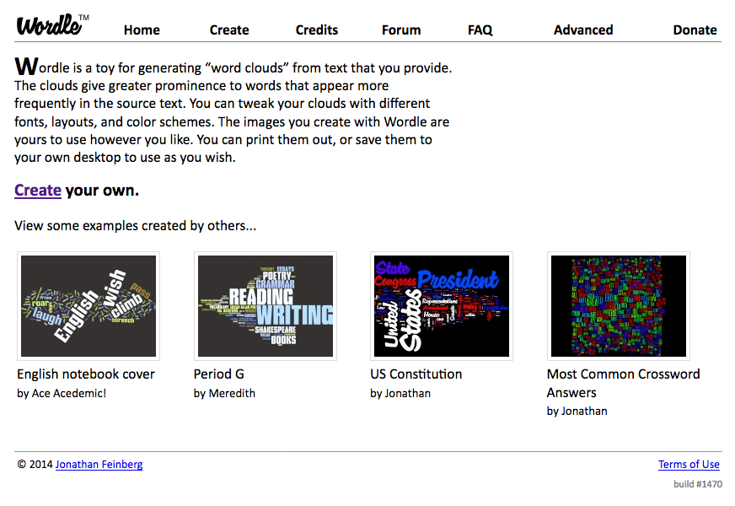
Figure 2: screenshot of the Wordle website

http://www.wordle.net/

