Remote Sensing for Earth Observation: Practical 5 - Supervised Classification

Aims and Objectives
The purpose of this practical session is to classify the land cover types of Hong Kong Harbour using supervised classification and to compare the results with the unsupervised classification produced in the last practical.

Core Tasks for this session
1. Training Site Development
2. Supervised Classification
3. Comparison of supervised and unsupervised classification approaches
4. Interpretation of the error matrix

Locating the Data for this Practical

Files for this practical we will use the same data as in practical 5 i.e. Hong Kong Harbour

Image Classification

In practical 2 you drew spectral response patterns for 3 types of land cover: urban forest and water. Hopefully, you recognised that the spectral response patterns of each of these cover types was unique. Land covers, then, may be identified and differentiated from each other by their unique spectral response patterns.

The methods for image classification fall into two categories: supervised and unsupervised classification. With supervised classification, the analyst develops the spectral responses of known categories, such as urban, forest, water (training site development) and then the software assigns each pixel in the image to the cover type to which its spectral response is most similar.

TASK 1: Training Site Development

A. Defining Training Areas
1. You will create five training classes for use in the supervised classification. These classes
and colours are the same as those created in your unsupervised classification namely:

1. Thick vegetation - Green
2. Sparse vegetation (grass) - Sienna
3. Urban - Yellow
4. Bare concrete/soil - Cyan
5. Water - Blue

2. Display a true and/or false colour composite of the Hong Kong image. Use these composites, along with higher resolution images available in Google Earth, to help you to decide on training sites for each of your land cover types.
3. Remember you can use the zoom and scroll windows to focus in more closely on your image if you need to.

B. Signature Extraction - Digitising Polygons

For each training class you will define a Region of interest (ROI) of the specified colour.
Read all the instructions before you begin digitising!

To start digitising polygons you must open the Region of Interest Tool window:

1. From the main image menu select Overlay > Region of Interest

You will use the ROI (Region of Interest) tool to gather spectral signatures for training sites.

The ROI Tool dialog window will allow you to digitize polygons on the image, in addition to editing and saving them. There are several choices across the top of the dialog box that let you digitize features from the Image, Scroll, or Zoom display windows. Depending on where you want to do the digitizing (i.e. what image window you want to digitize in), you can choose any one of these options.

2. To start digitizing, go to the location on the image where you want to draw a polygon.
Click the left mouse button. Move the cursor to the next position along the boundary and click again…and so on – you should now see a boundary line beginning to form.

3. Continue digitising until just before you have finished the boundary and then click the right mouse button to close the polygon, and to fill the polygon click on the right button again.

Inside the dialogue box, the name, colour, and number of pixels of each polygon are displayed in spreadsheet format.

4. If you want to add another polygon to an existing region, highlight the region (an * will appear to the left of the name), and digitize additional areas anywhere in the image. You will notice that the number of pixels column becomes larger when you add additional polygons.

Consider the disadvantages and advantages of a single large training site per class (or
ROI) versus many medium sized training sites.

5. To edit the name of a region of interest, click on the ROI Name (e.g. Region #1), change its name, and make sure to hit return. To edit the colour of the polygon right click on the colour cell.

6. To create a new ROI click on New Region, and repeat the above steps.

If you make a mistake, you can:

1. Delete an entire ROI by highlighting the ROI and pressing the “Delete”
button in the ROI dialogue box.
2. Delete individual polygons within a single ROI by toggling though the polygons by clicking on the “Goto” button in the ROI dialogue box. When the relevant polygon is highlighted select “Delete Part”. (Note this feature is only available in ENVI 4.6. and above)
NOTE: There are two things that are recommended when making your supervised classification ROIs. First, it is important that you label each ROI immediately after you create it. Second, you can have more than one ROI per class. Since each ROI, in effect, becomes a class, this can be useful for the classifier to account for the subtle variations in the same land cover classes, such as the differences within a forest based on stand dynamics and canopy structure.

C. How unique are my classes/ROIs?
You can examine the statistics of any (one or more) class(es) by selecting that class/ROI and clicking the 'Stats' button.

You can also compute a measure of separability between the ROIs that you have defined, using the selection: Options/Compute ROI Separability.... This outputs Divergence metrics between the classes you have defined. These values range between 0 and 2.0. As a guide to interpretation, values greater than 1.9 indicate good separability of classes.

If class separability is less than this, you might consider splitting the classes for the classification and recombining them post-classification (e.g. have two classes: forest1 and forest2) using the same procedure as outline in Practical 4, Task 2.

7. Once you collect all of the polygons you are interested in, go to File > Save ROIs...in the ROI Tool window. MAKE SURE YOU CLICK on Select All Items. Click Choose, and enter your personal directory and a file name. Don't forget to give an extension of
*.roi to this file (such as “superclass.roi”).

TASK 2: Supervised Classification

Now that you have specified your training sites, you are ready to proceed with the supervised classification – classifying the image based on the spectral data contained within your training sites (i.e. ROIs). Each pixel in the study area has a value in each of the five bands of imagery. These values form a unique signature which can then be compared to each of the signature files you created. Each pixel is then assigned to the cover type that has the most similar signature. There are several different supervised techniques that may be used to evaluate how similar signatures are to each other. For this practical, we will be using the Minimum Distance to Means and Maximum Likelihood classifiers. You should re-read your lecture notes if you are unsure about how this classifiers work.

1. Under the Classification menu in the main ENVI toolbar, choose the Supervised
Classification option.

2. Select Minimum Distance as the classification method

3. Specify Hong_Kong_TM_1998-16-03 as the input file and click OK.

4. Make sure you select all of your ROIs in the “select classes from regions.” Set "maximum standard deviation from mean" and "maximum distance error" as none.

5. Click on the radio button output results to file, navigate to your home directory and enter a name for your image

6. Change “output rule images ?” to NO
7. Select OK when everything is in place.

8. Open a new viewer and display the results

9. Now repeat the classification but this time using the maximum likelihood classifier.

Question 1
Use your skills gained from the last practical to create TWO maps
containing (1) the original image with your “training sites” overlaid and results from the minimum distance to means classifier and (2) the original image with your “training sites” overlaid and results from the maximum likelihood classifier. Attach the maps here. Do not spend too much time on map design for this question! (You can print in black and white but make sure the classes can be identified)

Using the information contained in these maps, discuss some of the major differences that appear between the two classification approaches and suggests reasons for these differences. (6)

TASK 3: Verifying the Accuracy of the Supervised
Classification

Are you curious how well the classifiers classify your image?
A confusion matrix compares that relationship between known reference data and the corresponding results of the classification. ENVI can calculate a confusion matrix
(contingency matrix) using either a ground truth image or using ground truth regions of interest (ROIs). In each case, an overall accuracy, producer and user accuracies, kappa coefficient, confusion matrix, and errors of commission and omission are reported.

Before you continue you must make sure that you have exactly the same classes mapped in each classified image. For example: If you decided to split your classes during supervised classification to help improve the classification and you have classes such as thick vegetation 1 and thick vegetation 2 then you need to combine these classes into a single thick vegetation class before you can continue with the accuracy assessment (see practical 4 to remind you how to combine classes)

Using Ground Truth Regions of Interest
I have provided you with a set of ground truth regions of interest to use in the production of a
confusion matrix. These regions are not entirely accurate themselves as they were derived from an old paper matrix, although they will allow you to derive the required accuracy measurements.

1. Load the original Hong Kong TM image, and classified images (Unsupervised and both supervised (minimum distance and max likelihood) into 4 new displays

2. We will now open the ground truth ROIs, but first we must clear the ROI menus so as not to confuse the ground truth ROIs with those used as training data during the classification. Select Basic Tools/ Region of Interest/Delete ROIs/ Select all/Ok from the main ENVI menu bar.

3. Now we will load the ground truth regions of interest. Select Basic Tools/ Region of Interest/ restore saved ROI file. Navigate to your home directory and select the Gtruth.roi file that you downloaded from blackboard and click OK.

If the ROIs appear in the TM image do nothing if not from the main ENVI menu select Basic Tools/ Region of Interest/ Reconcile ROIs and select the six ROIs in the display. Click Select values from source/destination files and select the Hong Kong TM file. Click Ok and then select the Hong Kong TM file again and click OK again. The ROIs should appear in the TM image in your display window.
4. We will now calculate the confusion matrix. From the main ENVI menu select Classification/Post Classification/Confusion Matrix/Using Ground Truth ROIs.

5. In the Classification Input File dialog, select your unsupervised classification image. The ROIs are automatically loaded into the Match Classes Parameters dialog.

6. When the Match Classes Parameters dialog appears, match the ground truth ROIs with the classification result classes by clicking on the matching names in the two lists and clicking Add Combination. The class combinations are shown in a list at the bottom of the dialog. If the ground truth and classification classes have the same names, they are automatically matched. If not you will need to match them manually by sequentially clinking on the Ground truth ROI and matching it with the class name. Click add combination and repeat until all classes are matched.

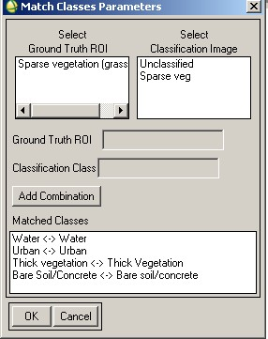

7. After all of your class combinations are made, click OK. The Confusion Matrix
Parameters dialog appears.

8. Next to the Output Confusion Matrix in label, select the Pixels check boxes.

9. Next to the Report Accuracy Assessment label, click the Yes toggle button and click
OK.

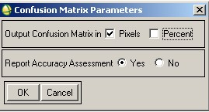
10. To save the classification accuracy report Select file/ Save Text To ASCII in the report window and navigate to your home directory and give it a useful file name. You can open this file in any text editor (including Word) or in Excel.

11. Repeat steps 4-10 above twice more but on each occasion select your supervised classification image (minimum distance to means or max likelihood) as the input image in step 5.

The output reports shows the overall accuracy, kappa coefficient, confusion matrix, errors of commission (extra pixels included in a class), errors of omission (pixels left out of a class), producer accuracy, and user accuracy for each class. Remember that producer accuracy is the probability that a pixel in the classification image is put into class X given the ground truth class is X. User Accuracy is the probability that the ground truth class is X given a pixel is put into class X in the classification image. The confusion matrix output shows how each of these accuracy assessments is calculated. See the following example for details.

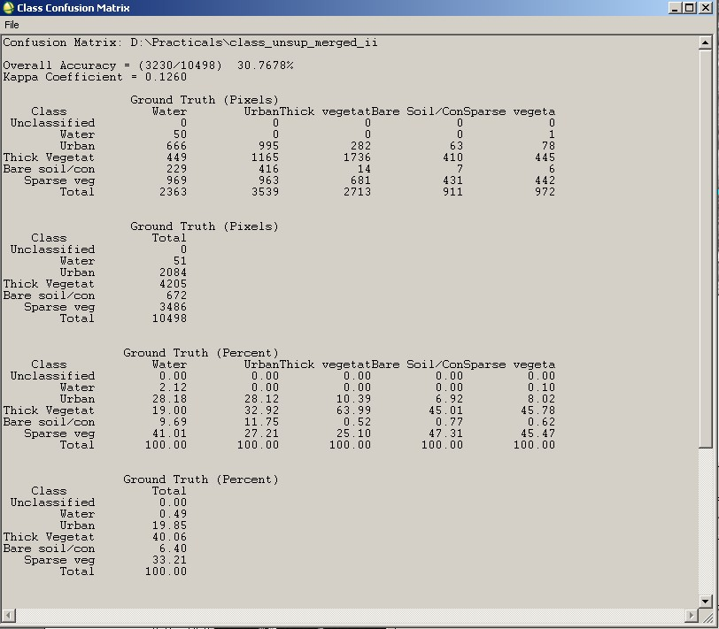

Print out your confusion matrices and attach them to this page. Use the accuracy assessment results to hep you answer the following questions.

Question 2
Use the confusion matrices to identify in each thematic map the classes
that were (a) the most accurately classified and (b) the most misclassified. Discuss why you think this may be? (4)

Question 3

Draw and annotate a flow diagram(s) to illustrate the theoretical steps (not ENVI specific steps!) of supervised classification i.e. how it works (chose ONE of the supervised classification algorithms used in this practical). On your diagram, indicate and briefly discuss where and how error may be introduced into the classification process. Do not copy existing flow diagrams from books or lecture notes! (8) .

9
Question 4

Give an example situation of (1) where supervised classification might yield better results than unsupervised classification AND (2) an example where unsupervised classification might yield better results than supervised classification (4) .

Total /22

10

