Oceans Deep Assessed Task
Oil spills– What’s the problem?
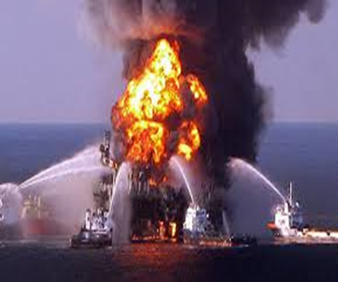
On 20th April 2010 there was an explosion on the Deepwater Horizon oil-drilling rig situated in the Gulf of Mexico, off the coast of the USA. The explosion lead to a number of leaks in a pipeline on the seabed, around 1.5km below the surface. Oil gushed out at a rate that was hard to calculate, but what soon became clear was that the scale of the leak had never been seen before. BP, who owned the rig, had difficulty stopping the leak and the oil continued to pollute the Gulf’s water as well as harm wildlife, damage the fishing industry and hurt the economy of the Gulf region long after the leak had been stopped.
Your task
Write a report which includes answers to the following questions:
- What is oil used for?
- What other serious oil spill incidents have there been?
- How are oil spills are cleaned up? Including the results of your class investigation.
- Why are oil spills so damaging to the environment?
- What possible solutions might there be to prevent oil spills occurring in the future?
Useful websites
http://www.geography.org.uk/resources/oilspill
http://www.bbc.co.uk/news/world-30699787
http://oceanservice.noaa.gov/education/stories/oilymess/supp_primer.html
http://www.kidzworld.com/article/24170-oil-spills-sad-but-true
Level | What must be included | Me | Teacher
3 | Identify a specific incident or oil spill
4 | Identify what oil is used for.
 | Identify a specific oil spill and list some of its effects on the environment.
 | Identify ways of clearing up a spill
5 | Explain what products are produced from crude oil.
 | Describe how an oil spill damages the environment
 | Describe how an oil spill may be cleaned up
6 | Explain how oil spills cause long term effects on the environment.
 | Describe the advantages and disadvantages of several methods for cleaning up oil spills.
7 | Provide at least two possible solutions for how this could be prevented in future.

