Task 2
You are now going to obtain 6 pieces of data about the Arctic to analyse.
Data set 1:
Go to the following website:
http://mynasadata.larc.nasa.gov/las/UI.vm
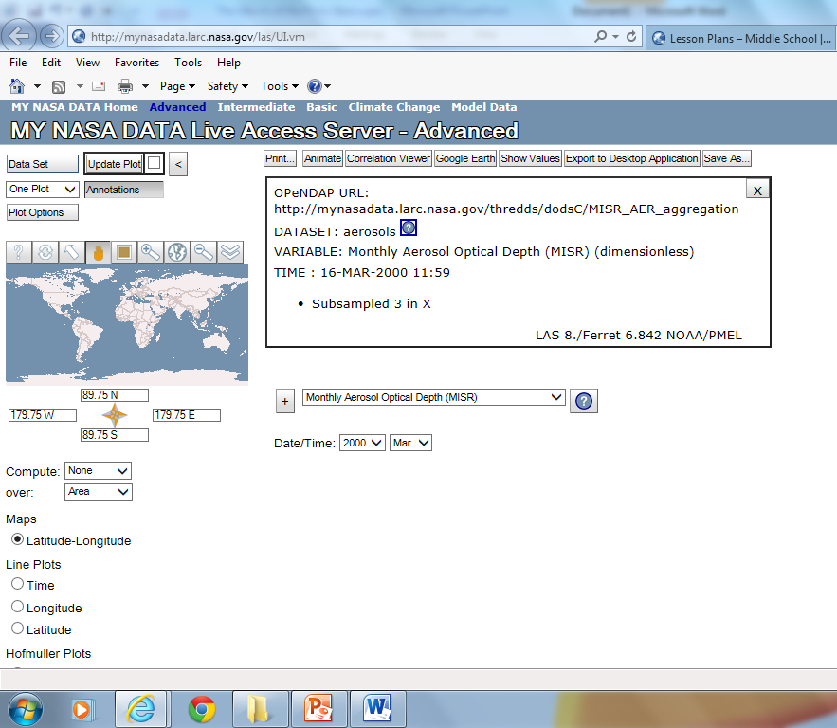
Click on the dataset in the top left hand corner and click as follows:
Atmosphere – atmospheric temperature – monthly near surface temperature (ISCCP)

Enter the following coordinates: for the region in the compass rose: LAT 50N to 78N, LONG 168W to 142W.
Change the date to June 1995
Click the update plot button
Download a copy of your colour map or note the
average temperatures across this region of the Artic.
Change the date to June 2005
Download a copy of this second map or note the temperatures across the region.

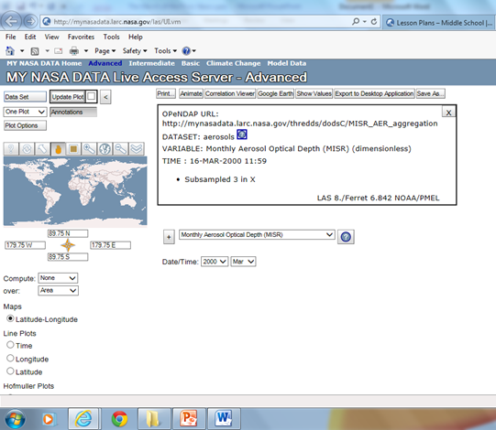
Data set 2:
Go back to the dataset button at the top and change it to:
Cryosphere- Monthly snow ice amount (ISCCP)
Download the two colour maps for June 1995 and 2005

Checklist:
A colour surface temperature map for June 1995
A colour surface temperature map for June 2005
A colour map of snow for June 1995
A colour map of snow for June 2005

