FY RTS Personal Reflection Exercise
Practice a simple way that you can conduct a written reflection is by following a three-step reflection template.
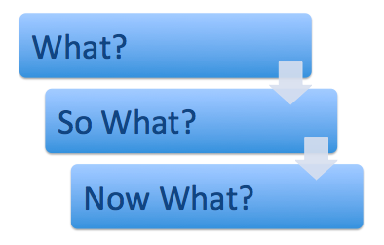
Complete this exercise after you have finished the comparing reflections exercise.

What?

Use the specific
- I completed a lab and received a mark for some work

Avoid the general:
- I keep missing deadlines and loose marks
- My marks for this module are OK

Although:
The general might lead you to the specific

So What?

An explanation of any logical conclusions that you draw:
- e.g. I think I was {over optimistic, unrealistic, realistic}
- The outcome might have been better if….
- The outcome was satisfactory/excellent but….

An objective evaluation of your experience

Now What?

A realistic and objective suggestion of what you will do now and how you might
- Change your behaviours and do things differently
- Look at things differently
NB: it will be different for everyone

Exercise
Think of one example from your everyday life on which to make a reflection. You could choose something from the portfolio, or it might be something relating to your personal life, Note this is a private exercise, you will not have to hand this in as part of your portfolio, although you may choose to discuss it with someone who you trust/respect.

Further Notes
It can be useful to identify your subject matter of reflection in terms of a question such as:
What is the issue / event / topic / plan /project / task / period of time etc that is to be the subject matter of the reflection?

Questions that may help with your reflection
- Out of the description, what is the issue / are the issues that could be addressed in reflective writing? These issues can be raised within the description or separately. They are like bits of velcro to which you can attach the reflective writing.
- Is there anything else you need to consider at the moment in terms of the context?
- What is the nature of the significance of this issue to you?
- How do you feel about it?
- How do your feelings relate to any action?
- Was it good / bad – and what are the implications?
- What do you need to do?
- What other information do you need (ideas, knowledge, opinion etc)?
- Are there previous instances of this event, issue arising that will help you to think more/ differently about it?
- Are there others, or the views of others who are relevant to this matter – and in what way?

These notes are based on material originally developed by Jenny Moon from the University of Exeter

