Requirements, Formats and Protocols

Task Overview
Each group of six members will work together to develop a ten-minute PowerPoint presentation on their allocated topic.
- Groups with seven members can have an additional minute (total 11 minutes)
- Groups with eight members can have two additional minutes (total 12 minutes)
- There will be a further four minutes available for questions.
- Two minutes will be allowed for handover

Marking
All presentation will be marked by members of the course team, and peer marked by the nominated audience.
- Presentations will be marked against a mark grid
- Presentations will be kept strictly to time. Failure to keep to time will be noted in the mark grid.
- After the set of presentations, immediate verbal feedback will be given to each group in turn by the course team.
Each group should conduct some research, to address the brief.
You will identify credible sources which can be used to provide evidence around which to structure their presentation. Expect the process to be similar to that which you adopted when preparing your technical report (although you will be working collaboratively in your group)

The slides
You are free to choose whatever presentation software you wish to prepare your presentation, although you will have to use PowerPoint or PDF to display your work. Your objective it to use that software in a professional manner as indicated by the mark sheet.
There is no specific limit on the number of slides, however: Your title slide should include
- One slide (the first slide)
showing presentation title, your group number and a chosen name, the name of all the presenters, and your tutor details
- One slide (second slide) should include a picture of all the presenters (group of headshots) with each presenter clearly identified.
- One slide (the final slide) should include a summary of all the references you have used in the presentation. You can also include references to any background reading.
You will lodge a copy of your slides on SideShare http://www.slideshare.net/
and via the ECS handin

The Abstract
You will also produce a single sheet abstract (one page of A4)
- Title
- Author List (name, email address)
- Keywords (as a list)
- Abstract (max 200 words)
- Text should be in 10 point Ariel Font
- Headings 12 Point Ariel Font Bold
Each team member will submit a copy of their group abstract via ECS Handin Machine C-Bass

Eventbrite invitations
Groups will each nominate a liaison officer who will collaborate with other groups in their slot to produce a single event invitation for their joint session using Eventbrite http://www.eventbrite.co.uk/
This liaison group should then advertise it by email to their audience, and enter the link on the student wiki (see the tab on the ECS module page)

What makes a good presentation?
In previous years the best presentations in terms of content were those which were clearly well researched and prepared.
Tutor teams also demonstrated that a considerable amount of thought had gone into constructing the argument which was being presented.
The best presentations finished on time and handled questions professionally.
The mark criteria are designed to guide you through this process. Analyse the mark criteria, and pay attention to each aspect of the mark scheme.
You will receive general verbal feedback on the presentations plus summary feedback by email after the marks have been collated
I have explained in the lecture that preparing a presentation can be a time consuming task. Please ensure that you dedicate sufficient time to this task to ensure that we enjoy the high quality presentations which we know you are capable of producing.

Mark Scheme
The Mark Scheme (available as an appendix to the document) will be used by the tutors in the sessions to determine the group mark.
In addition, marks are derived from an individual component, which you undertake by participating in the audience of another presentation slot. Details of how this part of the mark is derived is outlined below.

Peer Marking: Providing Constructive Feedback
We allocate a proportion of the final marks as an individual component based on the value of the feedback which you provide for the presentations you observe.
We ask you to fill in your mark on a paper sheet during the session, and then enter your mark via an online form for each completed evaluation sheet. You use the same sheets as those used by the course team memebrs who are marking the groups contribution.
On each sheet you provide feedback for the presenters on the quality of their presentations. We ask you to give numeric scores for various aspects of each presentation, and write brief, descriptive comments which you consider the presenter(s) might find helpful when reflecting on their performance.
The typical range of marks which you might expect to gain according to the quality of your feedback is as follows:
0 – did not complete this task
1-3 fail, scant comments, or marks not substantiated. Not clear that the marker was taking the task seriously.
4-6 pass, mostly realistic marks (may not be quite complete or may not be consistent with expert marker) adequate supporting comments, but could be improved by greater detail.
7-10 good pass, realistic marks justified by constructive and insightful comments.
The idea behind this component of the activity is that you further develop your ability to critically evaluate information (in this case part of a presentation).
The mark sheets are carefully constructed to guide you through this task.
But it will require a high level of attention during the presentations which you observe.

Mark Scheme
An explanation of the mark scheme follows.
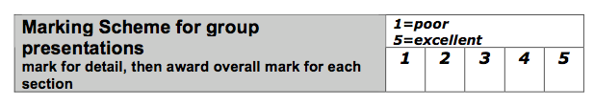
You should use the range of marks as a guide for each sections marks, and then finally for the presentation as a whole.
When you are preparing your presentation you can also use the mark scheme to help you decide where to focus your attention, and as a self check to see if you think your presentation is of sufficient quality before you actually stand up in front of any body to formally present it.
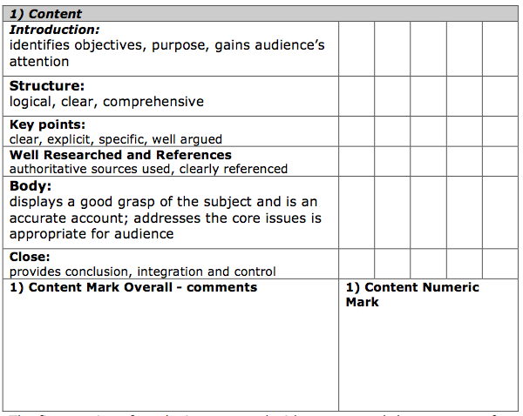
The first section of marks is concerned with content and the structure of the talk. You need good foundations to make a good talk.
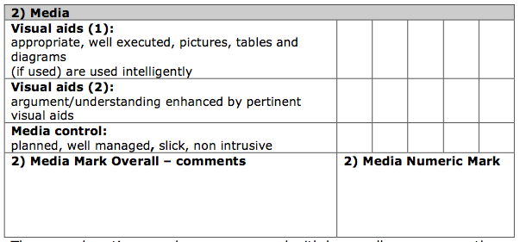
The second sections marks are concerned with how well you manage the presentation, in particular in terms of the media you use. Have you selected the right method of communicating, do you do it will? You need to put thought into how you go about crafting your presentation.
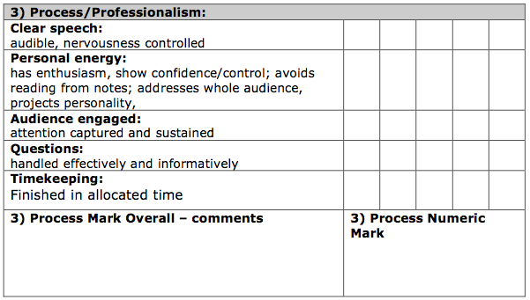
The third section is concerned with the personal processes of making a presentation. Planning and practice can help here.
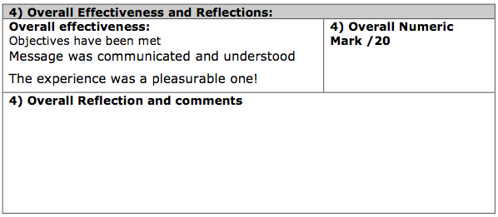
The final section allows you to consider the presentation as a whole, incorporating the detail you have already marked.

