The Builder: Russ Flaherty, 32, Sheffield
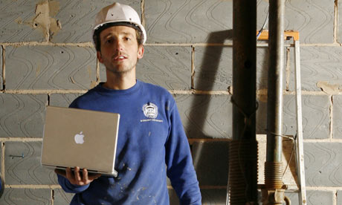
Builder Russ Flaherty with his new laptop, Sheffield. Photograph: Gary Calton
Russ Flaherty's girlfriend must be relieved that he's finally familiarised himself with the internet: up until now she has, as he puts it, "sorted it all out".
"To be fair," he admits, "I'm a bit lazy really. But obviously it's got to the stage now where I need to do it myself." His work as a builder has meant he didn't have much cause to use the internet. But recently he started his own business and realised that it was impossible to get by without it. "Everything's online now, isn't it? Your bills, your account, your tax and everything. It's all geared up for it."
The first thing he did online was look for a van: "You can compare prices so it saves time and everything's there for you to see so you don't have to mess about visiting garages." More recently, he's been designing flyers online for his business and looking up resorts in Bulgaria for a skiing holiday at Christmas. Now, he says, "whenever I need anything or want anything [the internet's] the first place I'll go."
Does he wish he'd got online earlier? "Yeah because you feel like you're behind the times. It's like with Facebook, all my friends are on it and I used to think 'bloody hell, haven't you got anything better to do?' but it's an addiction isn't it, once you start it you're there." So has the internet changed his life? "It's helped," he laughs, "put it that way!"

The single dad: Pete Tayor, 48, full-time carer, Bristol
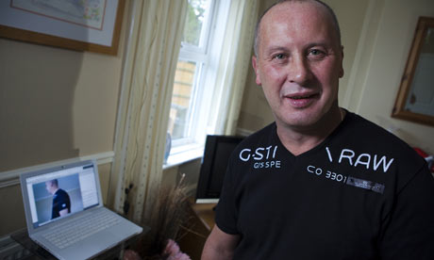
Pete Taylor at home in Bristol. He was helped to get on to the internet by the South Bristol Digital Neighbourhoods Programme. Photograph: Stephen Shepherd
Joining Facebook was a priority for single-parent Pete Taylor when he went online for the first time last week. As a full-time carer for his 27-year-old son Russell, who suffers with a rare terminal illness, adrenoleukodystrophy (ALD), he's found that his "social life has gone out of the window. But since I put myself on Facebook, people I haven't seen for over 20 years are now phoning me up, I've met new friends and can arrange dates. It sounds daft but [having the internet] gives you something to look forward to."
He's a self-confessed technology-phobe but in less than a week has learnt how to post items online: "I don't mess about! I've already stuck pictures of a recent weekend at Butlins on Facebook."
In addition to enjoying the "bit of escapism" which the social-networking aspects of the web offer, Pete has also been using it to help with his caring responsibilities and has joined online ALD support groups. "There's no cure for Russ's illness and it's really rare but now I can stay in touch with other people in the same boat, share advice," he explains. "Every day I keep thinking of things I can do online to make my life easier. If I get a letter from the hospital, for instance, I can just reply by email. I've even been shopping online. I need to buy a bed and was about to put my coat on and run around the shops when I thought 'Hang about, I've got a computer here.'"
Pete had been considering getting the internet installed for a while but feared it would be complicated and expensive. So when a local initiative, the Knowle West Web Project funded by Bristol city council, offered him a free computer, wireless and training he was delighted. "It was a lucky day, to say the least. I'll be on the internet every day now. It's already a necessity."

The grandmother: Caroline Williams, 79, retired, Guildford
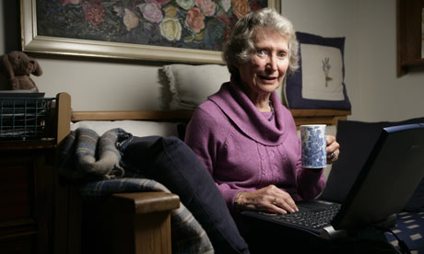
79 year old Caroline Williams at home in Guildford with her laptop. Photograph: Richard Saker
Juggling fitness classes, choir practice, collecting grandchildren from school and visiting family across the UK, until last week Caroline Williams had the hectic lifestyle of a teenager, minus the internet habit. "I'd been resisting going online for years, I'm so busy and just thought, well I've done without it for 79 years!"
But after some coaxing from her four internet-savvy children and grandchildren and a laptop donated by her daughter, she's now online and has completed two training sessions at her local Age Concern centre, which, together with Help the Aged, is running national online training programmes. She's found it a good learning environment for a nervous beginner: "The volunteers are all retired people who've learnt to use computers so they're very comforting and helpful. It's ridiculous I've put it off so long because it's really easy."
Keen to facilitate her regular cross-country visits to family, Caroline has so far mastered buying cut-price train tickets online and finding maps, "My oldest granddaughter has just started at Royal Holloway college and I wanted to go and take her out for lunch. I was able to find a map of her local area online and which trains and buses went there." She's already planning her next steps: "An email account is the next job. I also listen a lot to Radio 4 and often miss bits of programmes so I want to learn to use 'listen again' online." Would she say that her family have successfully converted her to the internet then? "Oh yes, I can see it will be jolly useful. I hope I don't get addicted to it!"

The young person: Anthony Fisher, 20, student, Sunderland
Anthony Fisher, who has just started using the internet thanks to the Pennywell Youth Project, Sunderland. Photograph: Gary Calton
Up until last week Anthony hadn't sent an email, which, for a 20-year-old, certainly puts him in a minority among his peers. He explains that the internet has, "sort of gone over my head the past couple of years, probably just because of confidence". Now, though, staff at Pennywell Youth Project, where Anthony volunteers and is training to be a youth worker, have helped him set up an email account and get to grips with Google, YouTube and the rest.
"I thought it was about time I started learning," he admits. "It was holding me back quite a lot because as a youth worker you need to have IT skills so you can plan trips and do risk assessments and that sort of thing." And other than a "few glitches with the dongle" he says he's been "sort of 70% OK". Getting lost seems to account for the other 30%: "The internet's such a big place so if you type in the wrong thing you get on to a whole different site."
Though it's already proved useful in terms of research for his NVQ in youth work, the possibilities for fun haven't eluded Anthony either: his best online find so far is an episode of CSI on YouTube that hasn't aired yet here. "I'd definitely say I've been missing out," he says. "This has opened up a whole new world really." So will he be introducing any friends to YouTube and the rest? "Yeah, the two I've got left who aren't online!"

