EBook Cataloguing

Bibliographic Record

Record type: a
245: |h[electronic resource]
300: Usual details as for print book
509: E-book: full text accessible via the link below (authenticated).
590: WILEY-INTERSCIENCE
590: MYILIBRARY

590 field should hold a simple uppercase key to retrieving the records by source or subscription, which must be identical in all records from the same source e.g. WILEY-INTERSCIENCE

856.4-: # - No information provided
856.40: 0 - Resource

856 should usually have indicators 4<blank> or 40. The clickable text in |z should be: "|zAn electronic book accessible through the World Wide Web; click for access". It doesn't matter whether this precedes or follows the |u. Some downloaded records also come with a |a and a |3 subfield -- I remove the |a but tend to leave |3

e.g. .856.40|3ScienceDirect|uhttp://www.sciencedirect.com/science/publication?issn=18742734&volume=10|zAn electronic book accessible through the World Wide Web; click for access

Call Number/Item

Call Number: Internet
Call Library: E-RESOURCE
Class Scheme: ASIS
Type: E-BOOK
Item cat1: E-BOOK
Home Location: INTERNET

Bibliographic
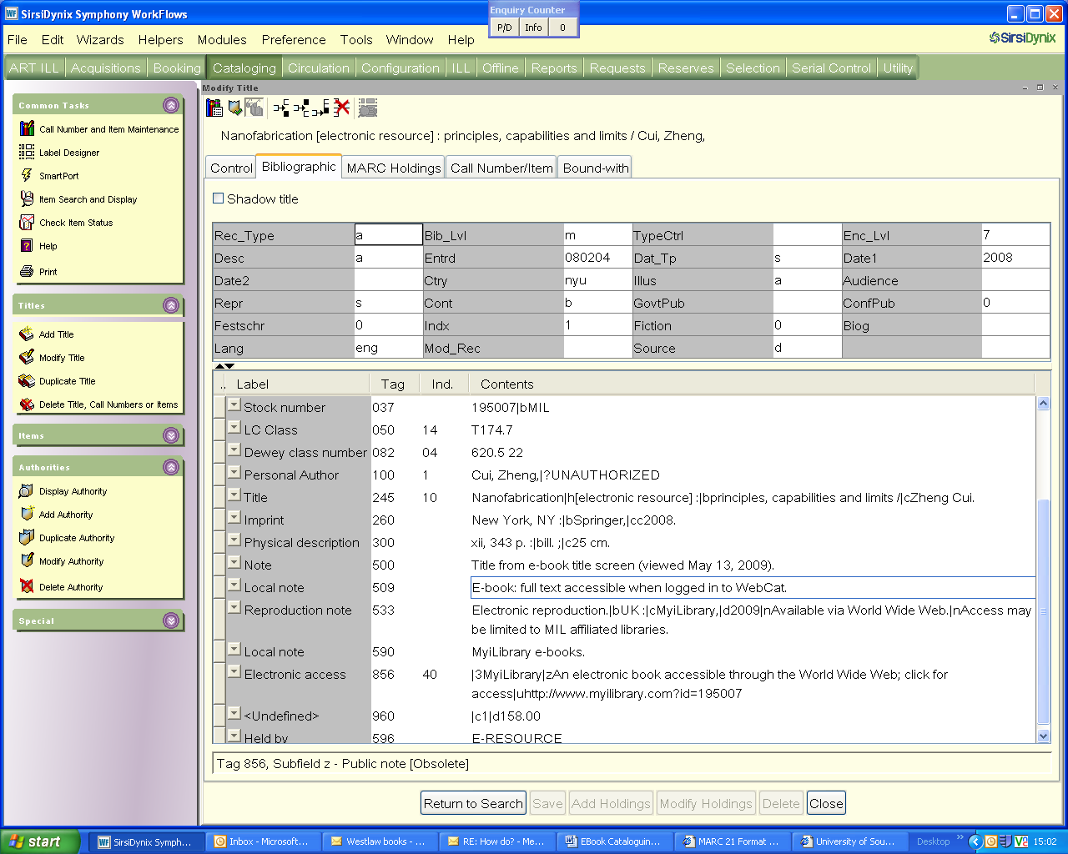

Call Number/Item
