SOES 6047 – Global Climate Cycles

Practical 5: Sea-level variations and calculations

When you submitted your extensive back-of-the-envelope calculations to the chief Earth Scientist of SWEAT from your last job, you commented that one could probably do a more accurate job if only there were more exact constraints on seawater temperature. In which case one could even dream of calculating sea-level curves from stable isotope data, rather than relying on those questionable seismic records ..... This perceptive deduction had not occurred to the Big SWEAT, who knew very well about faunal transfer functions, but had been in the business too long to know about all those fancy new chemical proxies. He was impressed, and immediately initiated three important moves: You were promoted from Junior Earth Scientist to Team Earth Scientist. Your three-speed company bicycle was exchanged for a 12-speed model, more appropriate to your new status. And you were given the task to calculate a new sea-level curve from oxygen isotope and Mg/Ca data. The good news was that you had seen someone else do it before, with some exciting new data from the Miocene. The bad news was that even though you could locate scraps of paper with some of the information you were given at University, some important parts were missing (due to exchanging messages with your fellow students at the time), meaning you had to re-calculate some values......

Procedure:
This practical aims to give give you practice in combining Mg/Ca and d18O data in order to estimate the variation of global seawater d18O ratios, and therefore the variation of glacio-eustatic sea-level.
You will need a calculator

Part (1): Converting Mg/Ca measurements into temperatures

A study concerned with deciphering the absolute sea-level variations of the various Miocene Mi- events defined by Miller et al. (1991) attempted to de-convolve ice-volume and temperature in a similar way as done by Lear et al. (Science, 2000).
The first step of this analysis involves converting the Mg/Ca measurements that were made from foraminiferal calcite into temperatures. As we are concerned with benthic temperatures, we do not need the typical exponential temperature equation for Mg/Ca ratios, as developed by Lear et al., and Rosenthal et al. (1997), but instead use a simpler linear equation, displayed in Fig. 1. Solve this equation for temperature, T, as a function of Mg/Ca concentration in mmol/mol

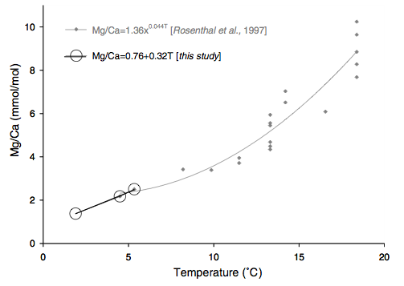
Figure 1: linear equation relating temperature and Mg/Ca concentrations for a temperature range of ca. 2-6 °C. (Billups, K., and D. P. Schrag, figure 4 pg 3-5 Paleotemperatures and ice volume of the past 27 Myr revisited with paired Mg/Ca and 18O/16O measurements on benthic foraminifera, Paleoceanography,17(1), 10.1029/2000PA000567, 2002. Reproduced courtesy of the American Geophysical Union.)

We can now use this equation to calculate a number of interesting data points in the spreadsheet below.

For a given age, the spreadsheet gives the measured benthic foraminiferal d18O ratio, this same value adjusted to sea-water equilibrium by adding 0.64 permil (d18Ocarbonate), and the measured Mg/Ca ratio of the shells in mmom/mol. A few important values are missing ...

First, work out the temperature for the given Mg/Ca values using the formula you solved above. What are the possible errors that this method could give you in terms of temperatures? Think about what goes into this equation.

Then, work out the sea-water d18O ratio by using the simplified formula from Shackleton (1974): , using the temperatures you calculated from the Mg/Ca values .....

Age | d18O | d18Ocarbonate | Mg/Ca | T | d18Osw | rel. Sea-level
(Ma) | (permil) | (permil) | (mmol/mol) | °C | (permil) | (m)
0.075 | 2.618 | 3.258 | 1.17 | 1.25 | -0.65 | 59
0.197 | 3.29 | 3.93 | 1.48 | 2.21 | 0.26 | -23
0.243 | 4.39 | 5.03 | 1.45 | 2.12 | 1.34 | -121
0.318 | 4.01 | 4.65 | 1.24 | 1.47 | 0.79 | -72
0.374 | 3.64 | 4.28 | 1.88 | 3.45 | 0.92 | -83
0.449 | 4.11 | 4.75 | 1.39 | 1.93 | 1.01 | -92
0.655 | 4.15 | 4.79 | 1.68 | 2.83 | 1.27 | -116
0.751 | 3.89 | 4.53 | 1.02 | 0.79 | 0.50 | -46
0.925 | 3.49 | 4.13 | 1.54 | 2.40 | 0.50 | -46
1.077 | 3.34 | 3.98 | 1.28 | 1.59 | 0.15 | -14
1.25 | 3.95 | 4.59 | 1.12 | 1.10 | 0.64 | -58
1.442 | 3.53 | 4.17 | 0.62 | -0.45 | -0.17 | 15
1.644 | 3.62 | 4.26 | 0.96 | 0.60 | 0.19 | -17
1.848 | 3.93 | 4.57 | 1.09 | 1.00 | 0.60 | -54
2.145 | 3.61 | 4.25 | 1.01 | 0.76 | 0.21 | -19
2.365 | 3.48 | 4.12 | 0.84 | 0.23 | -0.05 | 4
2.609 | 3.68 | 4.32 | 1.29 | 1.62 | 0.50 | -46
2.857 | 3.15 | 3.79 | 1.28 | 1.59 | -0.04 | 3
3.118 | 2.88 | 3.52 | 1.12 | 1.10 | -0.43 | 39
3.378 | 3.16 | 3.8 | 1.07 | 0.94 | -0.19 | 17
3.757 | 2.77 | 3.41 | 1.76 | 3.08 | -0.04 | 4
4.026 | 2.85 | 3.49 | 1.66 | 2.77 | -0.04 | 4
4.301 | 3.1 | 3.74 | 1.57 | 2.49 | 0.14 | -13
4.568 | 3.06 | 3.7 | 1.59 | 2.55 | 0.11 | -10
4.862 | 3.05 | 3.69 | 1.98 | 3.76 | 0.41 | -37
5.152 | 3.02 | 3.66 | 1.77 | 3.11 | 0.21 | -19
7.585 | 2.77 | 3.41 | 1.81
8.041 | 2.77 | 3.41 | 1.92
8.181 | 2.77 | 3.41 | 1.97
8.636 | 2.71 | 3.35 | 2.25
8.727 | 2.69 | 3.33 | 2.12
8.918 | 2.84 | 3.48 | 1.64
9.22 | 2.55 | 3.19 | 2.11
9.316 | 2.62 | 3.26 | 1.79
9.63 | 2.65 | 3.29 | 1.5
9.932 | 2.53 | 3.17 | 1.61
10.234 | 2.51 | 3.15 | 1.35
10.54 | 2.57 | 3.21 | 1.55
11.097 | 2.73 | 3.37 | 1.34
11.196 | 2.95 | 3.59 | 2.86
11.471 | 2.8 | 3.44 | 2.15
11.766 | 2.73 | 3.37 | 2.21
12.07 | 2.84 | 3.48 | 2.13
12.367 | 2.52 | 3.16 | 1.48
12.651 | 2.84 | 3.48 | 1.61
12.958 | 2.8 | 3.44 | 1.76
13.062 | 2.6 | 3.24 | 2.04
13.343 | 2.11 | 2.75 | 0.98
13.651 | 2.27 | 2.91 | 2
13.909 | 2.1 | 2.74 | 2.23
14.173 | 1.96 | 2.6 | 2.41
14.445 | 1.81 | 2.45 | 1.84
14.496 | 1.57 | 2.21 | 1.84
14.621 | 1.57 | 2.21 | 2.41
14.93 | 1.49 | 2.13 | 1.79
15.268 | 1.4 | 2.04 | 2.36
15.583 | 1.48 | 2.12 | 2.07
15.91 | 1.59 | 2.23 | 1.97 | 3.73 | -1.06 | 97
16.215 | 1.77 | 2.41 | 1.84 | 3.33 | -0.98 | 89
16.652 | 1.22 | 1.86 | 2.17 | 4.35 | -1.28 | 116
16.943 | 1.65 | 2.29 | 1.87 | 3.42 | -1.08 | 98
17.251 | 1.47 | 2.11 | 2.06 | 4.01 | -1.11 | 101
17.57 | 1.41 | 2.05 | 2.02 | 3.89 | -1.20 | 109
17.851 | 1.7 | 2.34 | 1.96 | 3.70 | -0.96 | 87
18.142 | 1.99 | 2.63 | 2.04 | 3.95 | -0.61 | 55
18.299 | 1.71 | 2.35 | 2.02 | 3.89 | -0.90 | 82
18.475 | 1.98 | 2.62 | 1.78 | 3.14 | -0.82 | 74
18.722 | 1.39 | 2.03 | 2.02 | 3.89 | -1.22 | 111
18.966 | 1.84 | 2.48 | 2.15 | 4.29 | -0.67 | 61
19.21 | 1.61 | 2.25 | 2.1 | 4.14 | -0.94 | 86
19.449 | 1.72 | 2.36 | 1.99 | 3.79 | -0.92 | 83
19.694 | 1.83 | 2.47 | 1.87 | 3.42 | -0.90 | 82
19.836 | 1.87 | 2.51 | 2.12 | 4.20 | -0.67 | 61
20.01 | 1.97 | 2.61 | 2.55 | 5.53 | -0.23 | 21
20.254 | 1.88 | 2.52 | 2 | 3.83 | -0.75 | 68
20.493 | 2 | 2.64 | 3.1 | 7.24 | 0.22 | -20
20.761 | 2.11 | 2.75 | 1.93 | 3.61 | -0.57 | 52
21.062 | 2.3 | 2.94 | 1.79 | 3.17 | -0.49 | 45
21.289 | 1.97 | 2.61 | 1.83 | 3.30 | -0.79 | 72
21.594 | 1.71 | 2.35 | 2.03 | 3.92 | -0.90 | 81
21.863 | 2.1 | 2.74 | 1.77 | 3.11 | -0.71 | 64
22.147 | 2.32 | 2.96 | 1.78 | 3.14 | -0.48 | 44
22.394 | 2.16 | 2.8 | 1.91 | 3.55 | -0.54 | 49
22.604 | 2 | 2.64 | 1.77 | 3.11 | -0.81 | 73
22.764 | 2.15 | 2.79 | 2 | 3.83 | -0.48 | 44
22.957 | 1.72 | 2.36 | 2 | 3.83 | -0.91 | 83
23.282 | 2.01 | 2.65 | 1.87 | 3.42 | -0.72 | 65
23.574 | 2.38 | 3.02 | 2.35 | 4.91 | 0.02 | -2
24.044 | 1.54 | 2.18 | 2.19 | 4.41 | -0.94 | 86
25.283 | 1.87 | 2.51 | 2.54 | 5.50 | -0.34 | 31
25.662 | 1.7 | 2.34 | 2.1 | 4.14 | -0.85 | 77
25.856 | 1.74 | 2.38 | 2.43 | 5.16 | -0.56 | 51
26.206 | 1.78 | 2.42 | 2.51 | 5.41 | -0.45 | 41
26.624 | 1.81 | 2.45 | 2.08 | 4.07 | -0.76 | 69
27.018 | 1.68 | 2.32 | 2.35 | 4.91 | -0.68 | 62

What are the uncertainties in your calculations above? What other seawater properties would you have liked to know from the Miocene oceans?

Now, using the approximation of Fairbanks and Matthews (1978), who stated that 0.11 permil of d18O change are equivalent to a change of 10m of sealevel, work out a relative sea-level curve from your values for d18O_{sw.}

Plot these values on the graph provided below, filling in the gap between the thick blue line. How does the sea-level curve, based on the oxygen isotope ratios, compare with that of Haq et al, based on seismic records from passive margins? Where are obvious differences?
How does the sea-level curve compare with the foraminiferal d18O measurements?
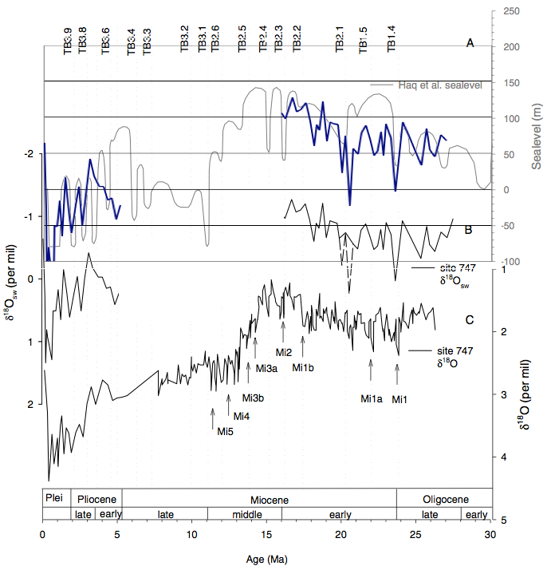

Billups, K., and D. P. Schrag, figure 9 pg 3-9 Paleotemperatures and ice volume of the past 27 Myr revisited with paired Mg/Ca and 18O/16O measurements on benthic foraminifera, Paleoceanography,17(1), 10.1029/2000PA000567, 2002. Reproduced courtesy of the American Geophysical Union.
Copyright Statement

This resource was created by the University of Southampton and released as an open educational resource through the 'C-change in GEES' project exploring the open licensing of climate change and sustainability resources in the Geography, Earth and Environmental Sciences. The C-change in GEES project was funded by HEFCE as part of the JISC/HE Academy UKOER programme and coordinated by the GEES Subject Centre.

This resource is licensed under the terms of the Attribution-Non-Commercial-Share Alike 2.0 UK: England & Wales license (http://creativecommons.org/licenses/by-nc-sa/2.0/uk/).

However the resource, where specified below, contains other 3rd party materials under their own licenses. The licenses and attributions are outlined below:
- The name of the University of Southampton and its logos are registered and/or unregistered trademarks of the University. The University reserves all rights to these items beyond their inclusion in these CC resources. <You will need to check the wording of this with the legal department of your institution and/or your repository>.
- The JISC logo, the C-change logo and the logo of the Higher Education Academy Subject Centre for the Geography, Earth and Environmental Sciences are licensed under the terms of the Creative Commons Attribution -non-commercial-No Derivative Works 2.0 UK England & Wales license. All reproductions must comply with the terms of that license.¹






