SOES 6047 – Global Climate Cycles

Practical 3 Working with isotope data and mass balances

Your supervisor has been impressed by the abilities you have shown so far. So much so in fact that when you let slip about the overdraft you have incurred during your recent months that she recommends you to a well-established geological consultancy (TIGHTCON) for an internship after your degree, which you gladly accept to be freed from the capitalistic claw that holds you to ransom. On your first day the managing director tells you that they are glad you joined for a job shadowing programme. “However, we have just won a major contract from HYDROBUCKS to assess the impact of the new carbon emissions trading scheme, and that involves preparing briefings for their management team, who know a lot about interest rates and taxes, but sweet all about Earth Sciences”. You are a bit startled – but are eager to hear more given that you actually get paid, and received a company bike to travel to their headquarters. “Well, what can I say”, he carries on, “We are a bit short on staff and expertise, do you think you could help us with some simple climate related examples for their presentation?”. Great, you think, I can make quick and efficient use of those lectures that ended only a few weeks ago, but already seem years in the past ..... “If you get this job done, we might consider you for a longer term contract ...”

Procedure:
This practical aims to give you practice and confidence in doing some fairly straight forward “back of the envelope” calculations regarding oxygen and carbon stable isotopes.

Part (1): Mass balance equations with oxygen stable isotopes. Refer to Lecture 4 (“Chemical & Isotope proxies”).

1. Given the mass balance equations
(i here is an index, i=1, i=2 … i=n)

and that a particular δ¹⁸O palaeotemperature curve (Shackleton, 1974, linear curve fit to Uvigerina data) is

assuming that the mean δ¹⁸O of glacial ice was -30 to -40‰

and given that

and the average density of sea-water
and the average area of the oceans is
and that the mean salinity of the ocean today is 34.7‰
and that sea-level was 130m lower during the last glacial maximum

and that the isotopic composition of interglacial benthic carbonate is 3.5‰
and that the isotopic composition of glacial benthic carbonate is 5.1‰

Calculate:
a) the salinity of the glacial ocean
b) The change in mean deep ocean temperature during the last glacial maximum, and how sensitive your answer is to the assumption of the isotopic composition of ice

Part (2): Calculations with carbon isotope data

Having observed that atmospheric CO₂ was lower during glacial than interglacial times, one possible way to seek an answer to this problem is to investigate the behaviour of the global carbon cyle components. One indicator for this are carbon stable isotope measurements from planktic (surface) and benthic (bottom dwelling) foraminiferal carbonate tests, and the contrast they show.

Modern day conditions:
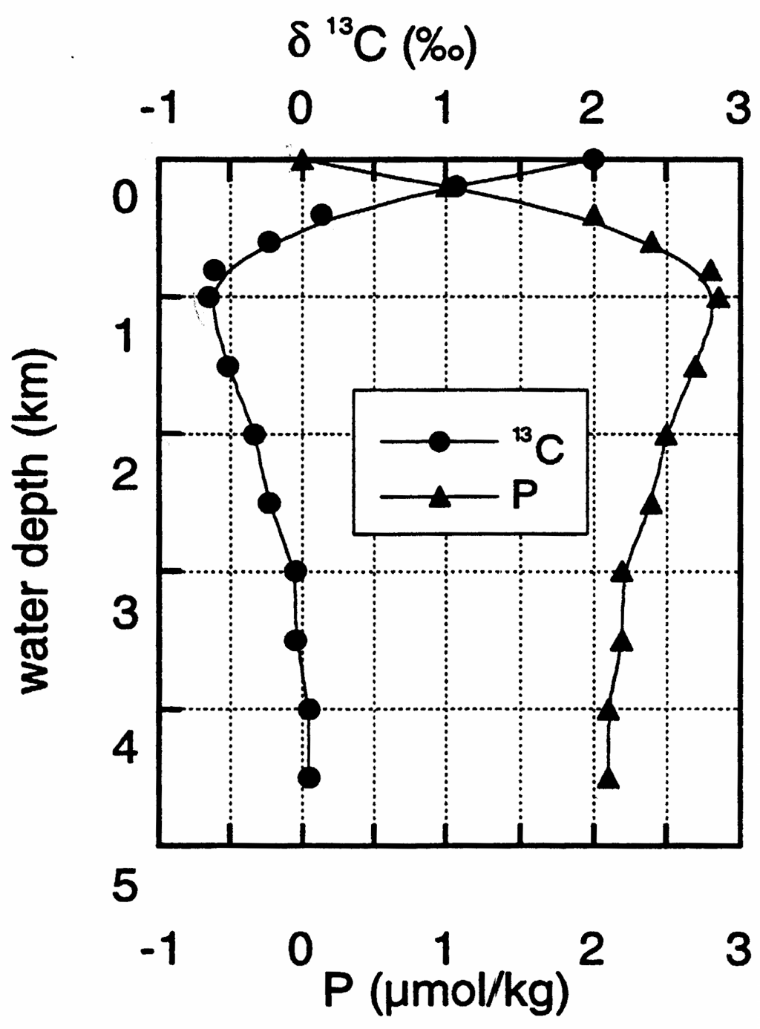
Figure 1: Vertical profile of δ¹³C and phosphate (P) from a deep-sea oceanographic station (sea-water)

c) What is the cause of the vertical differences in δ¹³C in the ocean waters? Also explain why δ¹³C shows a small increase, and P as mall decrease in waters deeper than ca. 1km (HINT: Atlantic vs. Pacific?)

d) Do lateral variations in δ¹³C occur within the present-day oceans? If so, why?
(HINT: “conveyor belt”)

e) Given that the isotopic fractionation between C in marine plants and the inorganic total dissolved CO2 pool is : Plant’s organic matter is enriched in ¹²C and depleted in ¹³C, and by considering Fig. 1, what fraction of ∑CO₂ in seawater is, on average, extracted to make marine organic matter?
(HINT: determine δ¹³C in surface and deep waters, and set up a simple mass balance, knowing that the δ¹³C in deep water has to be the average of the fraction of marine matter with its isotope composition plus (1-fraction) with the δ¹³C of surface water.

f) Referring to Fig. 1, determine the equation for
(the slope or gradient ) by plotting the data from Fig. 1 into the graph below

g) Make a list of factors that affect the numerical value of .
HINT: think about marine organic matter in the context of C and P, seawater concentration of XXX which affects how strong the influence of fractionation is on the isotopic ratio of XXX remaining, and isotope fractionation between XXX and XXX
The Redfield ratio is C:N:P 106:16:1, the concentration of TOT CO₂ is 2250 mmol/kg

h) An expression can be derived for:

i) Glacial ocean δ¹³C
You can see from the profiles in Fig. 1 what the difference is in δ¹³C between surface and deep ocean waters for the modern-day oceans. But this offset was different for the glacial ocean during the LGM. How can we quantify this? We cannot simply take the δ¹³C of glacial benthic and planktic forams, due to the “vital” species specific fractionation. But there is a solution:

The LHS of the following equation refers to δ¹³C of glacial and Holocene ocean waters. Complete the RHS of the equation in terms of δ¹³C of planktic and benthic foraminifera of glacial and Holocene ages:

(Δδ¹³C_{surf-deep})_{glacial}-(Δδ¹³C_{surf-deep})_{Holocene} = ???
HINT: Refer to Lecture 4

If you find the answer, you should recognise that this procedure takes care of species specific “vital effect” difference in isotopic fractionation.

j) Fig. 2 shows a profile of δ¹³C in benthic foraminifera from a sediment core. There is no age scale, but you should be able to work out the position of the LGM from the oxygen isotope data.

In addition, Fig. 3 shows measurements on a number of species of planktic foraminifera, comparing “warm” Holocene and “cold” LGM data from different cores. The planktic data show a lot of scatter (“real” data!), but lines are shown indicating average values. Use an average from all plots to answer:

k) How does the surface-to-deep ocean difference in δ¹³C for the LGM compare with the modern day value? In order to do that work out the glacial-to-interglacial offset of δ¹³C for benthic forams, and the glacial-to-interglacial offset of δ¹³C for planktic forams, and solve the equation you derived above for (Δδ¹³C_{surf-deep})_{glacial}
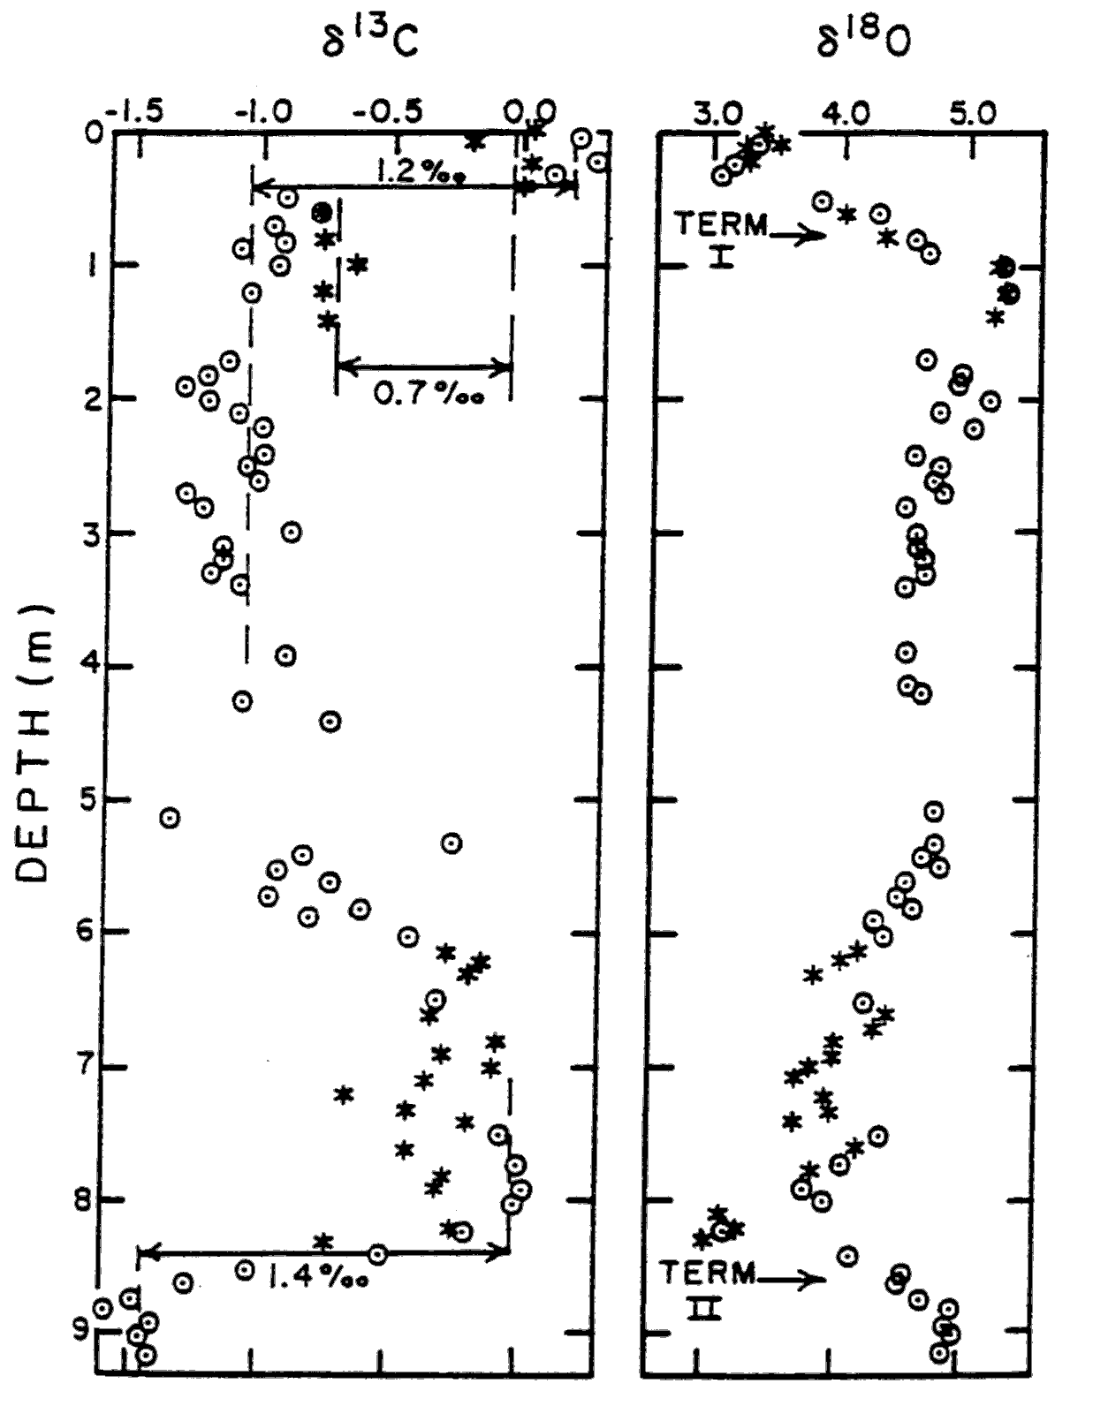
Suggest reasons for the difference. What does the difference imply about the strength of the “biological pump” during glacial times? How has the carbon storage in biological matter changed from glacial to interglacial times?

Figure 2: Profile of d13C and d18O from benthic foraminifera

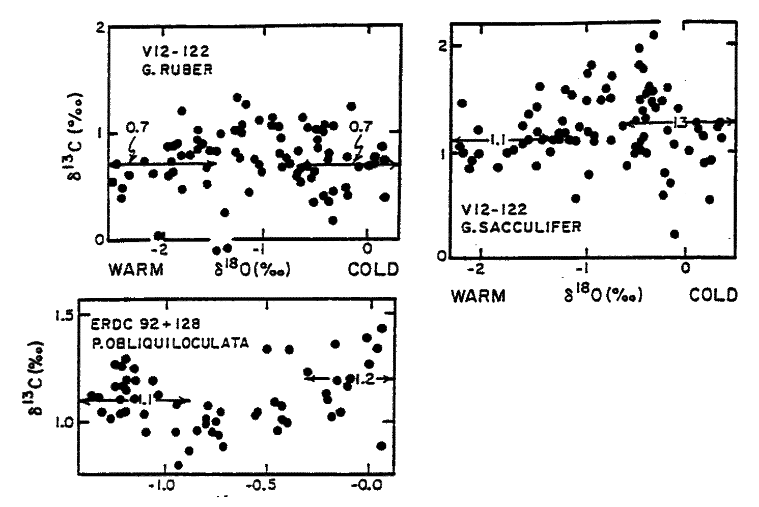

Figure 3: Planktic d13C data for different species
Image source for figures 2 and 3 (above): Figures 9-5 and 9-10 respectively, from W. S. Broecker and T. H. Peng (1982) Tracers in the Sea, Eldigio Press, Lamont Doherty Geological Observatory. Reproduced with permission.
Copyright Statement

This resource was created by the University of Southampton and released as an open educational resource through the 'C-change in GEES' project exploring the open licensing of climate change and sustainability resources in the Geography, Earth and Environmental Sciences. The C-change in GEES project was funded by HEFCE as part of the JISC/HE Academy UKOER programme and coordinated by the GEES Subject Centre.

This resource is licensed under the terms of the Attribution-Non-Commercial-Share Alike 2.0 UK: England & Wales license (http://creativecommons.org/licenses/by-nc-sa/2.0/uk/).

However the resource, where specified below, contains other 3rd party materials under their own licenses. The licenses and attributions are outlined below:
- The name of the University of Southampton and its logos are registered and/or unregistered trademarks of the University. The University reserves all rights to these items beyond their inclusion in these CC resources. <You will need to check the wording of this with the legal department of your institution and/or your repository>.
- The JISC logo, the C-change logo and the logo of the Higher Education Academy Subject Centre for the Geography, Earth and Environmental Sciences are licensed under the terms of the Creative Commons Attribution -non-commercial-No Derivative Works 2.0 UK England & Wales license. All reproductions must comply with the terms of that license.¹






