Problem-Based Learning Using CaseMaker

Richard Collier
School of Health Professions and Rehabilitation Sciences

CaseMaker is a Web-based system that supports the development and delivery of problem-based learning (PBL). It has been developed by Richard Collier in collaboration with Jason Sadler of GeoData Unit, who developed the database and user interface. The system could be easily duplicated and adapted to meet the needs of other disciplines that use PBL.

CaseMaker is used to support PBL on a full-time Masters in Physiotherapy through guided discovery using case studies. Students engage in four units of study over two years; they start at foundation level, then look at topics in isolation, then combinations of topics and finally at realistic ill-defined scenarios. The complexity of the cases studied increases at each stage.

The cohort of around 30 students is split into four groups. On Mondays, each group focuses on a ‘case study’ and identifies their own learning needs and learning outcomes. On Wednesdays, further developments or complications for each case are provided. On Fridays, there is usually a plenary session at which the cases will be discussed. There are taught sessions on Tuesdays and Thursdays.

All of the information on each case study required by the students is stored in the CaseMaker database, which is accessed using a Web-page interface. Links to the cases are embedded in the programme’s Blackboard course and are only made available at the appropriate time. For example, students should not be able to read the additional information about each case before the Wednesday. This controlled access is automatically handled by CaseMaker, not Blackboard. Each case study can be linked to a specific session on the integral timetable, which is available online to both tutors and students.

Programme tutors access a Web page to log in to CaseMaker using their standard (LDAP) username and password. The system guides tutors through the process of creating a case study and offers a more detailed view of each case study than the student view. For example, the learning outcomes (LO) for each case study are recorded and linked to higher-level unit outcomes, so that tutors can see exactly which case studies contribute to each outcome and ensure that all outcomes are met. Existing LOs can also be applied to new case studies, and this is helping to develop a shared language for LOs among the tutors. Resources such as book references and links can also be shared and reused by different case studies. A search facility enables tutors to identify where specific topics are taught.

The system has enabled tutors to build a large collection of case studies whose learning outcomes are mapped to the overall outcomes of the programme. The interface ensures that all these cases follow a standard design and encourages the reuse of resources. The timetable feature helps tutors deliver the cases in a controlled way and helps them ensure that the cases used cover the entire curriculum.

Screen shots:

This shows the list of case studies stored by CaseMaker. They can be sorted by clicking on any of the column headings. The icons to the right of each case show an editable summary, enable editing, copying or deletion, or generate a report.
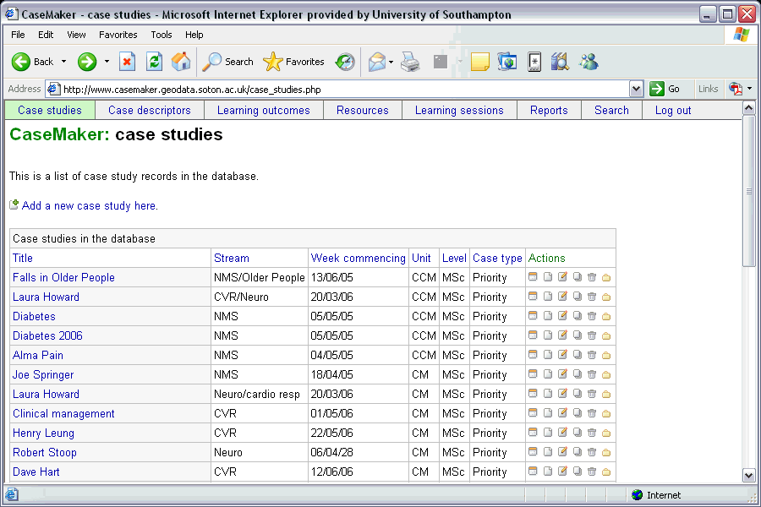

The report comes in two versions – this one is for students and provides all the information they need to start working. It is linked to the Blackboard course.
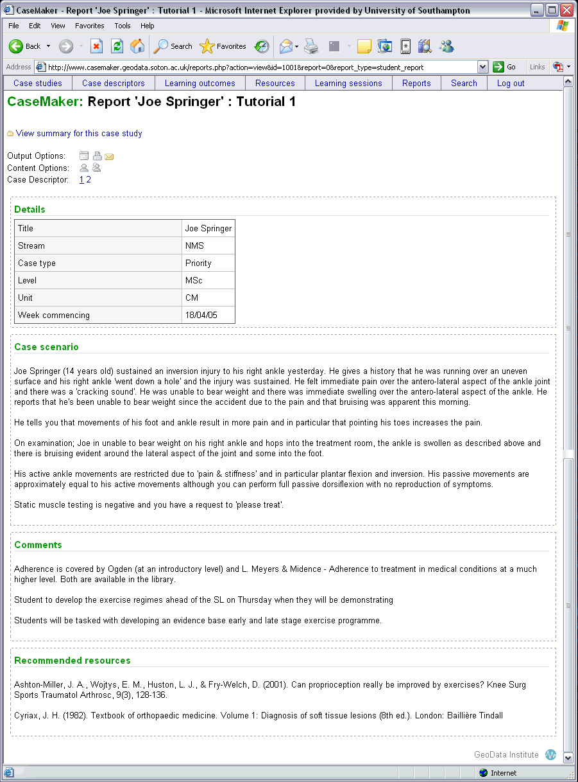

The tutor’s report has additional details such as the theme, indicative content, learning outcomes, tutor’s notes and comments. 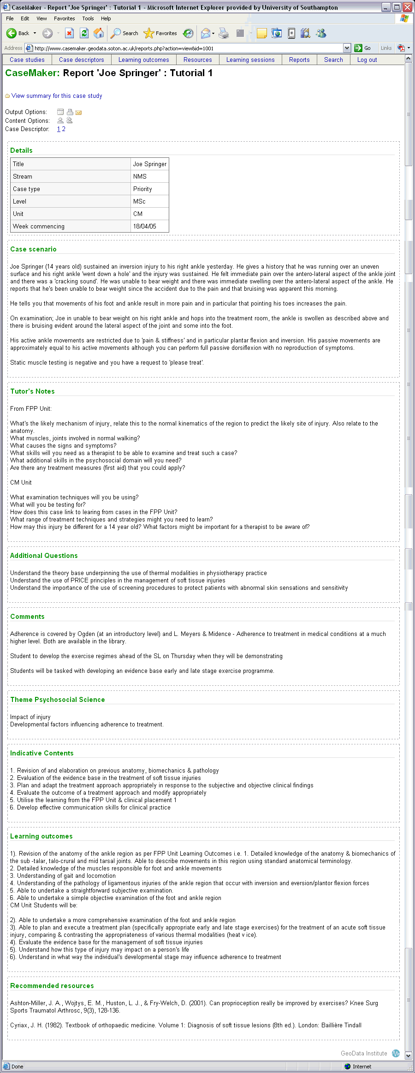
The summary screen enables tutors to construct and edit case studies – for example the tutor can use the links in the Resources section to create a new resource, upload a file or reuse an existing resource. 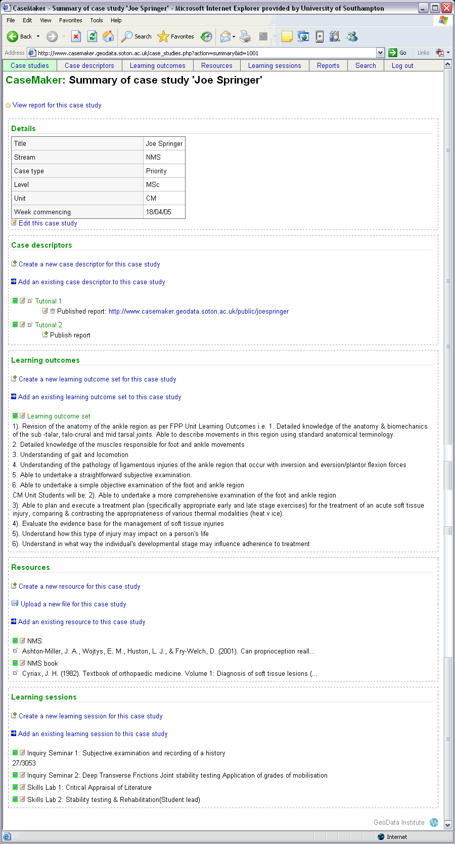

The case descriptor is one sub-set of information about the case. 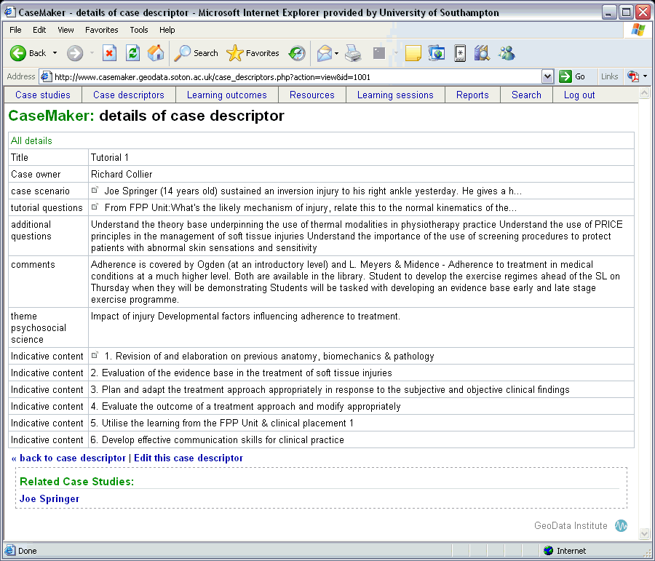

The learning outcomes are another sub-set of information about the case. 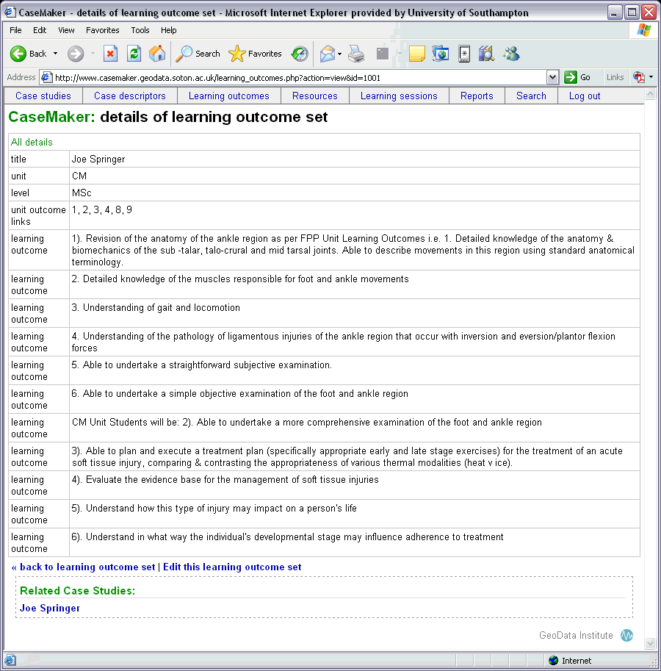

This is a list of all the resources used in the case studies, many of which are journal articles. It is easy to see which cases use a particular resource. 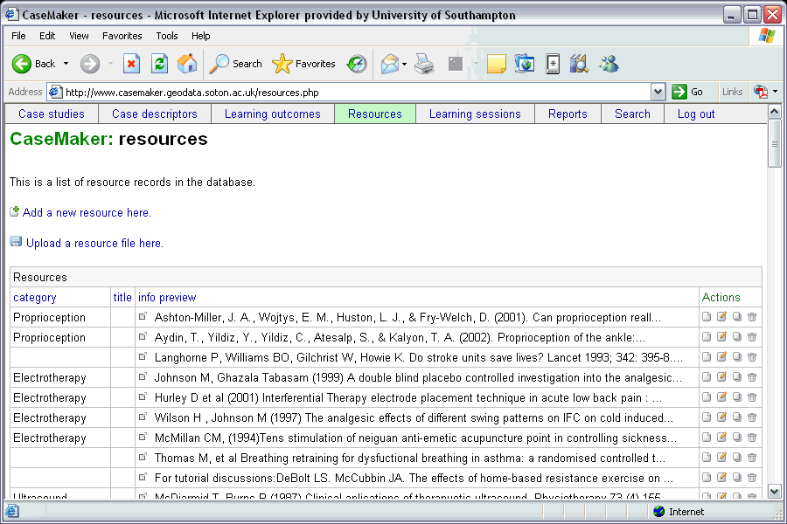

The timetable lists when and where the case studies are used. They can be sorted by clicking on any of the column headings. 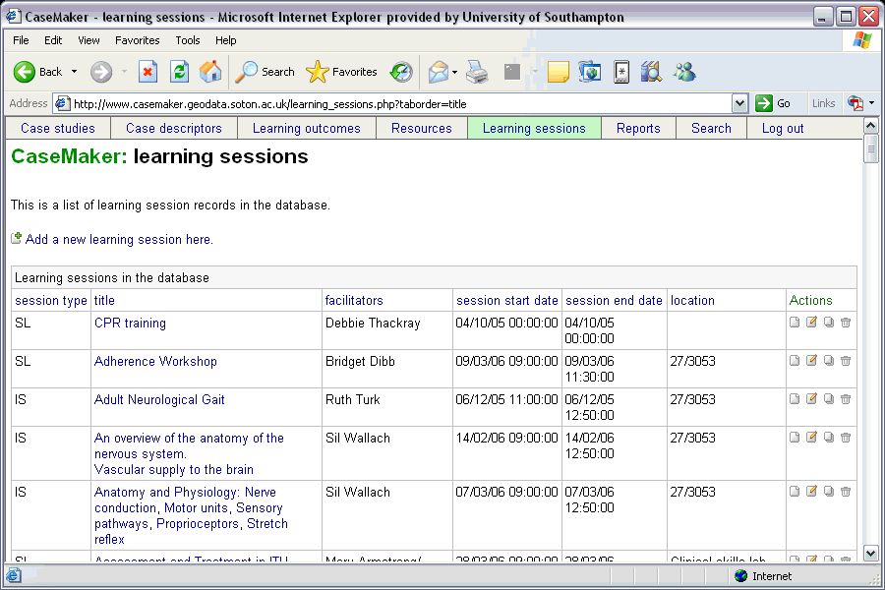

Reports can be generated which show which cases are used in a particular week, and these timetables are made available in Blackboard. This is a student view but there is also a much more detailed tutor view. 