Using Blogs to Share and Discuss Experimental Data

Cameron Neylon and Jeremy Frey
School of Chemistry

The School of Chemistry has developed custom blogging software (chemBlog) and is exploring how it can be used to record, share and discuss experimental data. Users need to register and this enables access control, so there are blogs for individuals, project groups and for specific experiments.

Every blog post needs to have one or more tags, which are used to group related posts and enable automated links between posts. Their system uses key value pairs as tags – so each tag has two parts e.g. DNA+plasmid, DNA+marker. Procedure+NMR or Procedure+PCR. Users are free to define both parts of any tag, but are encouraged to be consistent in their use of well-structured sets of key value pairs.

For example a post containing the results of an experiment will include details of the specific batch of each material used:
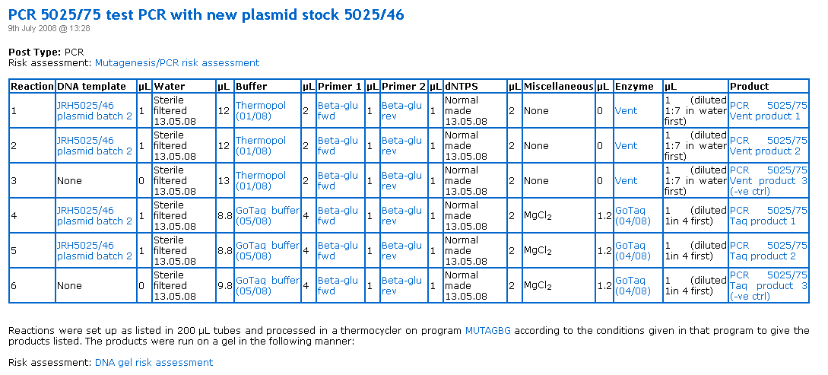

Clicking on a material name (such as a Buffer in this example) takes you to a post with details of that material and links to every post about experiments in which that specific batch was used. This can be very useful if there is a problem with a particular batch of material since the experiments affected can be easily identified:
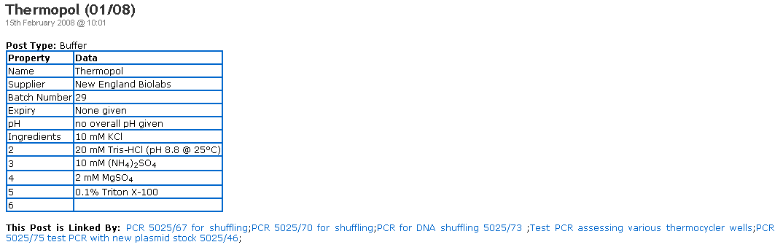

A menu option on that blog page enables you to print a barcode that uniquely identifies the material and that can be used to label its container:

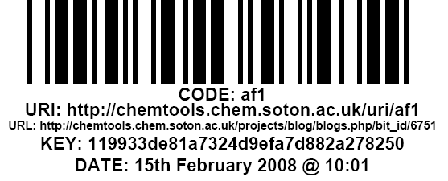

Usefully, the same applies to the products of an experiment, simplifying their storage while awaiting analysis. There is obviously extra effort involved in creating all these blog posts, but the data needs to be recorded somewhere anyway and its use as a ‘Lab Information Management’ system is a fantastically useful by-product.

Templates can be created that make it easy to record experimental results – so here is part of one that can be reused every time a DNA Shuffling experiment is carried out:
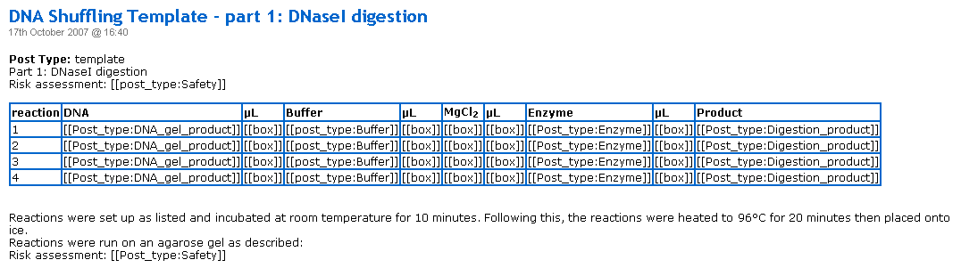

When filling in a new post based on a template you simply click on an area (e.g. labelled [[Post_type: Buffer]]) and see a drop-down menu listing all the posts that have that value-pair type. This makes it easy to select a particular batch of material and automatically establish a link between the posts at the same time. Areas labelled [[box]] allow free-form text entry.

A further advantage of templates is that they include several relevant tags which are automatically added to any post based on them. This ensures that related posts have a consistent set of tags, plus any others added by the researcher.

The ability to add comments to posts allows researchers to record additional details or thoughts about experimental results that do not fit on the template. It also enables co-researchers and research supervisors to comment.

Some blogs contain posts that have been automatically generated by equipment. For example, the environmental monitoring equipment in some labs generate reports which can be used to identify fluctuations in light levels, temperate or room occupancy which may have affected experimental outcomes:
