Effective use of PowerPoint and skeleton lecture notes

Dr Patrick Doncaster
School of Biological Sciences

BIOL2008 Quantitative Methods is a L2 course about the statistical analysis of data, a topic that students often find difficult. Patrick uses a combination of PowerPoint slides and skeleton lecture notes to help students get the most out of lectures. They also function as a reasonable substitute for students who miss a lecture, enabling them to catch up with some guided self-study.

The PowerPoint slides for all lectures are available from the start of the course. This is good practice as it allows dyslexic, international and even diligent students to review the content in advance. However, Patrick uses Blackboard’s controls to ensure that the lecture notes are only available after the lecture – which hopefully encourages attendance. He uses PDF format to ensure that the maths displays correctly. Printed copies of these notes are handed out in lectures.

The lecture notes include most of the material presented using the slides, but include questions and gaps for the students to fill in during the lecture. This means that they do not have to waste time copying down a great deal of material but do need to pay attention and interact with the notes and what the tutor is saying. Patrick does not feel he is so tied to ‘transmission of information’ and can make his lectures more interesting by including case studies and asides.

Every slide has a detailed heading to help students clearly identify the specific topic being discussed – see the example screenshot below. The slides are quite detailed and can support independent leaning and/or revision. Where appropriate they include simple animations, such as graphs that build up with axes, labels, lines and equations appearing with each mouse click. Adding this kind of animation to a static diagram created using PowerPoint only takes a couple of minutes extra, and can really help students understand by introducing the detail one step at a time.

Each presentation concludes with a final slide that summarises the main points that students should take from the lecture.

The course is also supported by other more generic resources that Patrick has created and made available through his website http://www.soton.ac.uk/~cpd/
- various lexicons of terms (e.g. statistical modelling)
- a list of organisations and conventions on environmental issues, with brief descriptions and links. Note that the descriptions really add value to a list of links.

An example slide – the graphs with green axes are animated and build up.

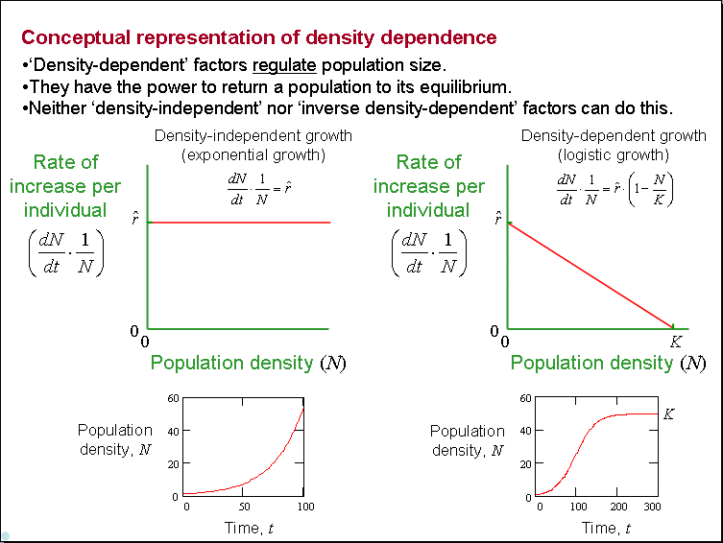

A matching page from the PDF lecture notes:
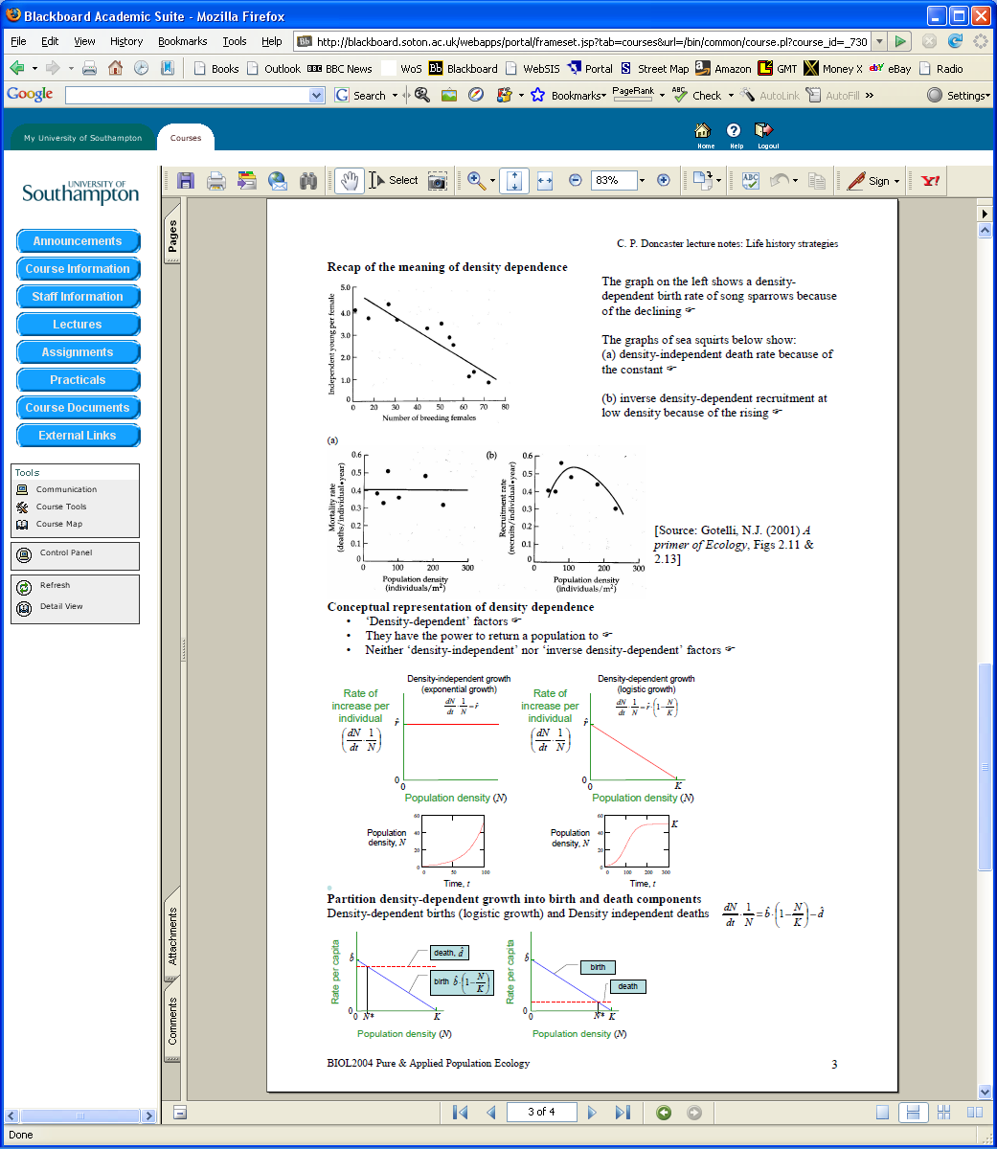
The hand symbols show students where they need to fill in information from the lecture or PowerPoint – e.g. the answer from the slide above is “can do this”.

