Peer Feedback for Group Projects

Dr Kenji Takeda, Dr Julian Wharton, Prof Jim Scanlon,
Dr Mohamed Moshrefi-Torbati, Joy Moloney
School of Engineering Sciences

In 2007, the Royal Academy of Engineering published a report ‘Educating Engineers for the 21st Century’ which included proposals on how engineering curricula could be adapted to better meet the needs of industry. This stressed the requirement for students to develop ‘enabling skills’ such as communication and team-working.

Students in the School of Engineering Sciences are introduced to team-work during induction and then develop it through a series of projects and workshops. The challenges they encounter are typically related to adopting the team roles required (e.g. no leader or too many leaders) and achieving a balanced workload (e.g. freeloaders or people who won’t delegate tasks). In most cases the solutions are a better understanding of how effective teams work and improved communication between the team members.

One technique that helps students develop their team-working skills is ‘peer feedback’ on their performance from the other team members. Ideally, this should take place at intervals throughout the team project, so that individuals can improve their performance based on the feedback they receive. Note that this is different from ‘peer assessment’ where students mark each other’s work.

Pilot studies of a paper-based peer-feedback system were piloted in two courses in 2007: SESM1014 Professional Engineer and SESA3002 Aerospace Design. The students responded well to the process, but processing the data and distributing the results was time consuming. In addition, because the feedback was collected at the end of the project, the results arrived too late to allow students to modify their behaviour in response.

The experience gained led to the development of an online version which was trialled in SESM2008 Engineering Design. This enabled feedback to be collected, collated and displayed at three points during the project, offering students with poor feedback the opportunity to improve. An average of the scores was used to allocate individual ‘teamwork’ marks to their final grade for the project.

Students log in to the system and choose a simple ‘traffic light’ indicator for each of their team members, including themselves: green for good, amber for OK, red for poor performance. They also select one or two corresponding comments such as ‘good level of responsibility’ or ‘need to attend meetings’ from a list. The list of comments was devised by students and reflects their experience of team work.

Once all the feedback has been collected, the students can log in again to see a summary of their own feedback: their own average score, their team’s average score and a list of the comments. These results are anonymous, of course – they cannot see the feedback from individual team members.

An evaluation of this initiative will be published as a journal article in due course. If you are interested in using this peer feedback system, please contact LATEU.
The list of comments
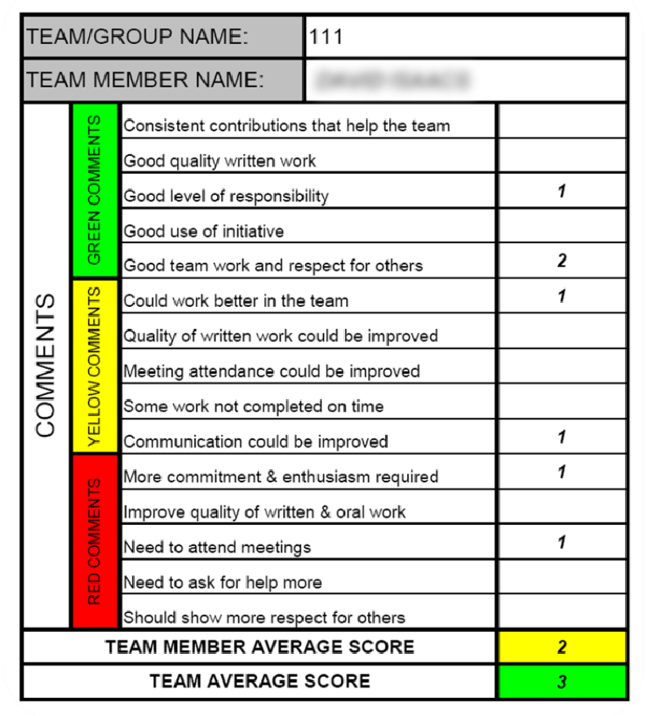

The user interface to the online system

