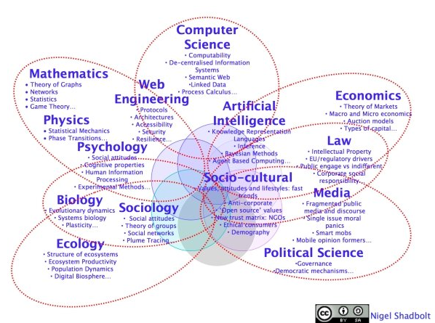Shadbolt’s Butterfly Diagram
Early on in the discussion of Web Science, a butterfly diagram of component disciplines was proposed.
This has been discussed extensively, and analytical comparisons with the content of web science discourse, has suggested a number of ommisions. (see for example Hooper et al 2012). Nonetheless, it can provide a useful starting step in understanding how many different established fields of study can feature in any piece of web science research.
Researchers and students embarking on a study of web science can usefully spend some time looking into the background of disciplinary differences before referring to more formal texts which specifically study interdisciplinarity (for example Repko, 2012)

Disciplinary Differences – a flying visit
Biglan looked at the nature of the subject matter of research (Biglan, 1973a, b) , whist Kolb was interested in styles of intellectual enquiry(Kolb, 1981) .

Becher has been concerned with academic and disciplinary cultures where he drew on the earlier work of Biglan and Kolb (Becher, 1993, 1994, Becher et al., 2001). He later returned to this theme and has worked with colleagues to consider the implications of these observations in an educational context (Neumann et al., 2002). Becher identified the relationships between the following broad disciplinary groupings

Broad Disciplinary Groupings
Biglan | Kolb | Disciplinary Areas
Hard Pure | Abstract reflective | Natural sciences
Soft Pure | Concrete reflective | Humanities and social sciences
Hard Applied | Abstract active | Science-based professions
Soft Applied | Concrete active | Social professions
(Becher, 1994)

Neumann, Parry and Becher undertook further work which sought to draw relationships between the learning and teaching dimension and the research dimension (Neumann et al., 2002).

White and Liccardi built upon the analysis by Neumann, Parry and Becher (shown in appendix) who undertook a survey of student’s perspectives seeking evidence to extend the analysis into the context of learning design (White and Liccardi, 2006).

Disciplines and teaching approaches
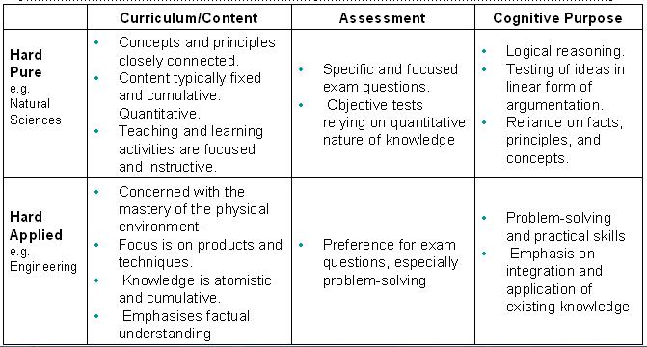
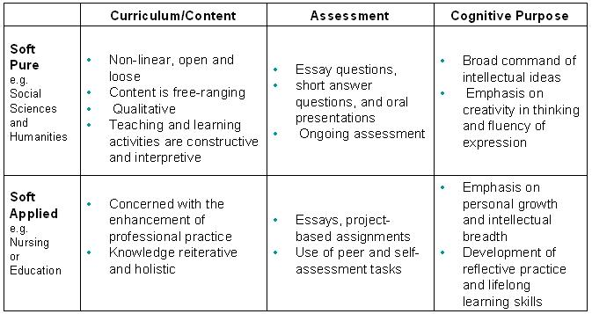
(White and Liccardi, 2006)
Whitmire found a relationship between Biglan’s categorisation of disciplines and the information seeking behaviours of undergraduates in the context of library and information science.

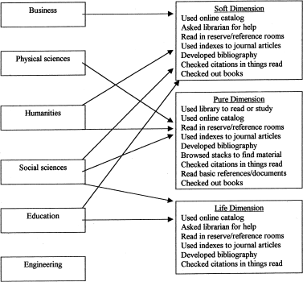

(Whitmire, 2002)
She commented
“It could be expected that undergraduates’ information-seeking behavior would differ from faculty and graduate students because their information seeking skills are not as well developed. However, similar information-seeking patterns could also be expected because undergraduate majors are socialized and indoctrinated into the research processes of their academic disciplines through course assignments and lectures. Faculty expose undergraduates to the major theories and researchers in the field including identifying which journals, authors, books are important, and perhaps which databases and academic libraries are useful for seeking information to complete course assignments.”
(Whitmire, 2002)
It might be reasonable to assume that similar factors come into play when we consider the way in which undergraduates might make use of educational learning resources.

References
Becher, T. (1993) Academic Tribes and Territories: Intellectual Enquiry and the Cultures of Disciplines, Buckingham, The Society for Research into Higher Education and the Open University Press.
Becher, T. (1994) The Significance of Disciplinary Differences. Studies In Higher Education, 19:2, 151.
Becher, T., Trowler, P. & Society for Research into Higher Education. (2001) Academic Tribes and Territories : Intellectual Enquiry and the Cultures of Disciplines, Buckingham, Open University Press in association with The Society for Research into Higher Education.
Biglan, A. (1973a) The Characteristics of Subject Matter in Different Academic Areas. Journal of Applied Psychology, 57:3, 195–203.
Biglan, A. (1973b) Relationships between Subject Matter Characteristics and the Structure and Output of University Departments. . Journal of Applied Psychology, 57:3, 204–213.
Hooper, C.J., Marie, N. & Kalampokis, E., 2012. Dissecting the Butterfly: Representation of Disciplines Publishing at the Web Science Conference Series. In Proceedings of the 3rd Annual ACM Web Science Conference. WebSci ’12. New York, NY, USA: ACM, pp. 137–140. Available at: http://doi.acm.org/10.1145/2380718.2380737.
Kolb, D. A. (1981) Learning Styles and Disciplinary Differences. in Chickering, A. (Ed.) The Modern American College. San Francisco, CA, Jossey Bass.
Neumann, R., Parry, S. & Becher, T. (2002) Teaching and Learning in Their Disciplinary Contexts: A Conceptual Analysis. Studies In Higher Education, 27:4, 405-418.
White, S. A. & Liccardi, I. (2006) Harnessing Insight into Disciplinary Differences to Refine E-Learning Design. 36th Annual ASEE/IEEE Frontiers in Education San Diego CA, IEEE.
Whitmire, E. (2002) . Journal of the American Society for Information Science and Technology, 53:8, 631-638.

Further Reading
Szostak, R. (2013). Research skills for the future: An interdisciplinary perspective. Journal of Research Practice, 9(1), Article V3. http://jrp.icaap.org/index.php/jrp/article/view/385/308
Repko A, (2012) Interdisciplinary Research Process and Theory, Sage, Thousand Oaks CA

Available from the University Library and the Web Science Library

