EndNote X7
Introduction and basic guide

February 2014

University of Southampton Library

1. Getting started with EndNote 4
1.1 Create a new library 4
1.2 Work with an existing library 5

2. The EndNote Library 7
2.1 Add new references 7
2.1.1 Use special characters 9
2.2 Set some EndNote preferences 10
2.2.1 Change Case 10
2.2.2. Change the EndNote Library display 11
2.2.3 Set criteria to manage duplicates 12
2.2.4 Find Full Text 13
2.2.5 Read/Unread options 13
2.2.6 PDF handling 14
2.2.7 Sync 14
2.3 Use the ratings option 15
2.4 Change the reference style 15
2.5 Edit the reference style 17
2.5.1 General 17
2.5.2 Citations 18
2.5.3 Bibliography 19
2.5.3.1 Author Lists 19
2.5.3.2 Author Name 20
2.5.3.3 Editors 20
2.5.3.4 Sort Order 21
2.5.3.5 Title capitalisation 21
2.5.4 Footnotes 22
2.5.4.1 Author Lists 22
2.5.4.2 Author name 22
2.5.4.3 Title Capitalisation 23
2.5.6 Save reference style changes 26
2.6 Use an edited reference style 27
2.8 Work with Groups 28
2.8.1 Custom Groups 29
2.8.2 Smart Groups 30
2.8.3 Group Sets 32
2.8.4 Create from Groups 33
2.8.5 Record summary 34
2.9 Search references 34
2.10 Quick edit a single reference 36
2.11 Edit a group of references 37
2.12 Manage duplicates 39
2.13 Print a bibliography 41
2.14 Export the EndNote Library 42
2.15 Convert to EndNote from Reference Manager 43

3. Work with external databases 44
3.1 Use the EBSCO platform 44
3.2 Export from DelphiS 47
3.3 Use the OVID platform 49
3.4 Use the Web of Knowledge platform 52
3.5 Databases without a direct export function 56
3.6 Export from Google Scholar 59
3.7 Find full text 61
3.8 Access library catalogues 63

4. Working with PDF files 66
4.1 Attach PDF files 66
4.2 Import existing PDF files 68
4.3 PDF handling 70
4.4 Use the PDF Viewer 71

5. Use EndNote with Word 74
5.1 Insert citations 74
5.2 Edit citations 76
5.3 Remove citations 78
5.4 Add page numbers 78
5.5 Insert footnotes 79
5.6 Change the bibliography layout 81
5.7 Change the reference style 81
5.8 Bibliography categories 82
5.9 Use abbreviated journal titles 85
5.10 Create a plain text file 89
5.11 Restore bibliographic format 89
5.12 Combine Word documents 89

6. Using EndNote Online 93
6.1 Synchronise the library 93
6.2 Share the library 97
6.3 Work with Word 98

7. Use EndNote with PowerPoint 101
With EndNote you can:

- Build a personal reference library - for the whole of your course, or for individual assignments within the course. Keep notes on key items, and assign keywords for searching at a later date.

- Use your EndNote library whilst you are creating a document to insert short references (citations) in your text, and build the related bibliography, according to the required reference style, as you write. Make changes to the reference style according to intended audience.

- Search on-line databases, and export references directly to your chosen EndNote library for future use.

1. Getting started with EndNote
From the Start Menu, select All Programs Bibliographic Software EndNote X7. The main EndNote screen opens.

1.1 Create a new library
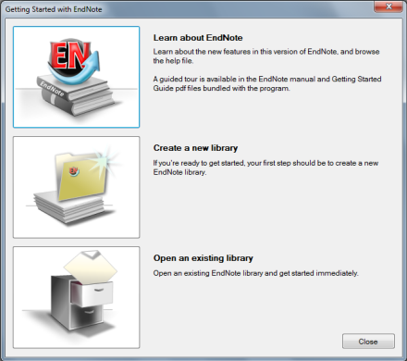

Click the Create a new library icon. The New Reference Library window opens.

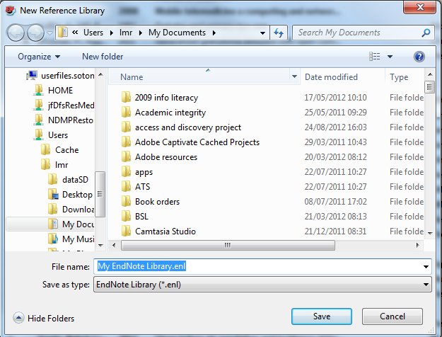

It is best to create a new folder called EndNote, or EndNote X7 to hold all EndNote information.
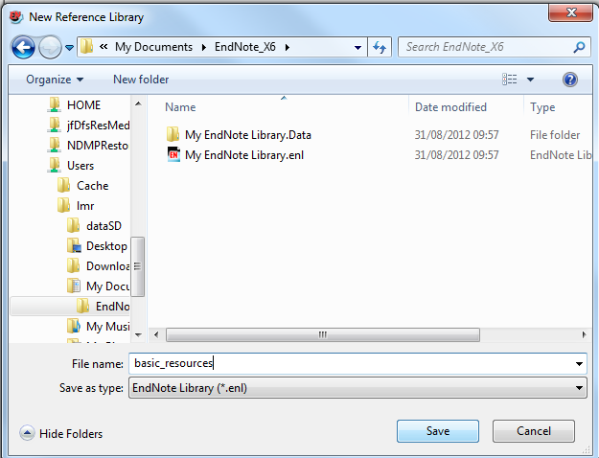

The EndNote Library always consists of two parts: the 'shape' of the library with the EndNote icon, and the information it contains, held in the Data folder.
Give the new library a name, and click Save.

1.2 Work with an existing library

Click the Open an existing library icon.
If already in EndNote, go to File Open Open Library.
The dropdown menu will display any recently accessed EndNote library.
In the Select a Reference Library window, select the Library name with the EndNote icon, and then click Open.

2. The EndNote Library
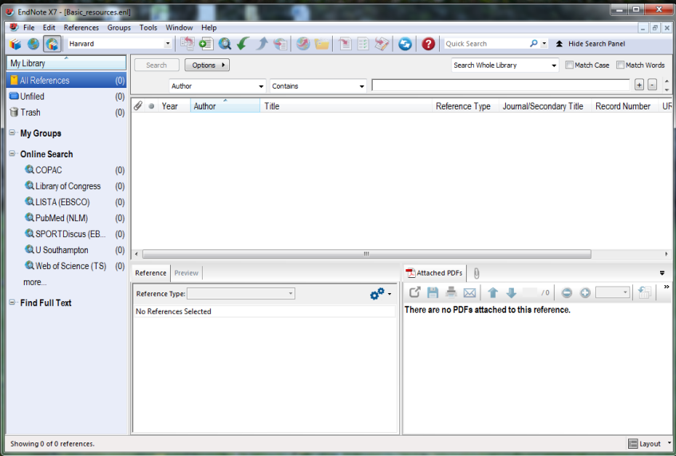

It is usually best to keep all references in one main library. Smaller libraries for particular topics can be created using the Groups options. A single library item can be added to any number of groups.
Use the layout dropdown menu to show or hide the Groups panel, and to hide or move the Reference panel.

2.1 Add new references
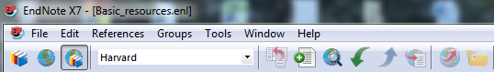

Click on the New Reference icon, or go to New Reference on the dropdown menu.
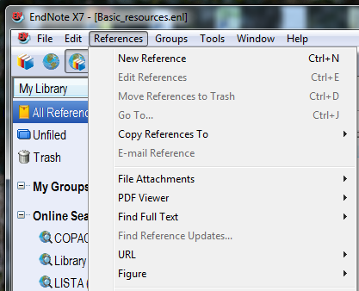

Click the record's Close icon (the grey cross) to save the completed or edited record automatically.

The default reference type is Journal Article. A different reference type can be chosen by selecting from the Reference Type dropdown menu:

Scroll down to see more fields and reference types.

The available fields change according to the type of source material.
A different reference type can be chosen at any time, and the data already entered will be rearranged accordingly. Enter data in as few or as many fields within a record as required. If the reference type required is not listed, choose the one with fields that relate most closely to the item being referenced. It is also possible to create a custom record type with specific fields if required.

Enter all data as plain text. EndNote will apply bold, italic, underlining and parentheses as required by the reference style.

Points to note:
  - Authors should be entered in the form Smith, S J with a comma after the surname.
  - Enter as much name detail as possible - EndNote will truncate to initials, or use full name, as required.
  - Multiple authors/editors should be entered on separate lines. Enter all authors - the number will be truncated as required by the referencing style.
  - Corporate authors should be entered in full, followed by a comma, e.g. Department of Health,
  - City and Publisher fields should be capitalised as required
  - Include keywords to enable searching/sorting of the library at a later date. Put each keyword on a new line.
  - Authors or journals already entered in a previous record will be suggested as options.
  - Full web addresses in the URL field are hyperlinked.
  - Use the Research Notes field to make links to hard copy or other non-electronic resources.
  - .pdf files and other electronic resources can be added as file attachments.

2.1.1 Use special characters
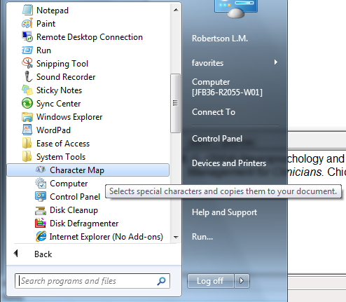
Some library entries will require accented or other non-standard characters. To edit EndNote records for non-standard characters, in any record field, go to Start All Programs Accessories System Tools Character Map.

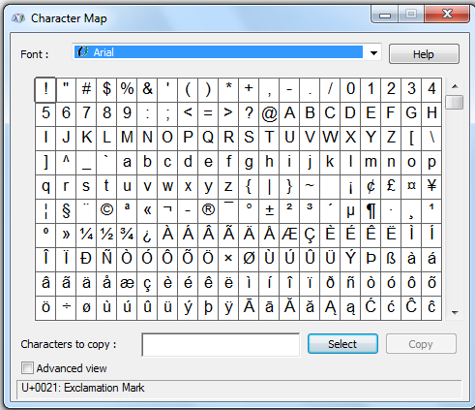

Select the character required then copy and paste in the relevant location on the record.

2.2 Set some EndNote preferences

Preferences controls how the EndNote Library itself appears, rather than the individual records. To see the options, go to Edit Preferences.

The EndNote Preferences window opens.

2.2.1 Change Case
One of the most useful features is the Change Case option.

This is an important tool: it permits the general rules for bibliographic display to be overridden in special cases e.g. abbreviations, non-English language names and characters. Any character string added to the list will be displayed 'as is' wherever it occurs.

2.2.2. Change the EndNote Library display

Choose the Display Fields option.
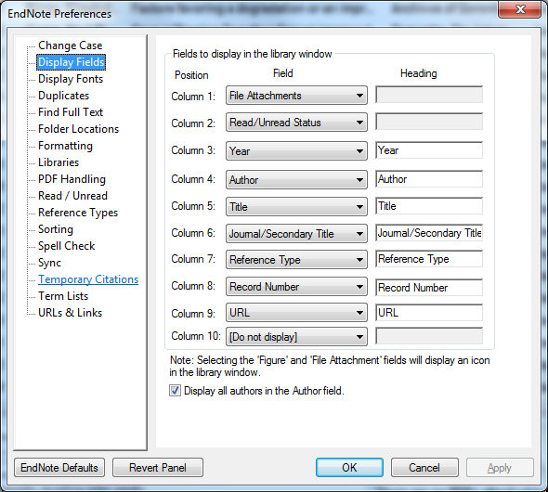

Record fields can be selected and ordered as required to display the relevant fields in the EndNote Library window. Up to ten fields can be selected and these can be renamed for the Library display if necessary.
Simple changes to the layout can be made in the Library window:
Left-click in any column heading e.g. Year, to organise references by this heading.
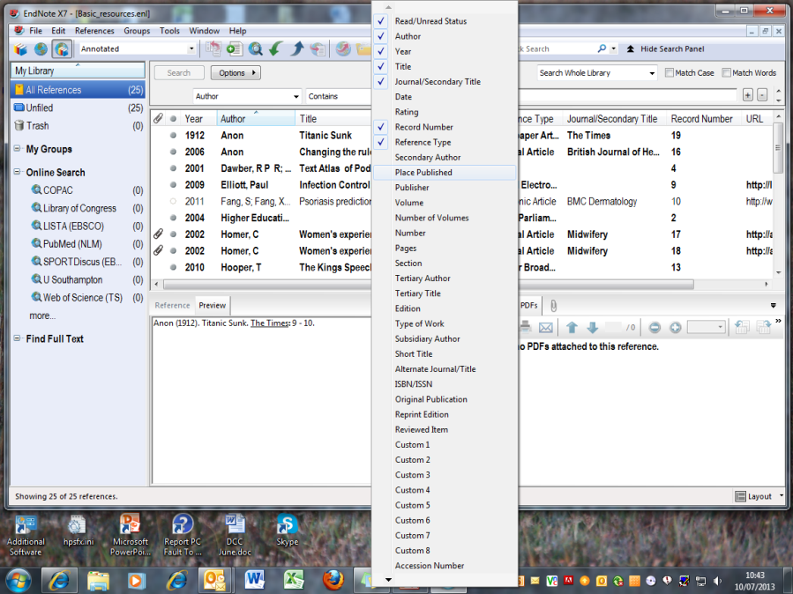

To select fields for display, right-click anywhere in the headings bar. Select or deselect any field from the EndNote record to be displayed in the library window. Up to 10 fields can be selected.
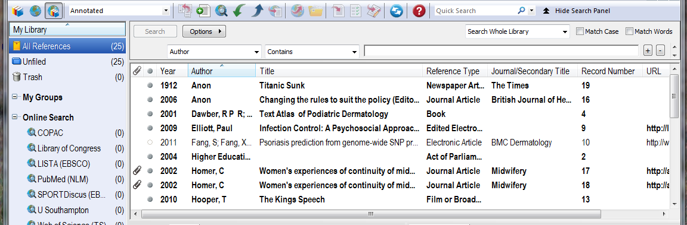

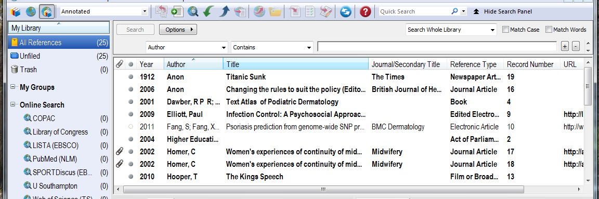

To change the order in which columns are displayed, click on the heading of the column to be moved and drag to the new location.

2.2.3 Set criteria to manage duplicates
Choose the Duplicates option.
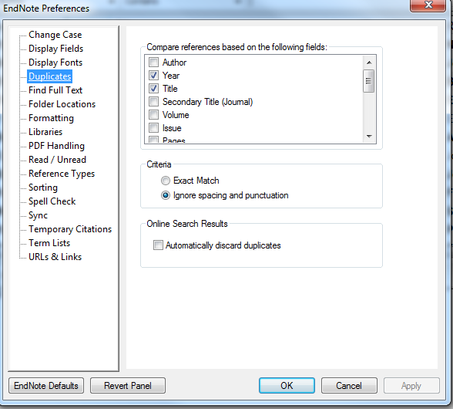

This allows you to manage duplicates automatically. . It is best not to be more specific than Year, Title. If your work includes regular database searching, it is helpful to check the Automatically discard duplicates box unless you need these for systematic review purposes. Author names should generally be omitted from the check criteria as these are often represented differently in different databases.
See later section on Managing Duplicates.

2.2.4 Find Full Text
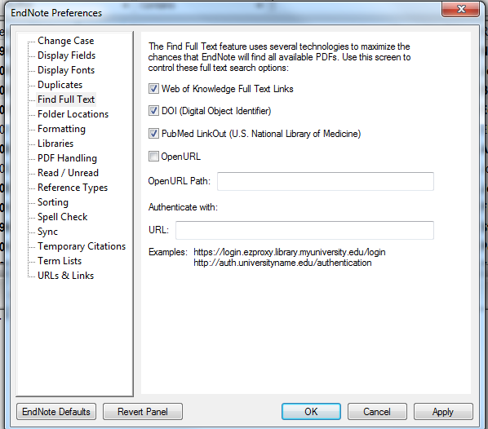

When downloading from databases, there is the option to automatically retrieve the full text pdfs for some records. Use this option to maximise the results. Ensure that Web of Knowledge, DOI and PubMed LinkOut are all ticked.

2.2.5 Read/Unread options
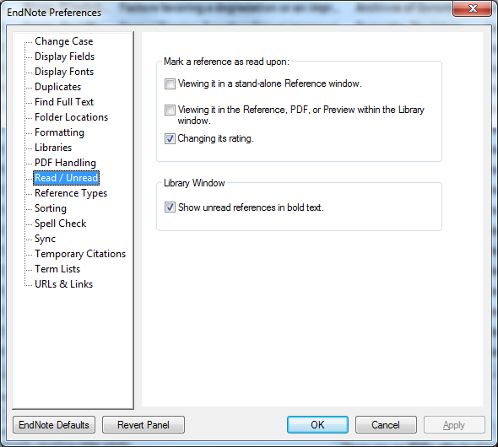

2.2.6 PDF handling
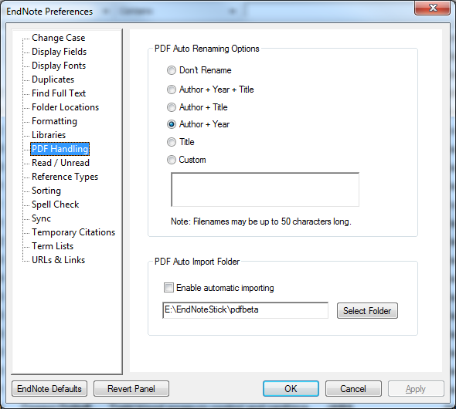

The PDF handling option allows you to change the description of PDF files to something meaningful, e.g. Author/Year. These changes will not always take place immediately but will be updated when the EndNote library is closed.
Use the Select Folder option to identify a location for PDFs which you would like added to your EndNote library. Check the Enable Automatic Reporting box to enable EndNote to background update periodically. If an EndNote record already exists, the PDF will be added: if there is no record, one will be created and the PDF added. PDFs that have been added to the Library will then be transferred to an archive folder within the selected folder location.

2.2.7 Sync
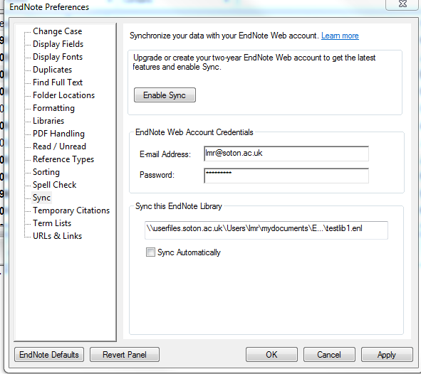

Use your Web of Knowledge login to synchronise your EndNote desktop library with EndNote Online.

2.3 Use the ratings option

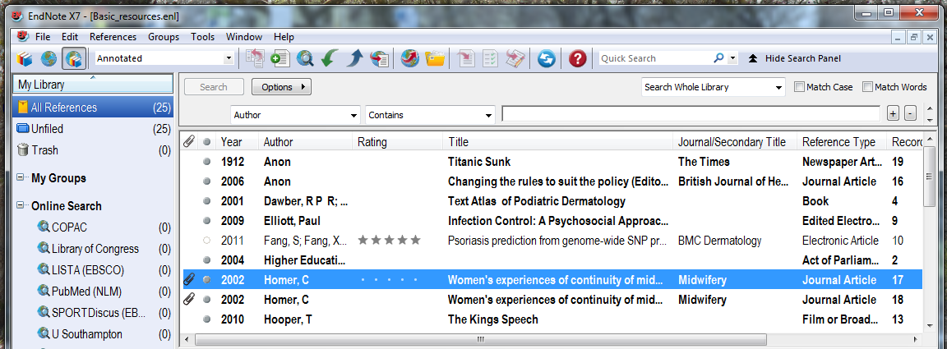

The Rating column can be used to mark particularly useful resources: click in the record, then on the dot corresponding to the number of stars (left-to-right)

2.4 Change the reference style
The default reference style is Annotated.
Use the following process to select a different style: changes can be made at any time.

Go to the dropdown menu in the reference library window and click Select Another Style.
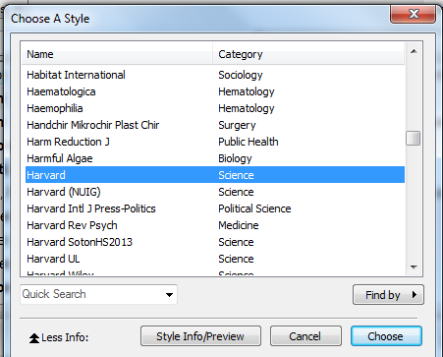

EndNote has nearly 6000 reference styles, including variations used by many academic journals.
In the Choose a Style window, scroll down to select the required reference style, and click Choose.
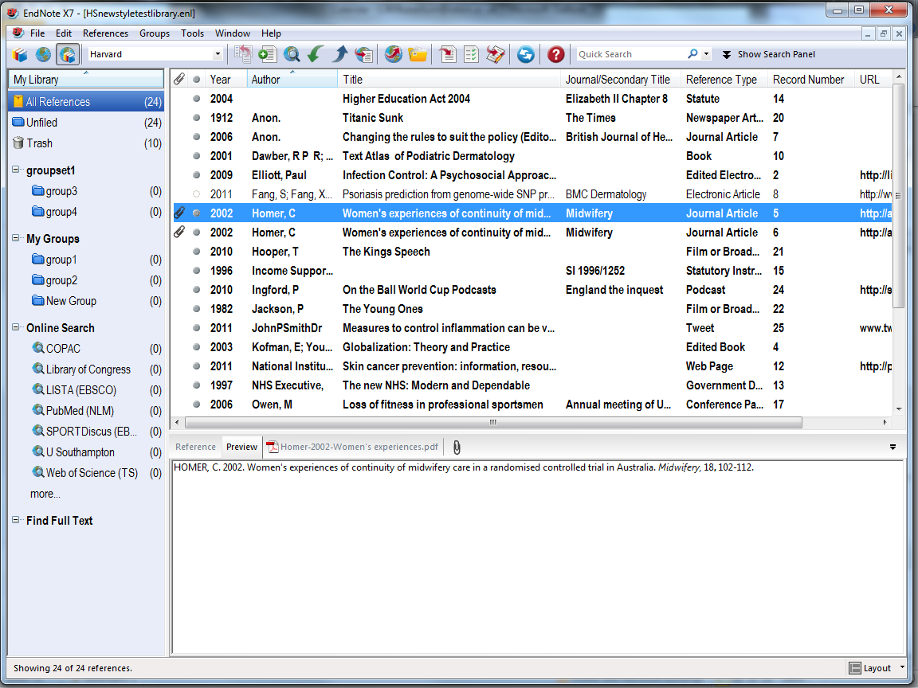

Selected references are displayed in the chosen reference style in the Preview pane.
If the standard style is not quite in line with Faculty or subject requirements, it can be edited.
Note that there are a number of custom styles for the University of Southampton:
Health Sciences: Harvard_SotonHS2013
Management: Harvard_SotonUNI2013
Medicine: Vancouver_SotonMED2013
If your department uses Harvard, but does not have specific requirements, then use the style Harvard_SotonUNI2013.

These styles are available on all public workstations, on EndNote Online, or can be downloaded for staff or personal use from
http://library.soton.ac.uk/endnote/downloads

2.5 Edit the reference style

2.5.1 General
Change the presentation of author and title information.
Modify the format for the citation and/or bibliographic reference.
Create a new bibliographic template for any given reference style.
Save preferences with a chosen style name - the new style is saved in the user profile for future use.

To make changes to the reference style go to:
Edit Output Styles Edit <style name> in this case Harvard.
To change a style not currently in use, choose
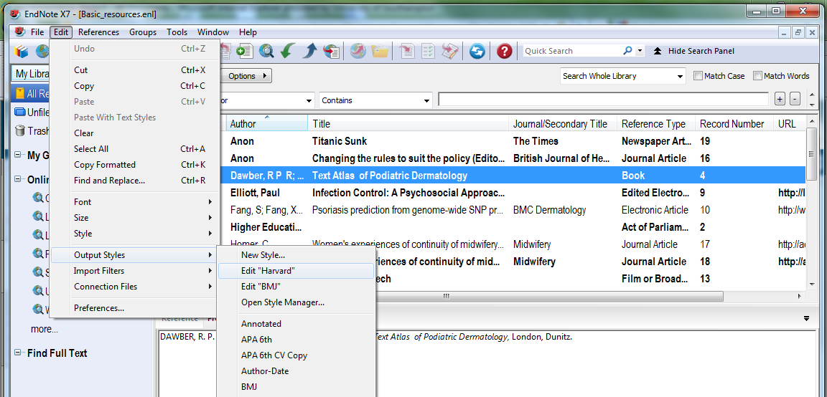
Open Style Manager…

The editing panel is displayed, with a range of options covering all listed styles.
The appearance of the citation, bibliographic reference and footnote, according to referencing style, can all be varied independently.
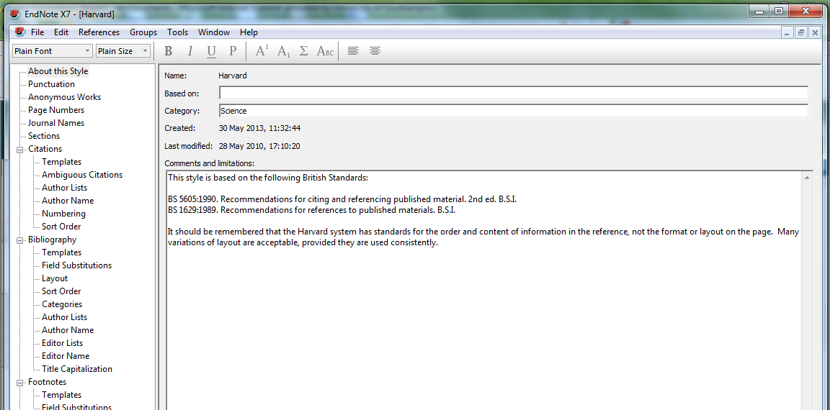

2.5.2 Citations
Click to modify different aspects of Author Lists and Author Name These have the same appearance as for the Bibliography, but can be separately specified.
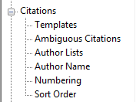
Click Citations then Templates to see how this tool works.

In this example, EndNote picks up the contents of the Author field from the record, adds a comma, then the contents of the Year field and encloses everything in brackets.
The vertical line links the following punctuation to the next field, so that if the field is empty, there is no stray punctuation in the record.

Use the Sort Order option to edit the in-text citation sort order.
The default order is Don't sort
If there are multiple citations at single points in the text, it may be better to arrange these either alphabetically or chronologically. Choose the relevant option from the list.
Make any changes required, and then click the close record icon.

2.5.3 Bibliography
In general any changes made to Authors must be replicated with Editors.

The Bibliography layout is best managed from the EndNote toolbar.
Different parameters from Citations or Footnotes may be set.

2.5.3.1 Author Lists
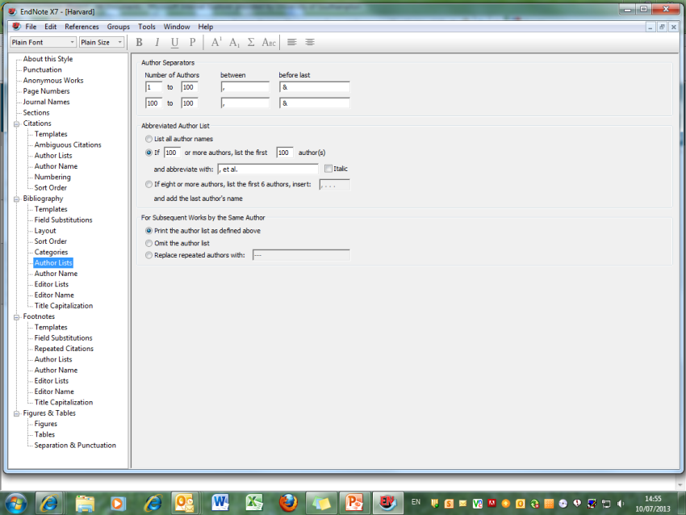

The number of authors chosen can be different from the citation section. Other changes can be made, for example replacing the separator '&' by 'and'

2.5.3.2 Author Name
Choices on this screen allow for variation in first name/surname order, and representation of initials, if these are preferred to full name. These rules will be applied however the author names are recorded in the individual Endnote records.
One important change is to the Harvard referencing style: the default is to use all uppercase for names, but some faculties prefer the use of conventional, capitalised names.

Choose Normal from the Capitalization dropdown menu.

To access the Initials choices, click the dropdown menu and select for preferred full stop/space combinations.

2.5.3.3 Editors
Any selections/choices made in Author Name or Author Lists, should normally be replicated in the Editor Name / Editor Lists options.

2.5.3.4 Sort Order
It is possible to sort the bibliography according to the information contained in any record field. Bibliographies are normally listed by Author, Date and Title. The more common options are listed on the Sort Order page.

Click the appropriate button, or to sort by any other field in the Endnote Library record, click Other.
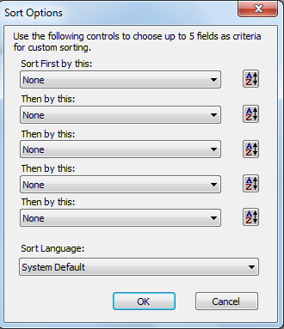
This permits sorting by any field in the record, in ascending or descending order, by up to five fields in order.

Click the dropdown arrow in each case to access a list of record fields.

2.5.3.5 Title capitalisation
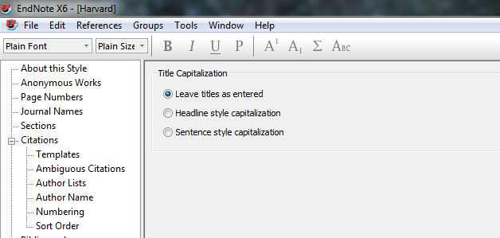

Choose the style for primary title capitalisation - Headline style will capitalise all major words, Sentence style capitalises initial word only.
Note that the same style will be applied to all records in the library: if the conventions for book titles and journal article titles differ, you may wish to leave titles as entered.

2.5.4 Footnotes
In general any changes made to Authors must be replicated with Editors.
Different parameters from Citations or Bibliography may be set.

2.5.4.1 Author Lists

The Author Lists section allows you to control how many authors are displayed, and the separating punctuation.
Any changes to Author Lists must be replicated in Editor Lists.

2.5.4.2 Author name

Changes to Author Name must be replicated in Editor Name.
These windows allow you to make choices about capitalisation - the default is As Is. Choose Normal for names in lower case but with initial capital letters.

Choices can also be made about the display of initials: with or without full-stops, with or without spaces between.

2.5.4.3 Title Capitalisation

Choose the style for primary title capitalisation - Headline style will capitalise all major words, Sentence style capitalises initial word only.
Note that the same style will be applied to all records in the library: if the conventions for book titles and journal article titles differ, it is better to leave titles as entered.

2.5.5 Editing and creating templates
Citation, bibliography and footnote templates are available for all standard reference types on public workstations. On private computers it will be necessary to create footnote or bibliography templates for anything other than basic reference types. It is important to have at least one template for e-resources.
The same principles apply to all templates.
Any reference type for which there is not a specified bibliography template will be fitted to 'Generic'.
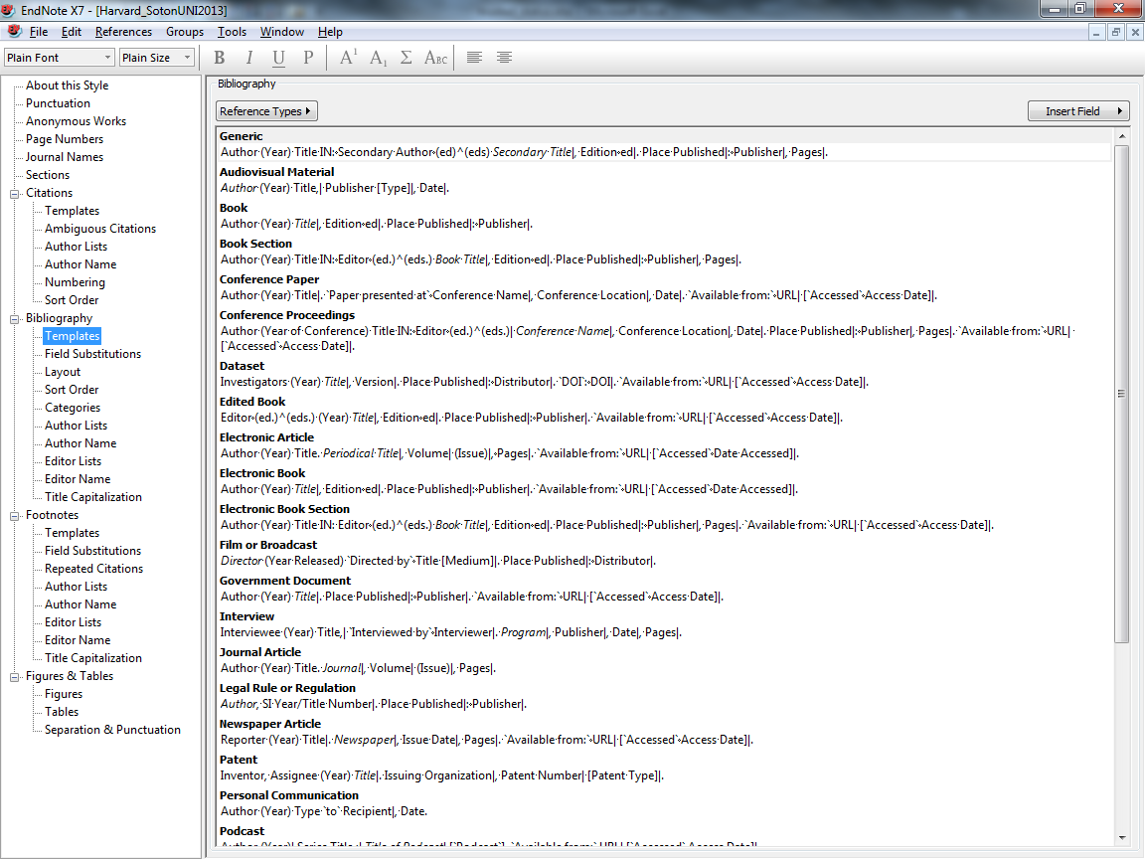
To create a new template, click on Bibliography Templates.

Bibliographic templates control the display of records when EndNote is used with Word documents for citations and references.
Depending on the Reference Style, there are already a number of templates created.
Additional templates can be created by choosing from the Reference Types list.
Generic is used when a specific template has not been created for a Reference Type that has been used to create an EndNote record.
Click Reference Types and select the new type. An editable panel appears.
Use existing reference types as examples.
- Words that are field names within the EndNote record will be replaced by the contents of that field when the bibliographic record is created.
- Words that are not field names will be replicated as typed.
- Field names are case sensitive
- Use relevant formatting, bold, italic etc as required
- Field contents will be displayed in the template format: (Year) would be displayed as (2009).
- Small dots separating record elements are created using the space bar.
- Vertical lines (Forced separations) are used to link punctuation to the field following, to avoid stray punctuation when record fields are empty.
- Small diamonds are used to link adjacent text, so that if the record field is empty, the text is not displayed e.g Editioned.
- For e-resources, the date viewed should be entered in the Access Date or Date of Access field of the EndNote record and this field included in the template.
- Field names/operators can be input manually or selected using the Insert Field button
Special characters are available from the Insert Field dropdown menu:
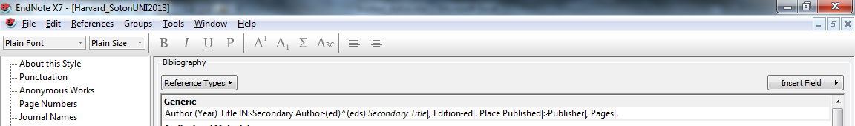

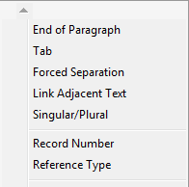

Forced separation generates a vertical line to link following publication to the next field: if this field is empty, punctuation will not be displayed.
Link adjacent text ties preceding or following text to the field in question. If the field is empty, the text will not be displayed. If there is a space in the character string, enclose the phrase in `accent grave` characters (usually located at top left of standard keyboards)
Singular/Plural generates a circumflex accent, so that Endnote can select between terms e.g. (ed)^(eds).

Custom reference types for unlisted media can also be created, with an associated Bibliography Template.
Templates can be edited at any stage, and the edited reference style applied to the EndNote Library and relevant Word documents.

2.5.6 Save reference style changes
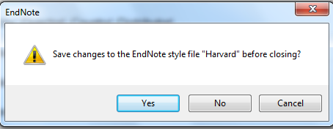
When all edits have been made to the given reference style, click the close icon.

The Save Changes window opens. Click Yes.
A Save As window appears.

By default this is (Reference Style) Copy, but can be changed to any other appropriate name. Endnote does not change the existing reference style, but creates a new style, which can again be edited. This is automatically saved within a folder called EndNote within My Documents, so can be accessed from any public workstation at any later time. It is necessary to save the changes separately to any staff or personal computer, but the style file created can be copied and pasted into a folder My Documents EndNote. Click Save.
The new style can now be found in the Choose a Style window.

Note that this edited style is not automatically applied to the existing Endnote library: see the following section.

2.6 Use an edited reference style
Changes to the Referencing Style are not automatically applied to the EndNote Library. To apply changes, go to the Reference Style dropdown menu and choose Select Another Style.

The edited style is now one of the choices - select and click Choose.

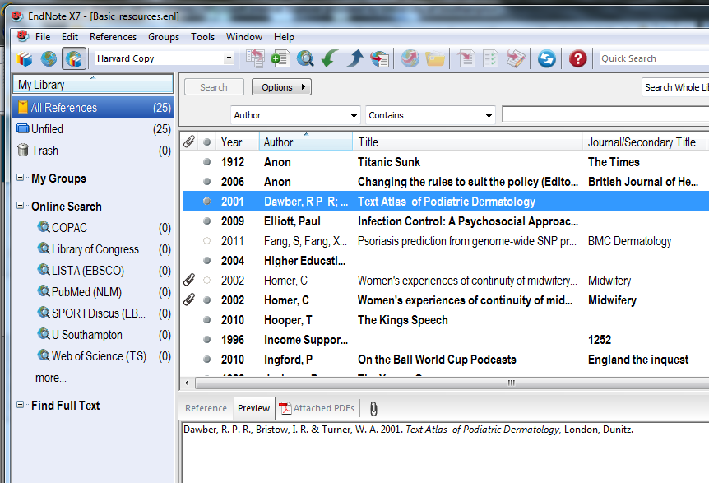

The edits are now applied to the EndNote Library.
Further changes can be made at any time, and the same copy style updated and then applied again to the library concerned. If references from the Library have already been used in a document, new changes can only be applied by using the Format Bibliography option in Word.
Ensure that the same reference style is being used in Word and in EndNote when inserting citations.

2.7 Work with Groups

The Group option in EndNote means that a single large library can be broken into subsets for different purposes e.g. separate subject assignments or papers. A group simply identifies a subset of references that always exist in the main library. A single reference can be part of any number of groups or none. It is easy to switch quickly from one group to another. Deleting a record from the main library removes it from all groups.

Up to 5000 groups can be created attached to a single library. Custom groups are created manually and can be amended at any time: Smart groups are created and updated automatically as new references are added to the library, according to user parameters set.
Group sets, containing both Custom and Smart groups, can also be created.
When the EndNote Library is synchronised with EndNote Online, only All References and Custom Groups are synchronised.
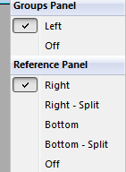

To hide/show groups, use the Layout dropdown menu

2.7.1 Custom Groups
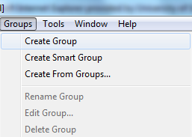

To create a Custom group, go to
Groups Create Group.

Name the group. The new group is displayed in the My Groups panel. Options to manage the group are available on right-click.
References can now be added to the Group:
Click and drag for single references
SHIFT + click on the first and last reference to select a block
CTRL + click on individual references to select from different parts of the library.

These items are then added to the group.
Items may be included in more than one group
Items may be added to or removed from a custom group at any time. This does not affect the entry in the main library.

2.7.2 Smart Groups
Smart groups are given set criteria - any item fulfilling these criteria is automatically added to the group. The criteria can be modified at any time. The criteria for a new Smart group will be applied to the existing EndNote Library, and to any items that are added subsequently.
All entries are included in the main EndNote library: they may be entries in more than one Smart group and may also be added to Custom groups.

Deleting a record from the main library removes it from all groups. It is not possible to delete an individual item from a Smart group, as this will also delete it from All References. Deleting an entire Smart Group does not delete the references from the main library.

To create a Smart Group, go to Groups Create Smart Group.
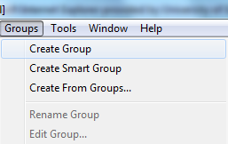

The Smart Group window is displayed. Name the Group, and select the search criteria.
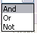
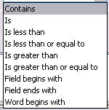

Criteria can be set for any record field and a range of operators.
Type the required terms in the search boxes. Choose Contains to force EndNote to search for letter strings.
Further search lines can be added, using + - symbols at the right of the window. When all choices have been made, click Create.
Matched records are copied to the New Smart Group.

In this example, the group will contain any item that has the word 'inflammation' OR 'infection' in the title field.

Items have been added to this Smart group from titles already in the EndNote Library.
Any future title added to the Library will also be added to any group for which it fits the search criteria.
Individual items cannot be deleted from Smart groups.

2.7.3 Group Sets
A Group set is created in the same way as a Custom group.
Go to the Groups drop-down menu, and select Create Group Set.
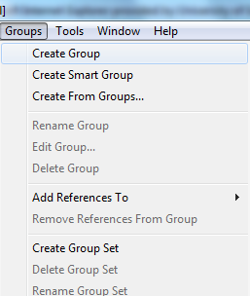

A new Group Set is created: this can be renamed via the Groups dropdown menu above. To populate the Group Set, select and drag Custom or Smart groups as required.

Group Sets can be expanded or contracted in the left-hand panel.

2.7.4 Create from Groups
Existing groups can be combined with AND, OR, NOT operators. This allows you to create nested searches, and to identify records appearing in a particular combination of custom and/or Smart groups, or in one group but not in another.
In the Groups dropdown menu, choose Create from Groups.

All existing groups are listed in the Create From Groups window.

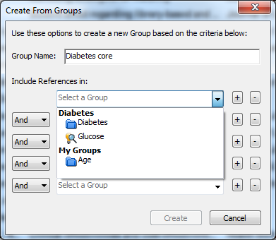

Choose which to combine using the operators And, Or, Not
A new group is created within the Group Set.

In this example, only two references were part of the self-selected group Diabetes and also fulfilled the criteria for the smart group Glucose.

2.7.5 Record summary

To view additional information about an individual record, in particular inclusion in groups, highlight the record, go to the References dropdown menu and click Record Summary.
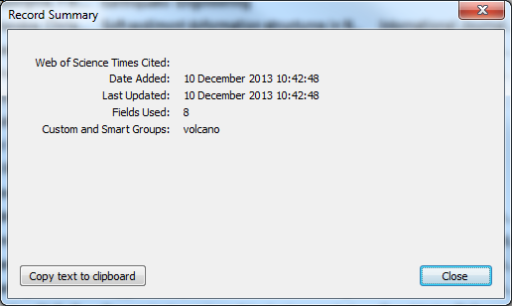

Information can be viewed, and exported if required.

2.8 Search references
As the Endnote Library becomes larger, it may be easier to search for references rather than scrolling through lists. You can either search the whole Library or a group of references.
For a simple search of the whole library, including all PDF text and all sticky notes, use the Quick Search box on the main toolbar.

For a more sophisticated search, or to search a group, use the Search panel.

Click in the toolbar to show or hide the Search Panel.

Search the whole library, or select a group and choose Search Whole Group. Use the Search tab to search all words in the references using Any Field or to search specific fields, such as Author, Title or Keywords.
It is also possible to search just PDF text and/or sticky notes: these options are above Author in the dropdown list.

Create more complex searches using the Boolean operators, And, Or and Not, and by using other limiters such as Greater than, Less than.
Use Contains to search for a letter string and add extra search lines with + if required.
Search results appear as a temporary group. They can be saved into a Custom or Smart Group if required.

2.9 Quick edit a single reference
Individual references can be edited either by opening the full record, or more simply by selecting the record in the library and going to the Reference tab.

Choose whether to show or hide empty fields at the top right of the tab.

Make the required changes, then click the next record in the library pane. The Save prompt displays.

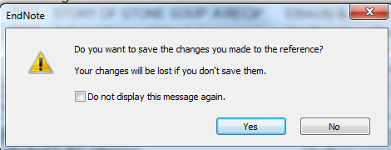

Click Yes to save changes.

The edited record is displayed.

2.10 Edit a group of references
It is possible to make changes to existing text in a given field in all records if required. Alternatively, copy records to be edited into a custom group and work with these records only.
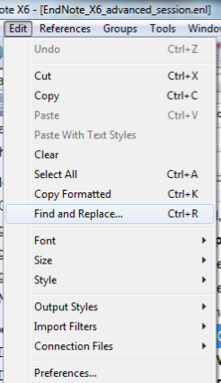
To make changes to existing text, go to
Edit Find and Replace….
The Find and Replace window allows you to
replace any text string in a given field with
another.

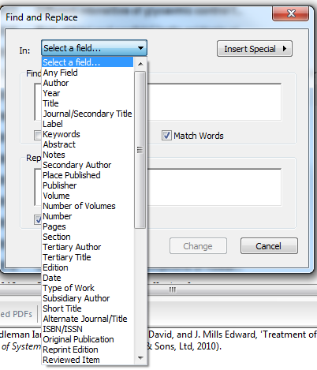
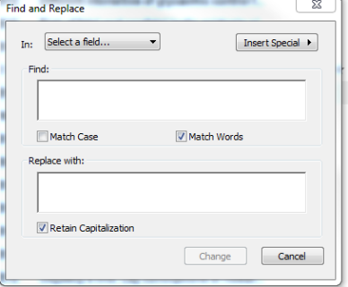

Go to Select a Field.. to choose any field in the EndNote record and type exact character strings, including spaces, in the Find: and Replace with: boxes.
Save the changes to apply the edit to the EndNote library record.
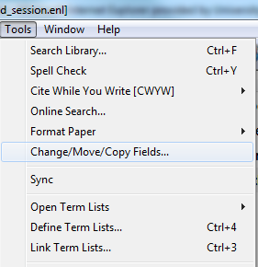
To add text, for example a note or a keyword to a group of references, create or select the group, and go to Tools Change/Move/Copy Fields…

Use the Change Fields tab.
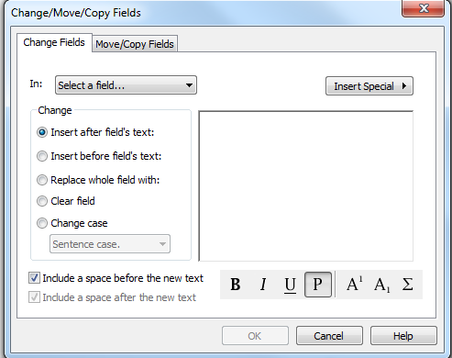

Choose the location in the field for the new text, and enter text string in the box.
Select the field to be modified from the dropdown menu.
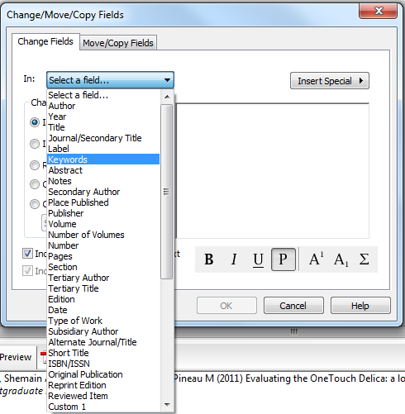

In this case the 'Keywords' field is chosen.
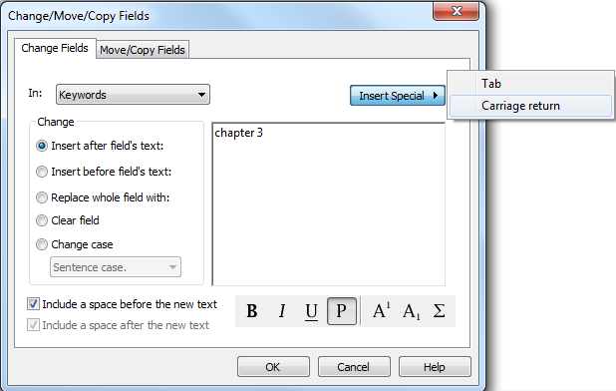

This action will add the term 'Chapter 3' as the first term in the Keywords field.
Inserting a Carriage return will cause this term to be on a separate line in the keywords list.
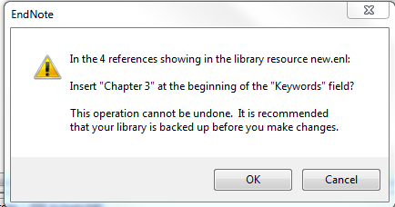

A popup window confirms the
number of records selected.

2.11 Manage duplicates

Set your duplicate criteria in Edit, Preferences, Duplicates.

Tick Automatically discard duplicates if you regularly import references from different sources. You may find it useful not to compare authors, as names can be indexed very differently by different databases.
You can check any group or selection for duplicates, but when using this option for the first time, go to References, Find Duplicates.

Endnote then carries out a search for duplicates. Each record it finds is displayed alongside its duplicate so that the two can be compared. Check to see whether these two records are indeed duplicates of each other as they may have been matched in error. Where there are multiple records, EndNote will display in records in pairs until all unwanted records have been eliminated.

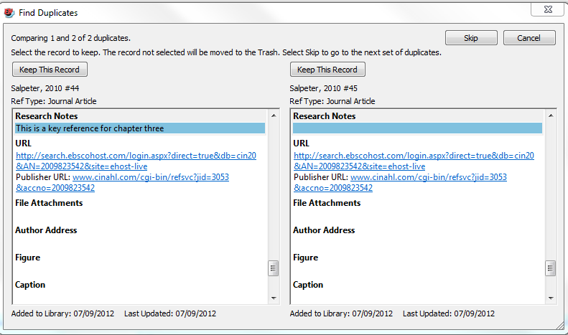

For ease of comparison, any fields which differ between the two records are highlighted.
If you don’t wish to delete either record then click on the Skip button. Otherwise, click the Keep this Record button above the record that you want to retain: the other is then deleted. If you have been using the library for a while, it is wise to keep the earliest record as this may already have been cited in documents.

2.12 Print a bibliography
It is possible to create a separate bibliography, without citing references in a Word document. The whole library can be printed, or any subset chosen.
To print the whole library as a separate bibliography, select a single record then go to Edit Select All.
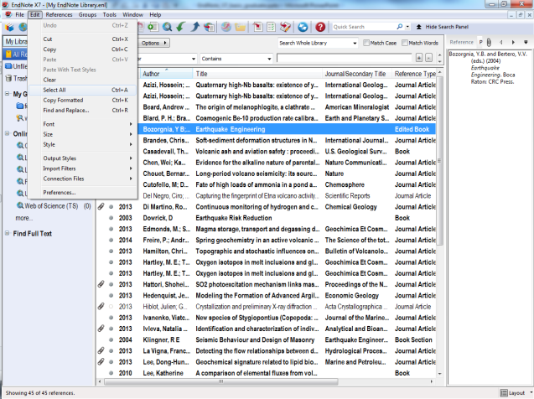

SHIFT + click on the first and last reference to select a block
CTRL + click on individual references to select from different parts of the library.
When the required titles have been selected, go to File Print.

Individual entries are printed as determined by the bibliographic templates.

Format decisions can also be made for the overall appearance of the bibliography: see section 4.

2.13 Export the EndNote Library
An EndNote library has two elements: the shape of the library, linked to an EndNote icon and file type .enl, and a data folder, with the same file name and a file type, .data. If exporting manually, both files must be copied to the new location. It is also possible to do this automatically:
go to File Compressed Library (.enlx)
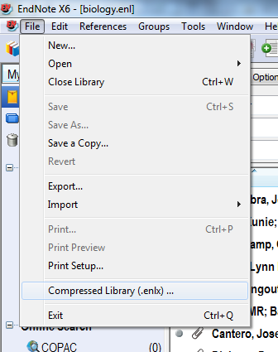

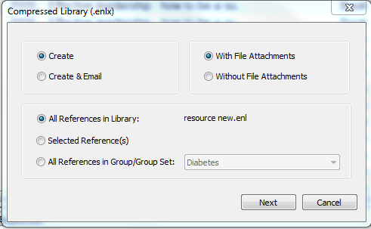

Various choices for the exported library are available: make selections and click Next.

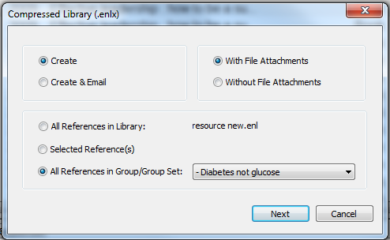

Exported references can be
limited to a particular group.

Although only Data folders are displayed, the corresponding .enl file is also acquired. The compressed file saves as an Archived EndNote Library in the required location.

Choose a location for the compressed library, and click Save in the usual way.

2.14 Convert to EndNote from Reference Manager
Any bibliographic text file in field format with two character field descriptors can be imported into EndNote. This includes the information saved in other programs such as Reference Manager.
To transfer records from Reference Manager to EndNote, first open Reference Manager, and the database to be converted. From the File menu, choose Export. Select the RIS format, and choose All References. Export as a text file and save.
In EndNote, open or create the library to contain the imported references.
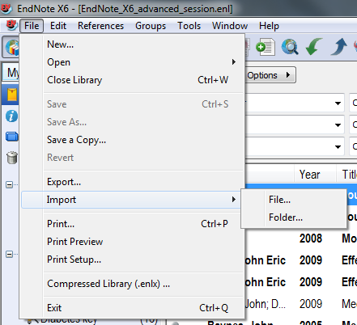

Go to File Import File…

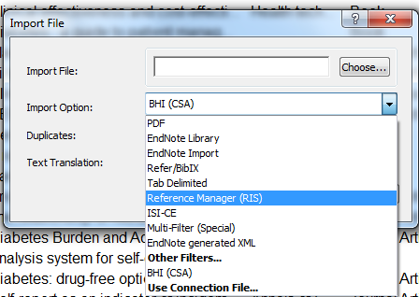
Choose the Import Option Reference
Manager (RIS).

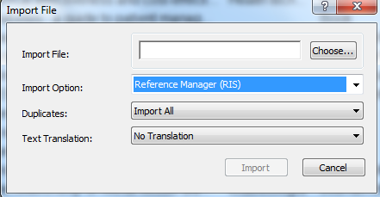
Choose … to browse and locate the file exported from Reference Manager, and then click Import.

All references will appear as a temporary group, and will also be added to the main library.

3. Work with external databases
Most databases offer the option to export references directly to a new or existing EndNote Library or Group. Each database platform functions in a slightly different way.
Generally the export includes citation information and the article abstract: it may also contain additional features such as controlled vocabulary.
Some databases also export a hyperlink to the corresponding information page in the database, or to the journal article.
Searching within the database and then exporting to EndNote makes a more comprehensive search strategy available.

Bibliographic information can also be downloaded from library catalogues including University of Southampton and this uses a slightly different process -see the separate section below.
The EndNote export process uses connection files and import filters: all these are installed on public workstations. If you have purchased a copy of EndNote then additional files and filters can be downloaded from the supplier's website.

3.1 Use the EBSCO platform
Typical databases on this platform are CINAHL, PsycInfo, Medline.
The university discovery layer, DelphiS, also uses this platform.
It is best, but not essential, to open the EndNote library before starting the search. Make sure you are in Library view.
Go to the home page of the required database, in this case, CINAHL.
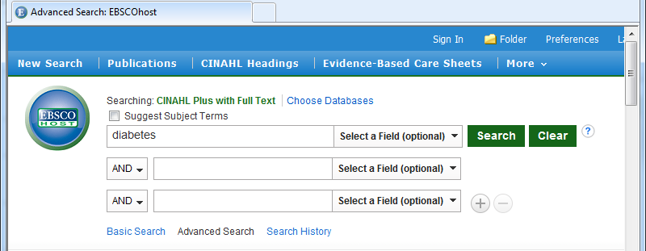

Enter the search term, in this case 'diabetes', in the box and click Search.
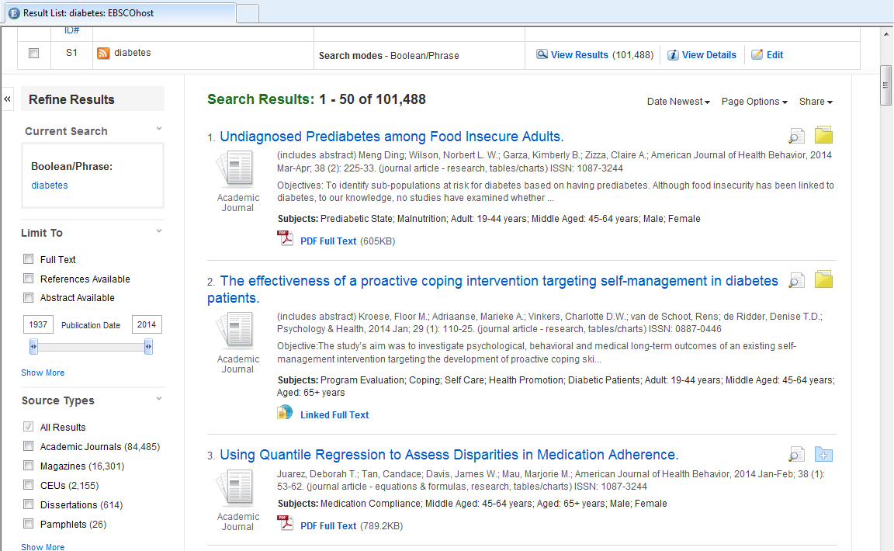

Go through the search results, and click the Add to Folder option for each required item.

These will be saved to a temporary folder. Click the icon to go to Folder View.

This window allows you to edit the selection before saving. Check the boxes of individual items required, or check Select all. It is also possible to delete unwanted items at this stage. Click the Export icon with the green right arrow.
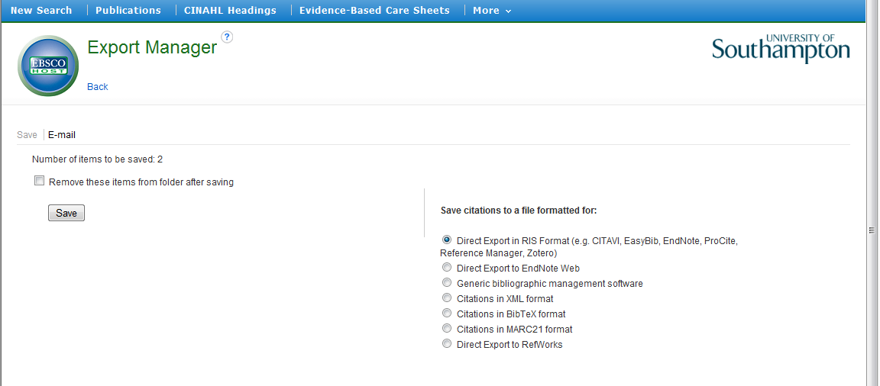

Choose the radio button to save citations to a file formatted for Direct Export in RIS format. Click Save. There may be a pop-up window asking if you wish to Open or Save the file - in this case, click Open.
The records will import directly into the EndNote library.

These become a temporary group of Imported References, but are already added to the main library of All References. The temporary group will be overwritten at the next import activity, or when the library is closed.

Click on any imported reference to view the whole record.

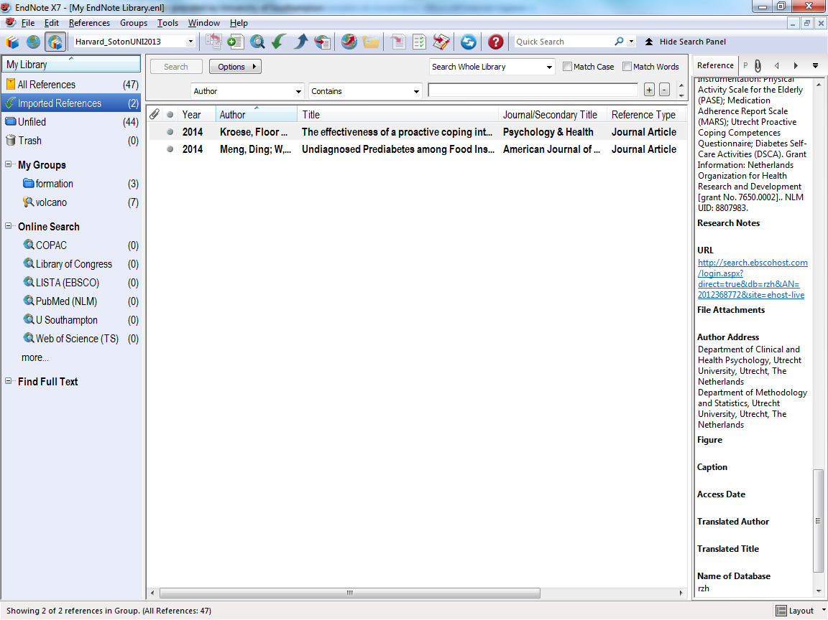

Details include the full citation, key search terms, the abstract and hyperlinks to the publisher webpage and the EBSCO database record.
Click the URL link to return to the EBSCO database entry.
The EBSCO link goes to the corresponding page in the database.
The publisher URL goes to the home page of the journal or directly to the specific article.

It is possible to view the full text if available.
PDF files of full text can be saved to attach to the EndNote record at a later stage.

3.2 Export from DelphiS

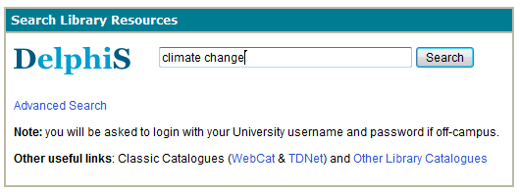

Access the library search tool Delphis via SUSSED, Libguides or the Library website. Enter search term(s) and click the Search button.

Click the Add to folder icon for any required items. These are listed in Folder has items but note that however many are selected, only three individual items will show. To see all selections, click Go to Folder View.
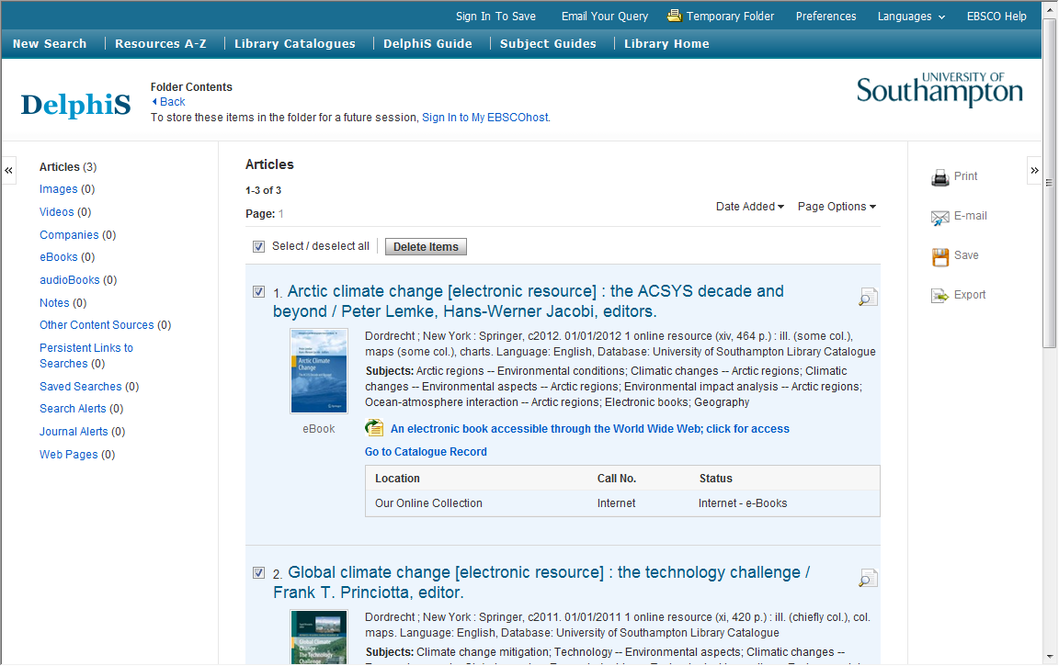

On this page, select the items for export (or delete any not required), then click the Export button.

The default is to RIS format (for EndNote etc). Click the Save button.

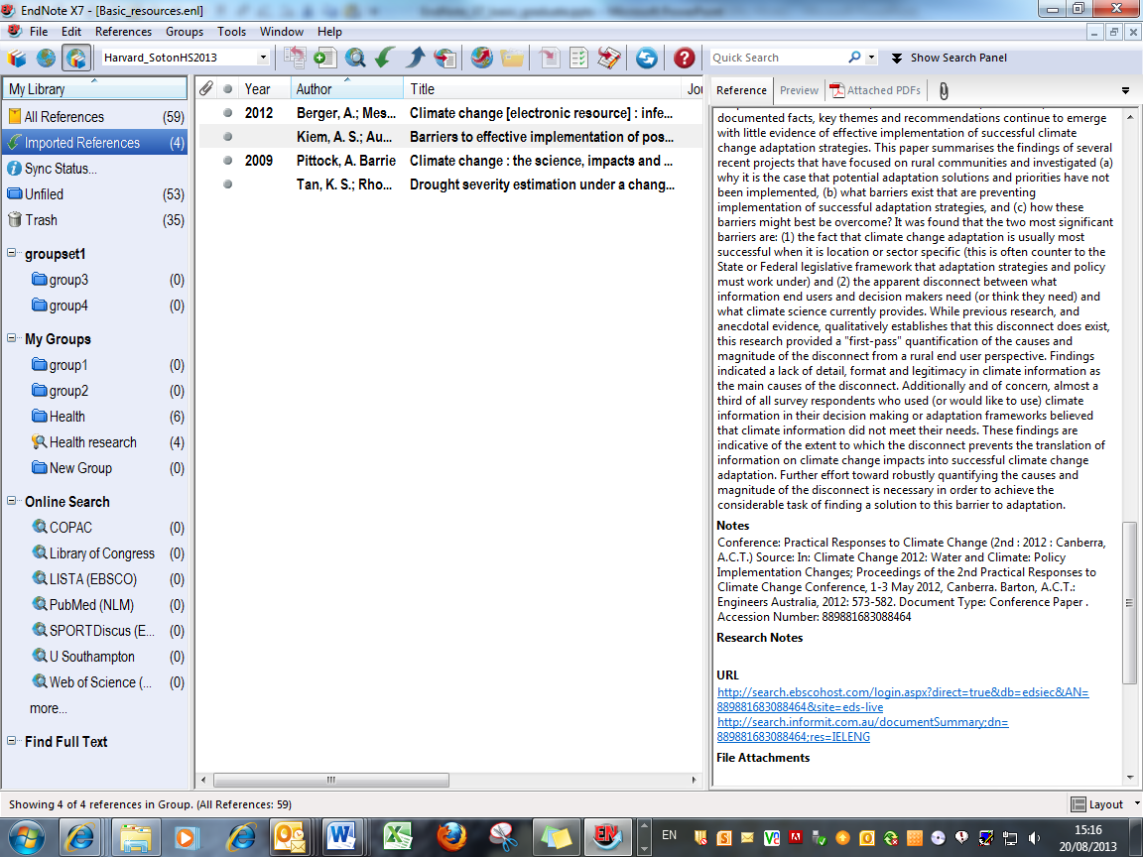

The selected records are imported as a temporary group and also added to All References. The records include links back to the database, and where relevant to the actual item.

3.3 Use the OVID platform
It is best, but not essential, to open the EndNote library before starting the search. Make sure you are in Library view.
Use this procedure for any database on the OVID platform. In this case, Medline is the chosen database. Use the library website to locate the database and choose the 'Medline' option to locate the home page.
The instructions here are for exporting required articles to EndNote rather than conducting an effective search strategy.
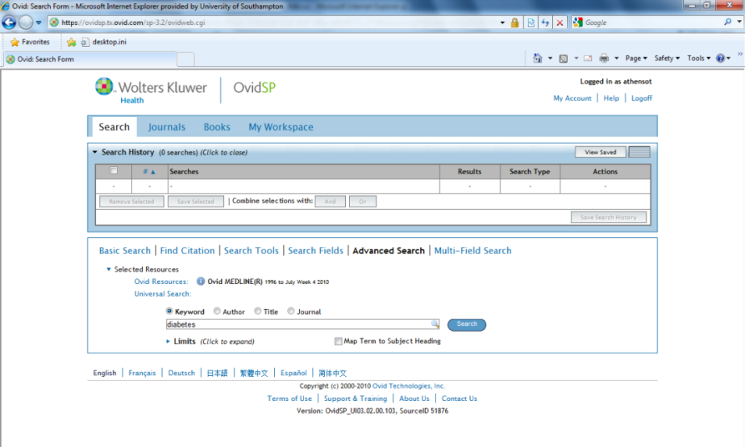

In this case, carry out a free text search for the term 'diabetes' (uncheck the Map Term to Subject Heading box). Click the Search button.
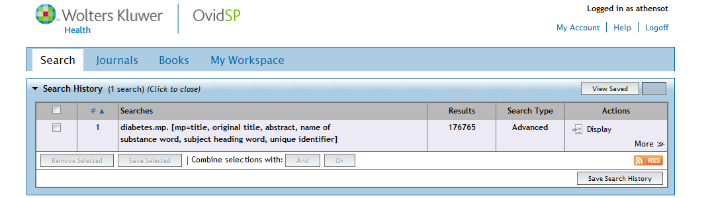

When the search is complete, click Display to view the results.
Check the boxes for any required papers. At the top of any page there is the option to keep selected results on the current page to export later, or to export directly to EndNote.
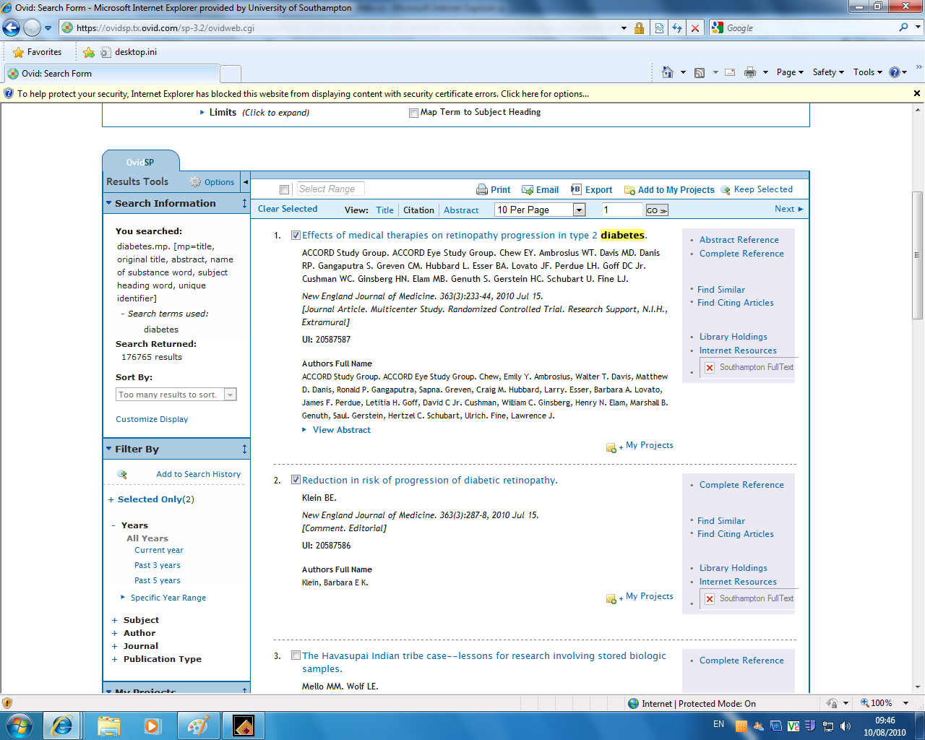

In the Export option, the numbers of all the selected results are listed.
Choose Export To EndNote from the dropdown list and Complete Reference in the Select Fields to Display section.
Click Export Citations.
There may be a pop-up window asking if you wish to Open or Save the file - in this case, click Open.
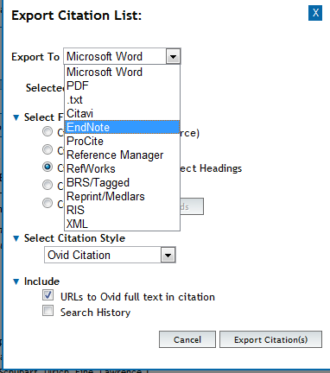
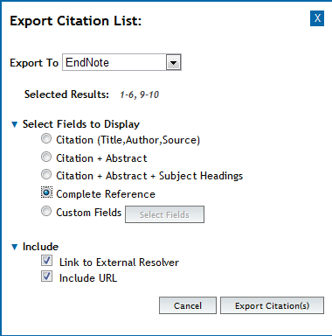

The database will export to whichever referencing software is available on the computer: if there is more than one, a pop-up window will ask you to choose.

The records will import directly into the EndNote library. These become a temporary group of Imported References, but are already added to the main library of All References. The temporary group will be overwritten at the next import activity, or when the library is closed.
Double click on any record to view.

Details include the full citation, key search terms, the abstract and hyperlinks to the publisher webpage and the OVID database record.
Click the URL link to return to the OVID database entry.

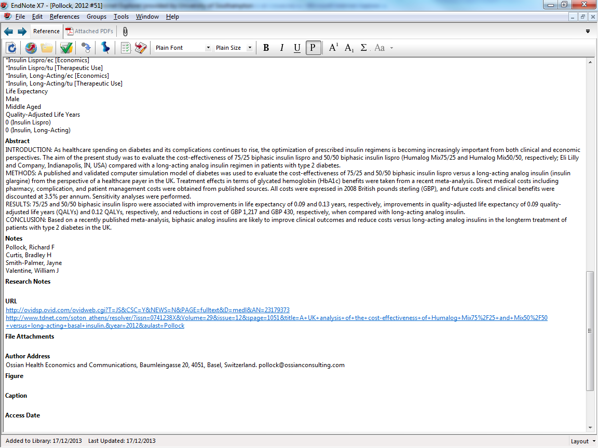

The OVID link goes to the corresponding page in the database.
The publisher URL goes to the home page of the journal or directly to the specific article.
It is possible to view the full text if available.
PDF files of full text can be saved to attach to the EndNote record at a later stage.

3.4 Use the Web of Knowledge platform

Typical databases on this platform are Web of Science and BIOSIS.
Open the EndNote library before starting the search. Make sure you are in Library view.
Carry out the search, and check the boxes for required records.
Records can be exported directly from individual pages, or added to the Marked List and the same Export procedure followed from that point.

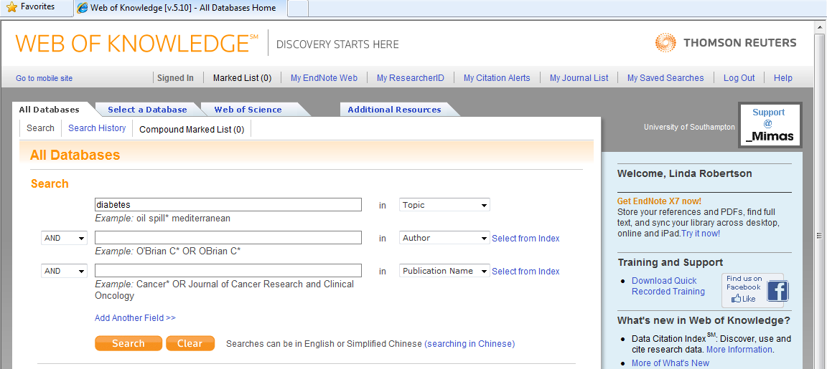

Enter a search term, in this case 'diabetes' and click Search.
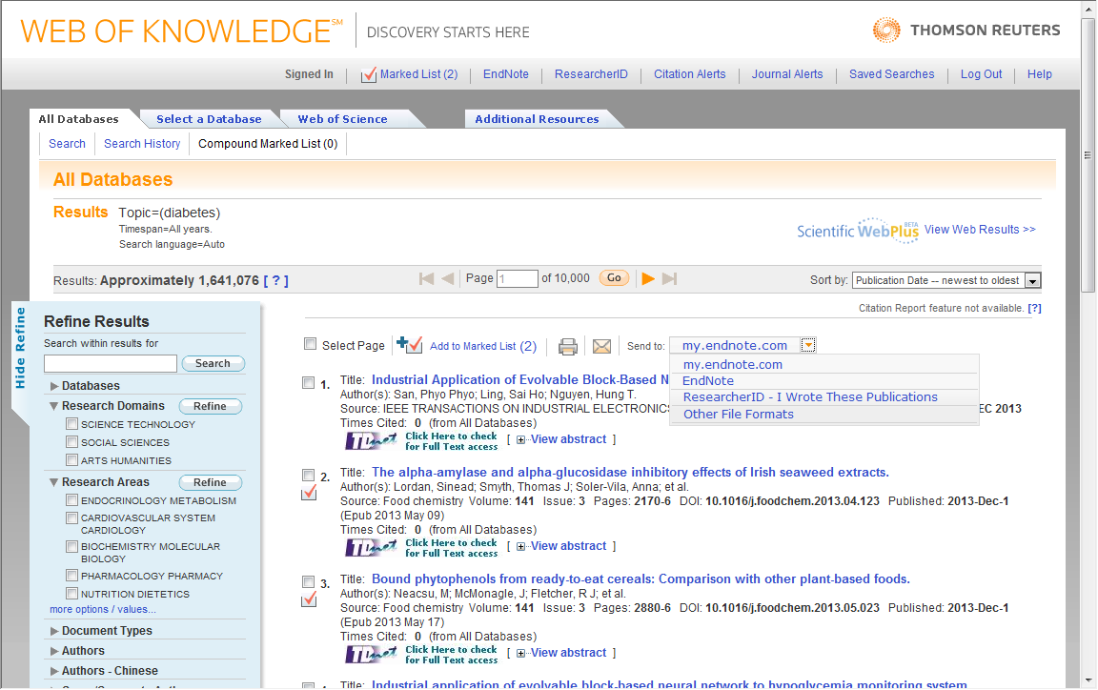

On the Results pages, check the boxes for required items and then click the dropdown menu to choose EndNote. Do not use the my.endnote.com link as this goes to EndNote Online, which is a different process.
If there are several pages of results, check the boxes for required items, then Add to Marked List.

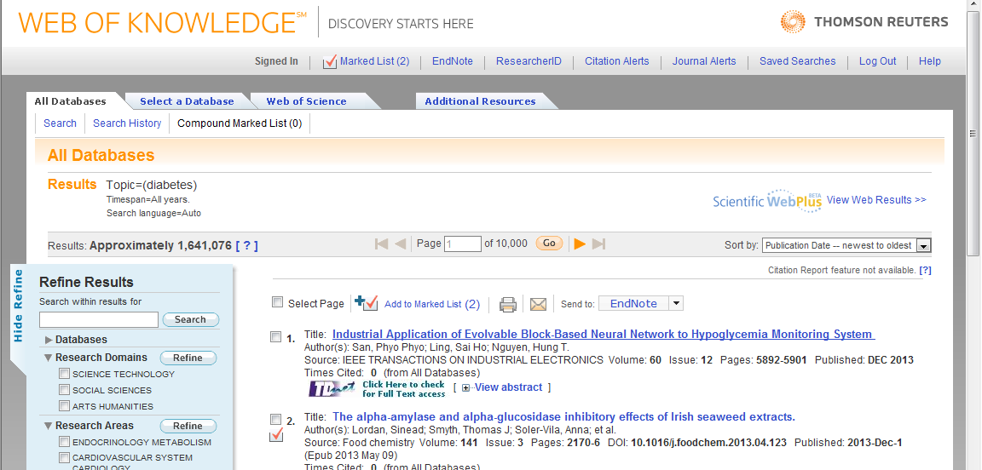

Marked records are identified, and the Marked List can be accessed at any time. The Marked List can then be exported.
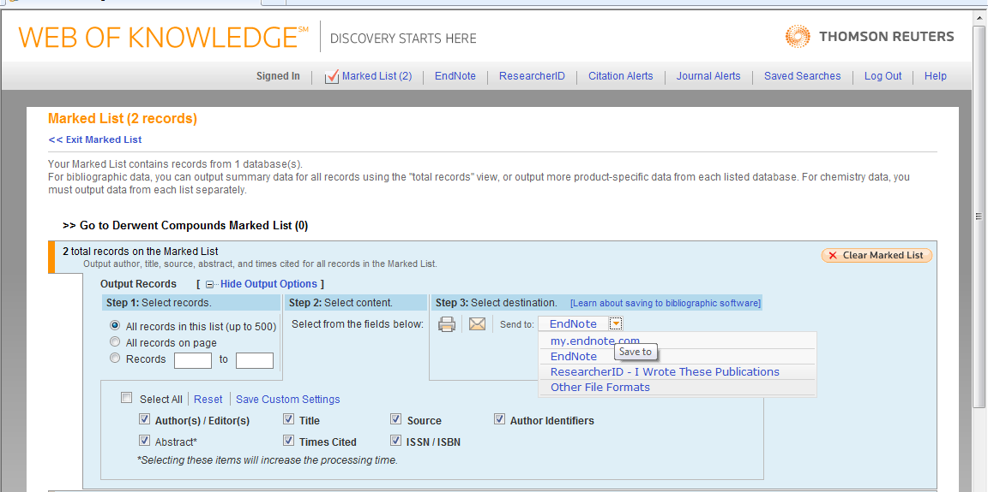
Any unwanted records can be deleted.
Select records to be exported, the database fields required (remember to select abstract as this is not included by default) and click EndNote on the dropdown menu.

The records will import directly into the EndNote library. These become a temporary group of Imported References, but are already added to the main library of All References.
The temporary group will be overwritten at the next import activity, or when the library is closed.

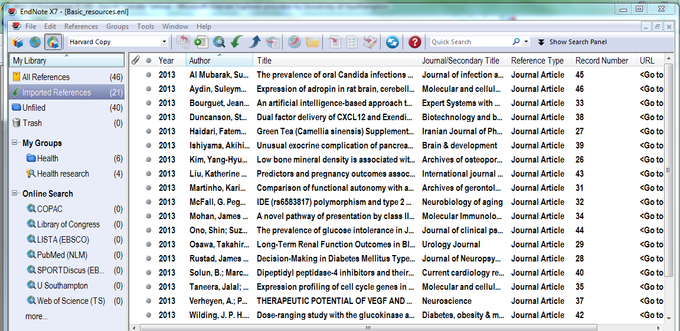

Double click on any of the imported references to view, and scroll down the page to view all fields.
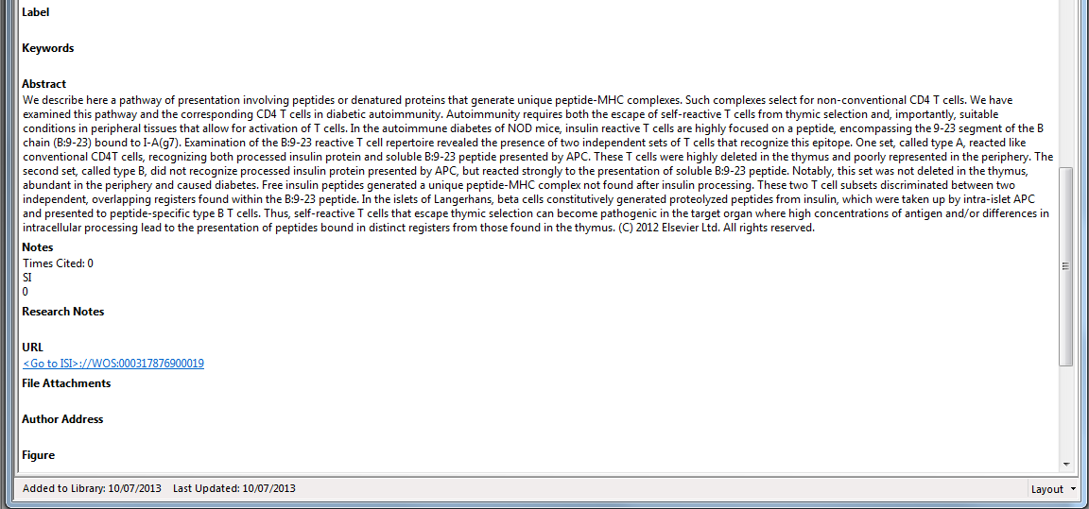

The URL field contains a hyperlink to the original database record: click to view.
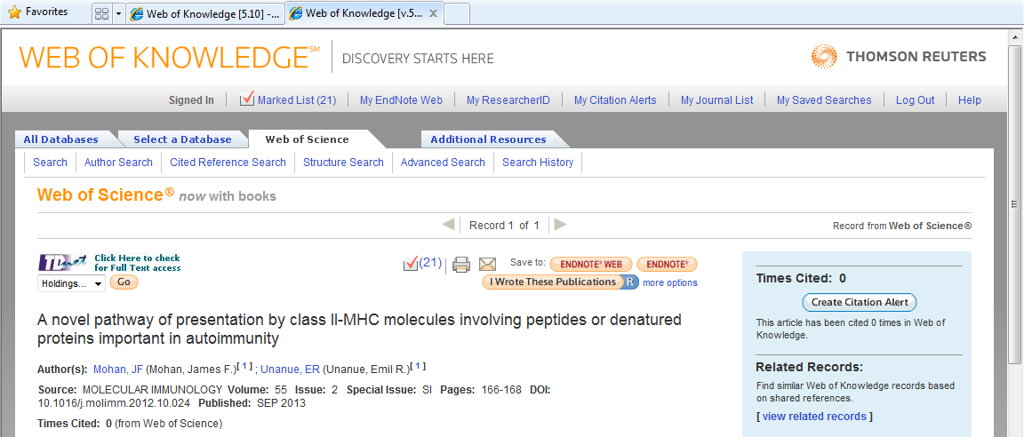

Click the TDNet button to check for full text access, and download the PDF to attach to the EndNote library later.

3.5 Databases without a direct export function
Use this method to export reference data from databases which do not have a direct export facility to EndNote. Many of these databases will export records as plain text (.txt) files with tagged field information in a form which can be imported to an EndNote library. Databases such as the Cochrane Library are in this category.
It is best, but not essential, to open the EndNote library before starting the search. Make sure you are in Library view.
Use the library website to access the Cochrane Library.
Enter the required search term(s) and click Search.
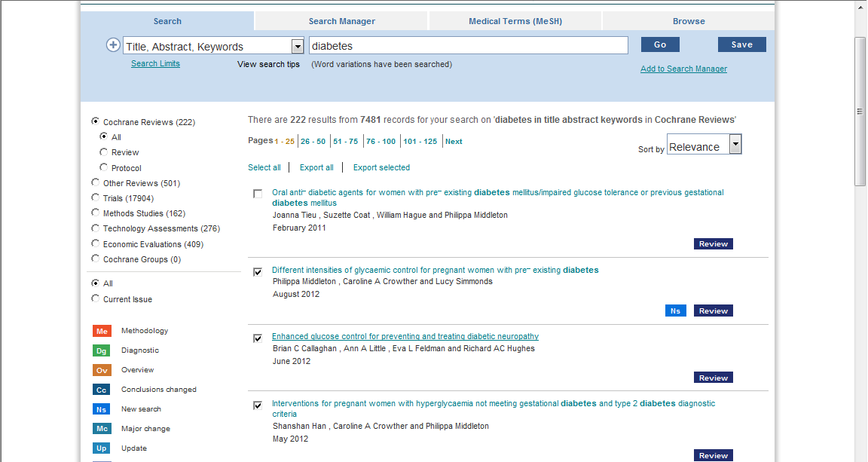

Work through the records on each page, checking the boxes for required items and then click Export selected.
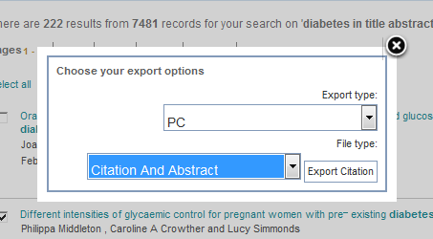

Choose the Citation and Abstract option, and click Export citation.

In the next window, click Save again. (NB in the direct export method from other databases, you would click Open if this pop-up appears - this process is different)
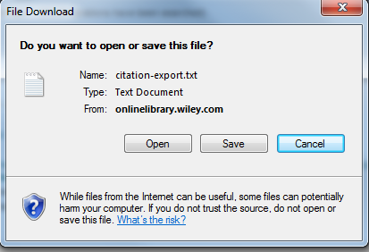

Choose a location to save this file: if using a public workstation, check that the My Documents window that opens is the home file store (usually drive H), and not the My Documents on the C drive, the workstation itself, as these files are lost at logoff.
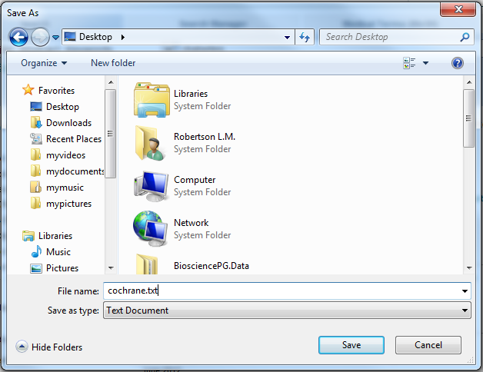

Allocate a name and save file as type Text Document. Click Save.
Open the EndNote Library. Go to File Import File…

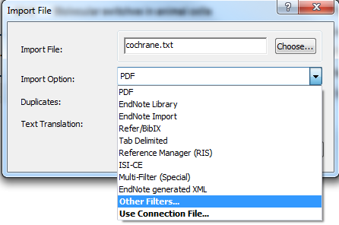

In the Import File box, go to Choose.
Browse to locate the text file and click Open.
In the Import Option dropdown box, select Other Filters…
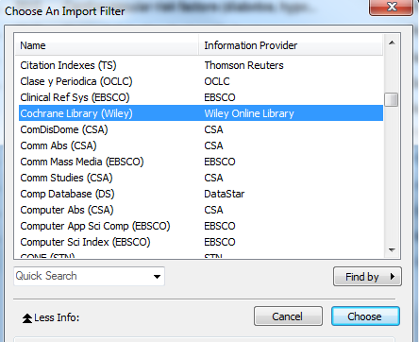

Filters are usually listed under database name.
Select the required filter and click Choose.
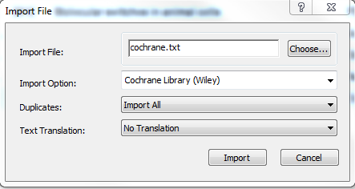

Click Import.
The records will import directly into the EndNote library.

3.6 Export from Google Scholar

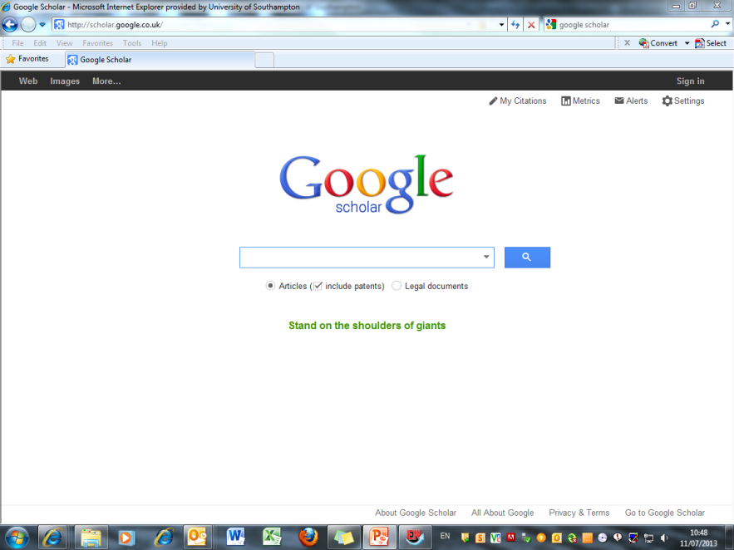

Unlike the main Google search engine, Google Scholar enables references to be exported to Endnote. However, before any searches are carried out, check that Google Scholar is properly configured to do this. To do this click on the cog wheel and choose Scholar Preferences from the dropdown.
Near the bottom of the page, is the Bibliography Manager section. Check that the Show links to import citations option is marked and that Endnote is chosen from the drop-down menu beside it.

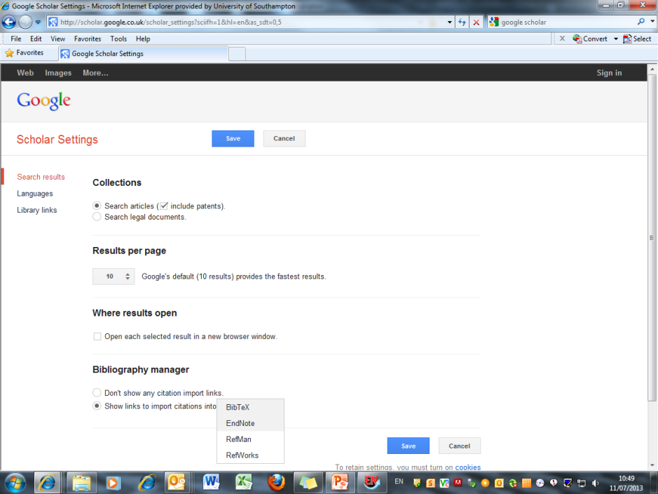

To return to the search screen, click Save.
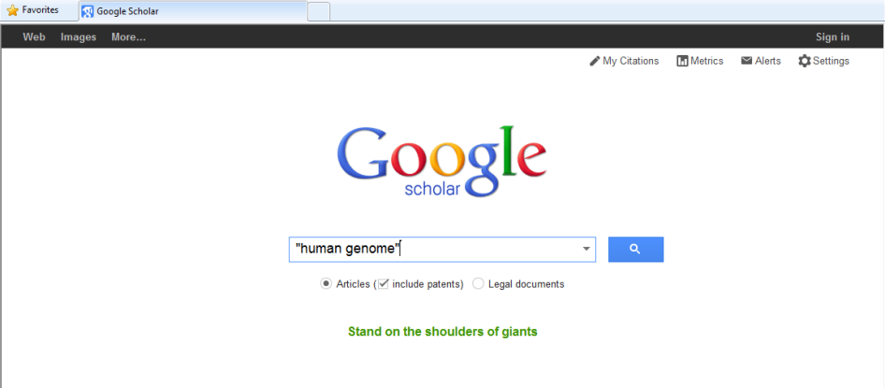

You can now perform a search. It is recommended that you open the EndNote Library before starting the search on Google Scholar.
This search is for material on the human genome.

Google Scholar produces a large number of results for this search. To import information from any of these webpages into Endnote, select the Import into EndNote link that appears at the end of each entry.

In the File Download window, select Open.

Bibliographic details are then imported into Endnote. These become a temporary group of Imported References, but are already added to the main library of All References. The temporary group will be overwritten at the next import activity, or when the library is closed.
Click on this reference in order to view its full record.
Google Scholar won’t allow you to import more than one reference at a time. To export more items from the ‘human genome’ search into Endnote then you will need to return to the Google Scholar search page and select the next reference required.

3.7 Find full text
The Find Full Text option currently works between EndNote and Web of Knowledge to automatically download PDF files and attach these to the EndNote record for any papers which are either publicly available, or supplied free of charge through the database platform. This does not currently include papers from journals for which the university pays a subscription.

To ensure that all available resources are searched, go to
Edit Preferences.

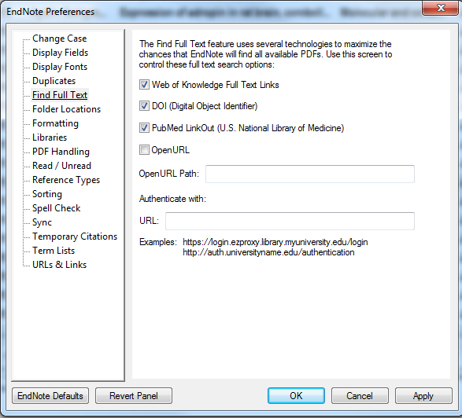

The EndNote Preferences window opens.

Choose Find Full Text. Ensure that Web of Knowledge, DOI and PubMed LinkOut are all ticked. Click OK

To search all records in the EndNote Library, select one entry, then go to Edit Select All.

In the References dropdown menu, select Find Full Text Find Full Text …

EndNote works through the library, searching for full text and reports progress in the left hand pane.
Any full text PDFs located are automatically attached to the File Attachments field of the individual EndNote record and denoted by a paperclip in the library or group window.

Double click on an individual record: the .pdf file is available in the File Attachments field. Double-click to view the full text
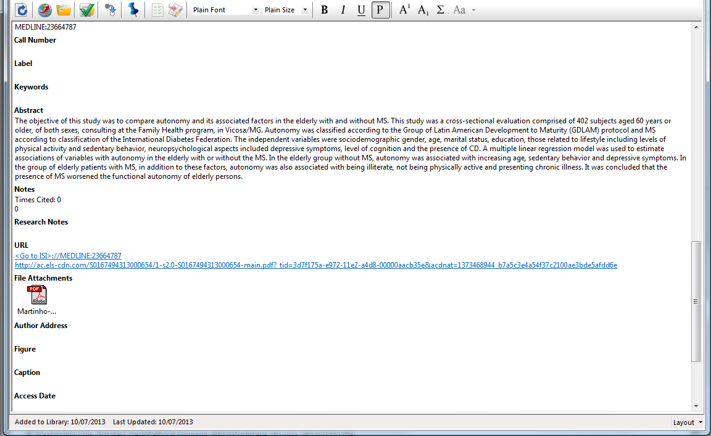

3.8 Access library catalogues

Most library catalogues, including Southampton's own, do not have a bibliographic export facility. However the catalogues can be searched and results downloaded by initiating the search via EndNote. Note that this is a less sophisticated search than those commenced from within an individual database.

To make the connection with the University of Southampton catalogue, in the Online Search section of the left-hand panel, click more…

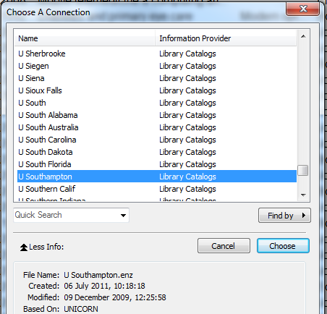

In the Choose a Connection window, scroll down to select U Southampton and click Choose.

Use the same method to search catalogues of other libraries.
The new connection will now appear in the Online Search list.
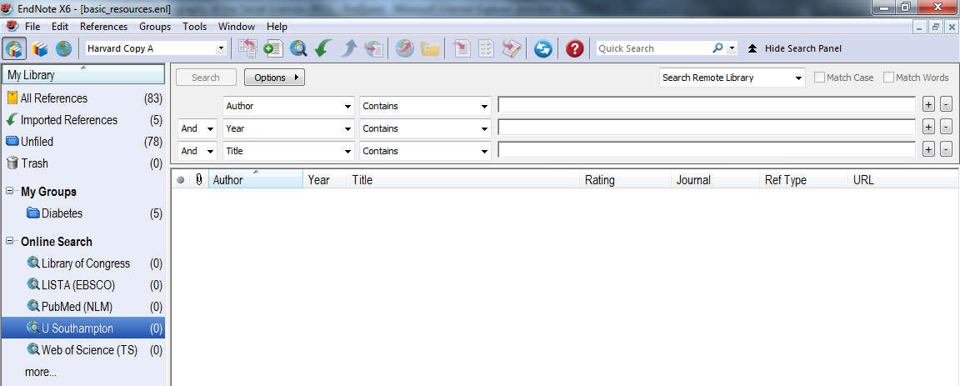

The search panel is directed to the selected library catalogue.
A range of search fields, search criteria and search terms can be selected.

Select as many terms as required: more lines can be added if necessary. Click Search.
The Confirm Online Search window shows the number of records retrieved. If the number of hits is large, it may be necessary to refine the search further.
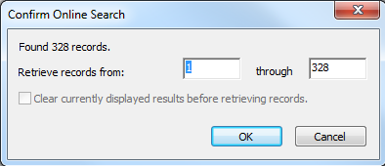

Click OK to add the retrieved records to the EndNote Library.

Imported records display as a temporary group and are also added to the main library.
Double click on any record to view. All fields in the catalogue record will be imported to the EndNote Library.

4. Working with PDF files

4.1 Attach PDF files
PDF and other types of file such as Word, Excel, graphics, can be attached to the EndNote record, using the File Attachments field.
On the Reference pane click the paperclip symbol
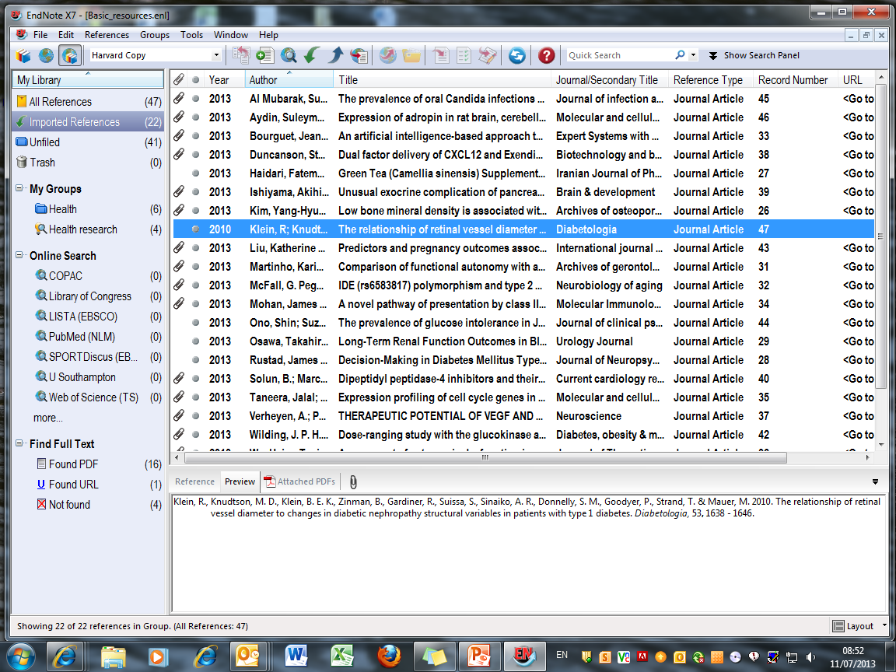

Browse to locate a previously saved PDF file. Click Open.
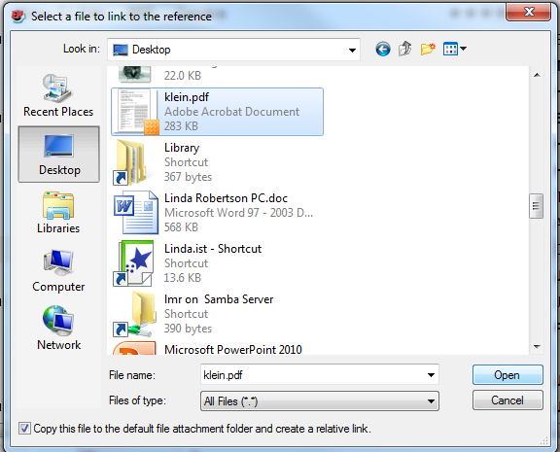

Note that it is helpful to rename PDF files when saving from online resources so that they can be more readily identified for addition to the EndNote records.
The file is attached in the corresponding field of the EndNote record.
The PDF file can be opened directly from this new location but to use the PDF viewer tools in EndNote, go to the PDF tab on the Reference pane.
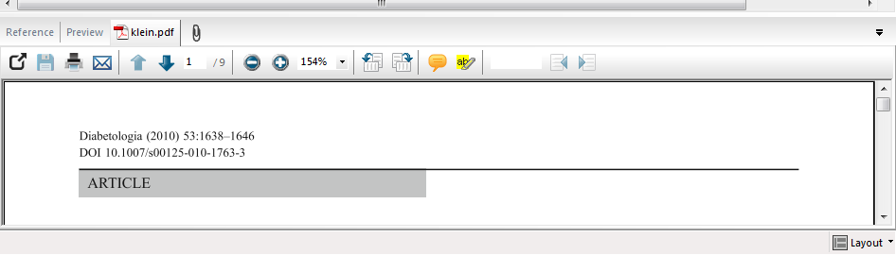

If there are a number of records to be updated, it is helpful to save all the PDFs in a single folder and open this window alongside the EndNote Library.
Select the required PDF file and drag it on to the main library record as displayed in the main library view.
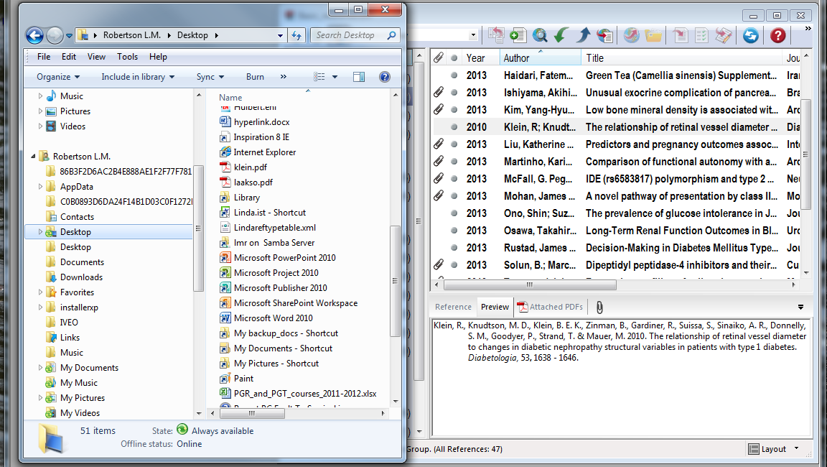

The File Attachment symbol displays in the library window.

The PDF is added to the File Attachments field.

This process can be carried out automatically - see sections 4.3 and 4.4 below

4.2 Import existing PDF files
PDF files which have been previously saved, but which do not have existing EndNote records can also be imported. EndNote uses the doi information within the PDF to generate field contents and create an EndNote record. The PDF is attached to the record in the File Attachments field.
To import a group of PDF files, locate them in the same folder. Then go to File Import Folder …

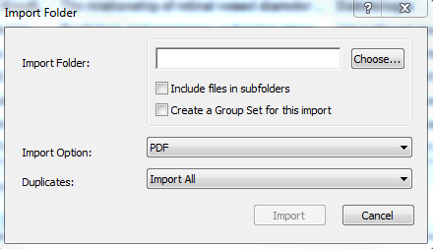
In the Import Folder window, click the Choose button to open the Browse for Folder dialog window.

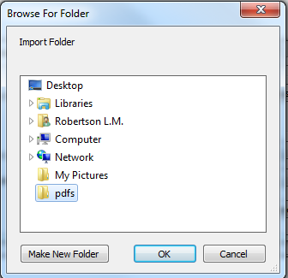

Select the required PDF folder and click OK.

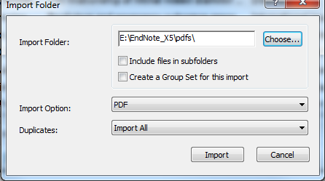

If the selected folder includes subfolders, click the Include files in sub-folders option. A Group Set for these records can also be created automatically - the records will also be in All References.
In the Import Option list, choose PDF. Click Import to import the files contained in the selected folder(s).

New references display as a group of Imported References and are added to the All References group. The PDF file is attached to the record in each case.

EndNote uses Digital Object Identifier (DOI) information to construct the record. Check the record details to ensure citation data has imported correctly. If there is more than one DOI embedded in the first two pages of the paper, Endnote cannot identify the primary DOI and so will create a blank record with the PDF attached. In these cases, field contents must be added manually.

4.3 PDF handling

Go to Edit Preferences PDF Handling

The PDF Auto Renaming Option allows you to change the description of PDF files to something meaningful, e.g. Author/Year. These changes will not always take place immediately but will be updated when the EndNote library is closed.

The Auto Import Folder Option allows the software to import PDF files automatically from your computer.
Use the Select Folder option to identify a location for PDFs which you would like added to your EndNote library. Check box to enable EndNote to background update periodically.

If an EndNote record already exists, the PDF will be added: if there is no record, one will be created and the PDF added. PDFs that have been added to the Library will then be transferred to an archive folder within the selected folder location.

4.4 Use the PDF Viewer
PDF attachments to EndNote records can be viewed from the library page without having to open the individual record. This gives access to additional editing tools.
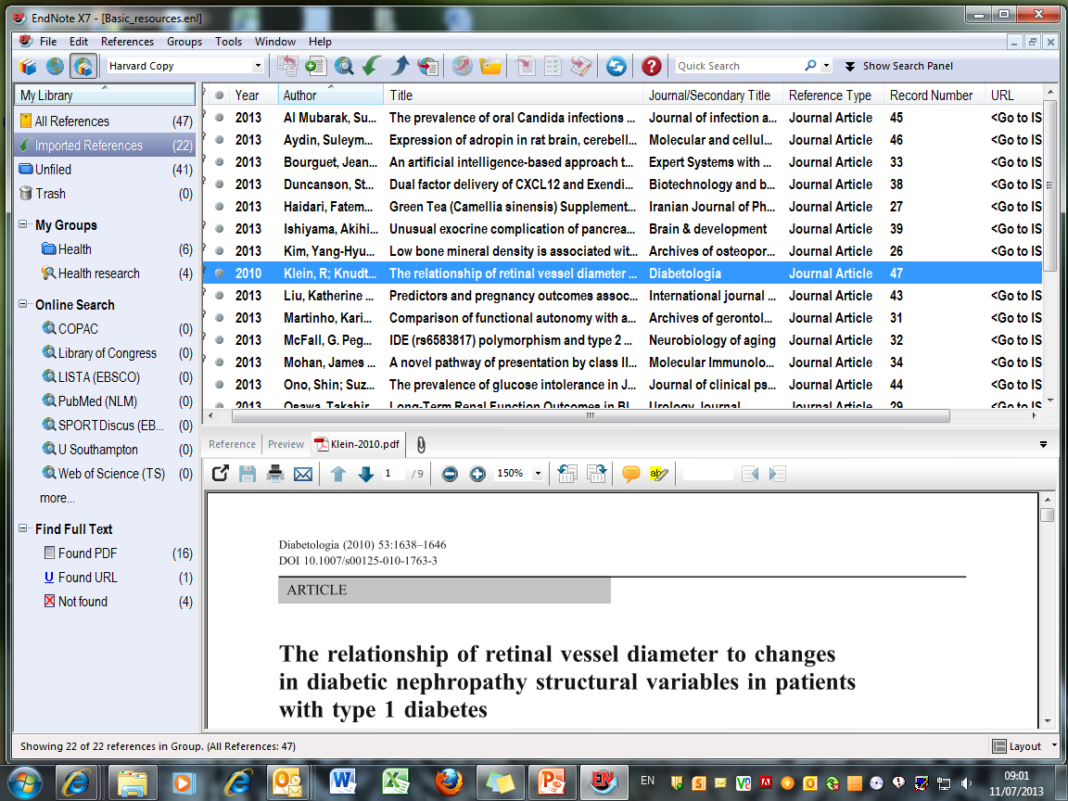
Select the required record in Library View and go to the PDF tab.

The file name is shown on the tab.

Use the PDF toolbar to navigate and annotate the document:

- view in full screen
- save changes to the PDF
- print, including highlights
- scroll through pages
- zoom in/out
- rotate page
- add sticky note
- highlight text
To view in full screen, click the toggle icon at the left of the PDF toolbar.
Click the toggle icon again to save any editing changes and return to the EndNote Library.

To highlight a section of the text, select the text in the usual way, then click the highlighter tool. Click outside the highlighted text to view.
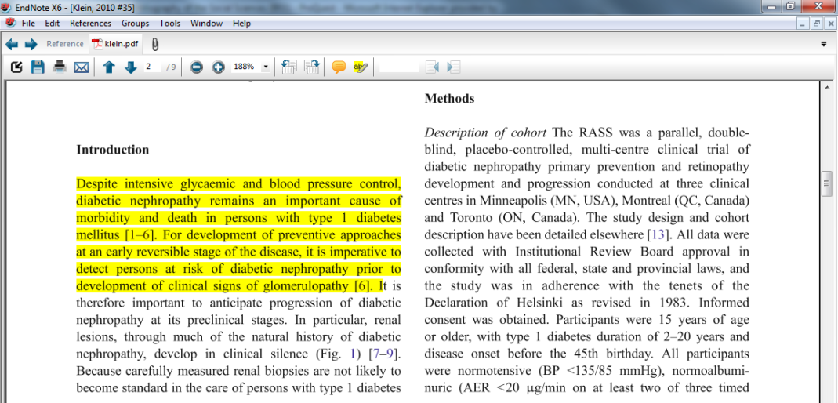

Saved highlights will be reproduced if the document is printed.
To add a sticky note, click on the sticky note icon and then click at the required location in the text. Double-click this sticky note icon to open the comments window.
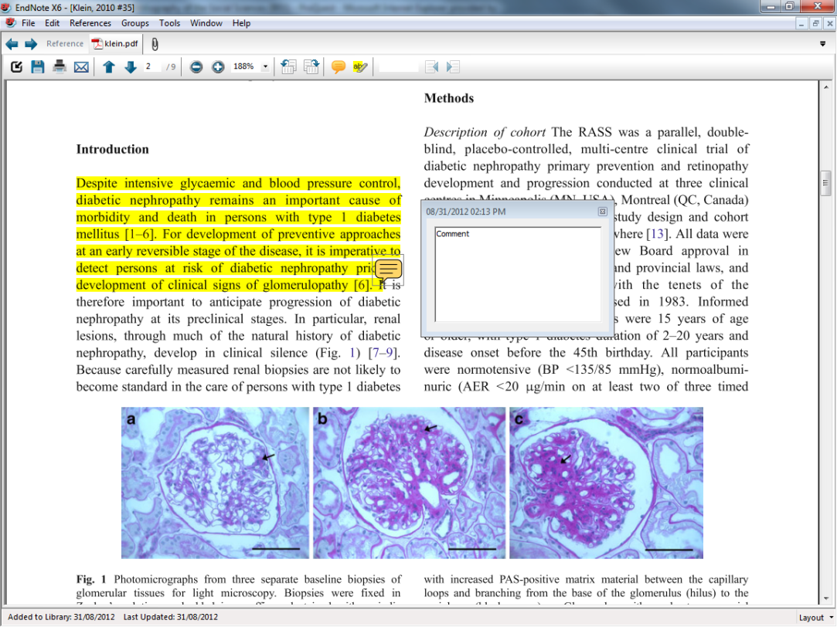

To save changes, click the Save icon in the PDF tab, or click the toggle icon to return to the EndNote Library.
Sticky notes are searched in Quick Search along with all other record fields and PDF text: to search sticky note text only, use the EndNote Library Search panel: scroll up above the Author field in the dropdown menu to see PDF options.
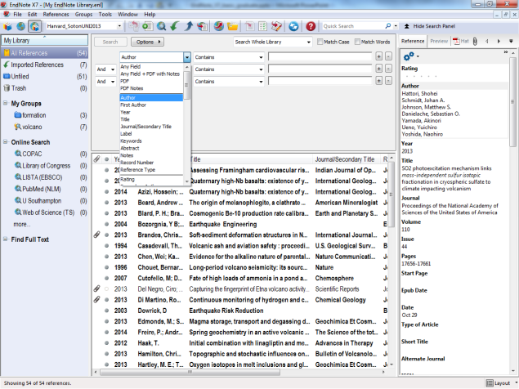

5. Use EndNote with Word
Use the EndNote Library to automatically insert citations and create footnotes and bibliographies according to the selected reference style. The EndNote Library should always be opened before Word - this causes the EndNote tab to display in Word.

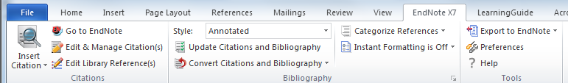
The EndNote toolbar is displayed in Word

Insert citations, or manage bibliography from either toolbar
Use these icons to move between the EndNote library and the Word document

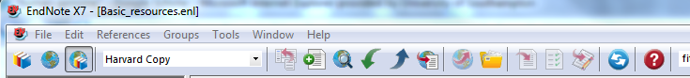

Some icons occur on both toolbars allowing operation from either window. The icon with the red down arrow is used to insert citations, and the one with green ticks to manage the bibliography.

5.1 Insert citations
EndNote inserts citations and creates a simultaneous bibliography at the end of the text. It is helpful to insert a page break.
In the Word document, select the point in the text to insert the reference.

Go to EndNote to select the required reference.
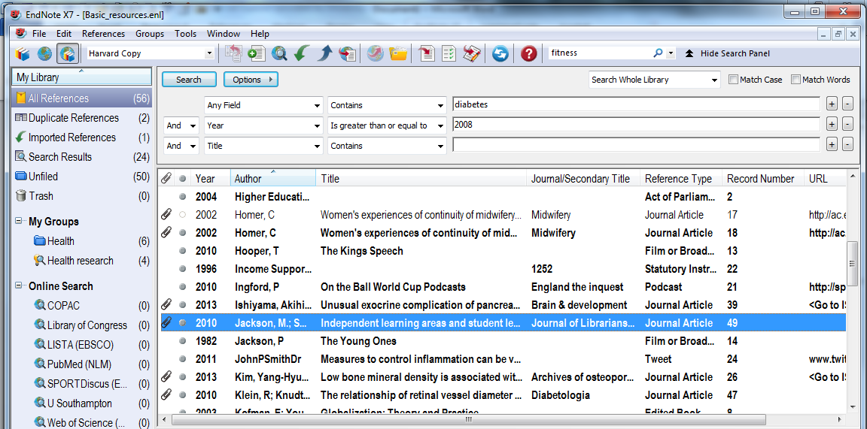

Click to highlight the required reference in the EndNote Library.
Click the red down arrow on the EndNote toolbar and return to Word.
The citation is displayed in the text, and the full bibliographic reference at the end of the document, in accordance with template parameters and the chosen referencing style.

Alternatively, return to Word and click Insert Selected Citation in the drop-down menu on the EndNote toolbar there.
The citation is inserted at the selected point in the text, and a full bibliographic record created at the end of the document.

EndNote also creates a new folder of references which have been cited in the current document.

Multiple references can be inserted at a single point in the text: locate the cursor immediately to the right of the close bracket then select the reference from the EndNote library as before.

The citation will be included within the brackets and the full reference at the appropriate location in the end of document bibliography. Note that the sort order for citations and bibliography is determined by editing parameters in the referencing style.

5.2 Edit citations
The common forms of editing are to add page numbers to a citation, to remove author and/or year from a citation, or to remove a citation altogether.
It is essential that all these changes are made using the relevant EndNote tools, so that linked field codes are also amended. Click in the citation to highlight it, then go to Edit and Manage Citations.

Highlight the specific citation to be edited in the top panel.
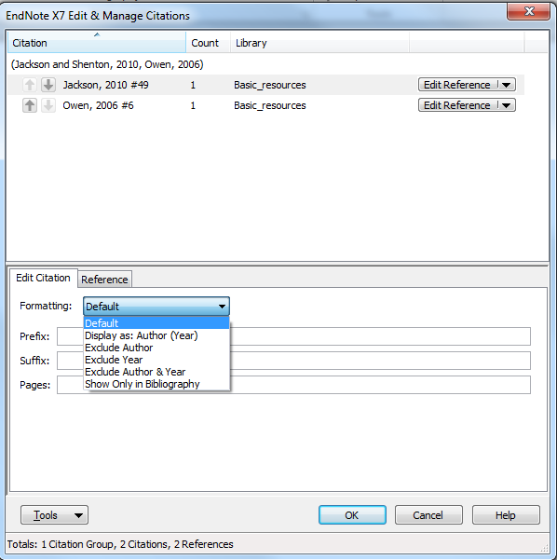

To include an item in the bibliography without citing in the text, insert in the document, and then choose Formatting Show Only in Bibliography in this panel. Click OK. The citation disappears from the text but remains in the bibliography. This is useful for example for an edited book, where individual chapters by different authors are cited in the document.
Use this same option to display the citation as Author (Year) if the text requires this format.

5.3 Remove citations
To remove a record completely, go to Edit & Manage Citations, select the reference to be removed, and go to Edit Reference. Choose Remove Citation then OK.

Both the citation and the full reference are removed from the document together with hidden field codes.

Note that if the same source is still cited elsewhere in the document, it will not be removed from the bibliography.

5.4 Add page numbers
To add page numbers to a citation, use the same Edit Citation tab in the Edit & Manage Citations window.
Select the required citation, then type the exact letter string, including any required leading/following spaces, in the Suffix box, note, not in the Pages box. Then click OK.

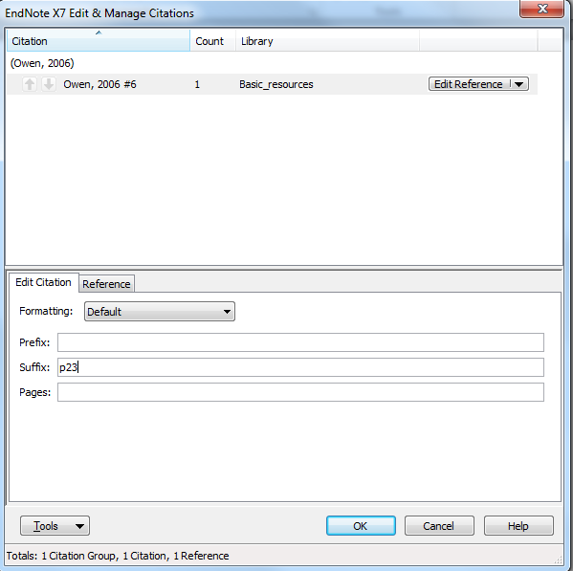

The suffix text becomes an integral part of the citation. The same principle applies to prefix text.

5.5 Insert footnotes
The insertion of footnotes is a two-stage process: first use the footnote facility in Word, then insert the chosen reference via EndNote. A footnote reference is created at the bottom of the page, and a full bibliography at the end of the document. According to the reference style chosen and modifications made, the format of the footnote entry may vary from the details in the bibliography. See the separate sections on editing reference styles
Place the cursor at the insertion point in the text for the footnote, go to the References tab, and click Insert Footnote.
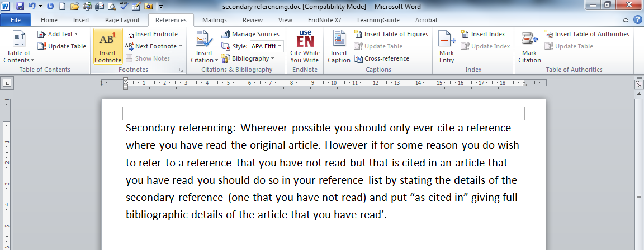

A superscript citation number is inserted in the text, and a corresponding number in a created footnote section at the bottom of the page. If citations are later moved to a different point in the text, the associated footnote is correspondingly moved.
With the cursor in the required footnote, go to the EndNote Library, select the required reference, and click the Insert icon.
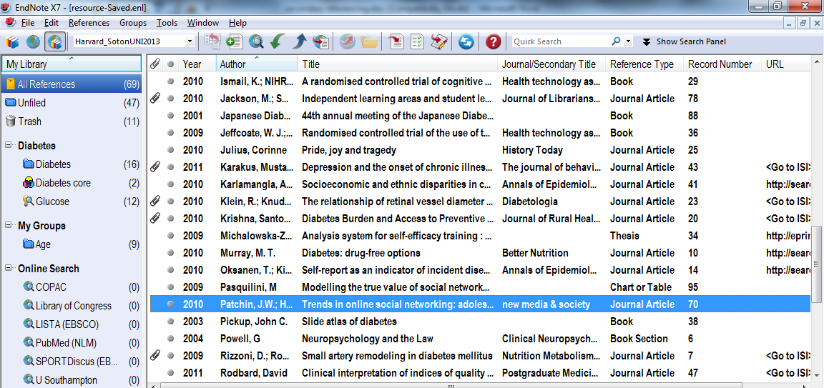

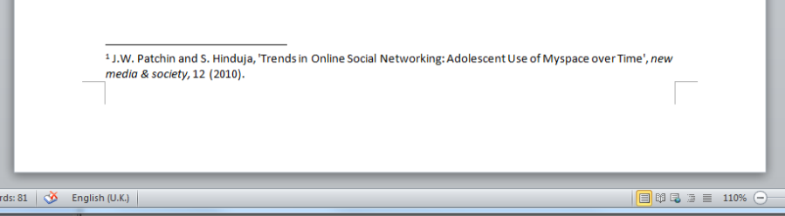

Footnote information is displayed in the chosen format. An end of document bibliographic entry is also created: it is helpful to insert a page break so that this is not displayed in the working page.
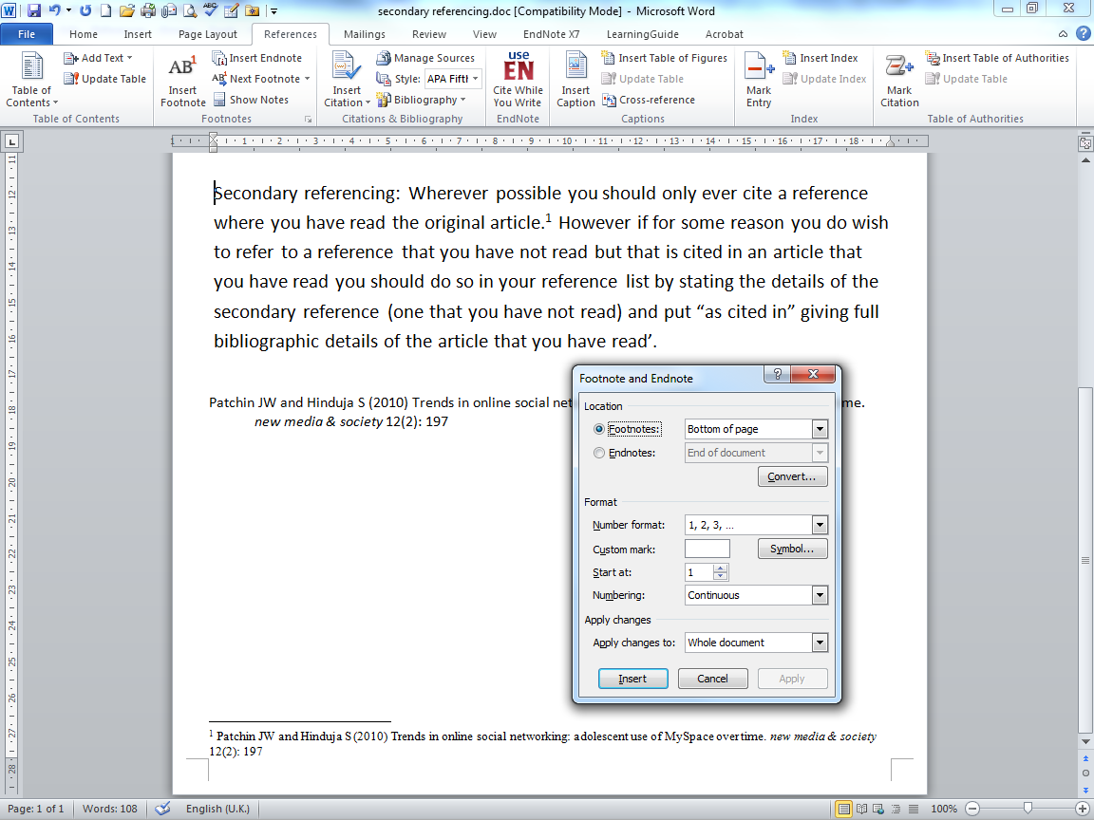
Multiple citations can be inserted at any point by repeating the process.
When further citations are added, the bibliography sorts automatically according to the selected sorting criteria.
Footnote layout and numbering is managed from within Word by expanding the Footnotes tab.

5.6 Change the bibliography layout
Use this option to define the appearance of the bibliography at the end of the Word document.

Click to expand the Bibliography menu.
To make changes to the physical layout of the bibliography, click the Layout tab.

This window lets you manage indents, the line spacing within a reference, and the line spacing between references.
To insert a single space between references, go to the Space after drop down list and choose Single.
Remove the hanging indent by changing to 0cm. Click OK when all choices have been made.

5.7 Change the reference style
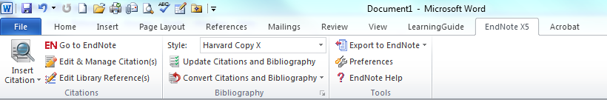

EndNote contains reference styles for many popular academic journals. An existing document created with one reference style can be reformatted for a specific publication.

Expand the Bibliography pane to access the Configure Bibliography window. Click the Format Bibliography tab.

Click Browse… to choose a new reference style, and click OK. This will change all the citations and bibliographic references to the new format. Note that the reference style of the EndNote Library must also be changed if further citations are to be inserted.

5.8 Bibliography categories
It is possible to use the Categorize References option to subdivide your bibliography if required. The categories can be removed at any time if not required in a particular context.

Click Configure Categories to see all the references cited in the current document. Category Headings are either Title, which are centred on the page, or Category, which are left justified. Headings can be renamed, reordered, and further headings of either category can be added.

Select the references to be added to a particular category and drag onto that heading.

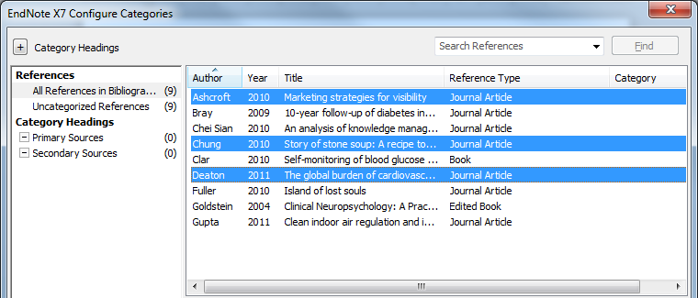

The references included under each heading can be viewed by clicking the heading.

Click Uncategorized References to see those still unassigned to headings.
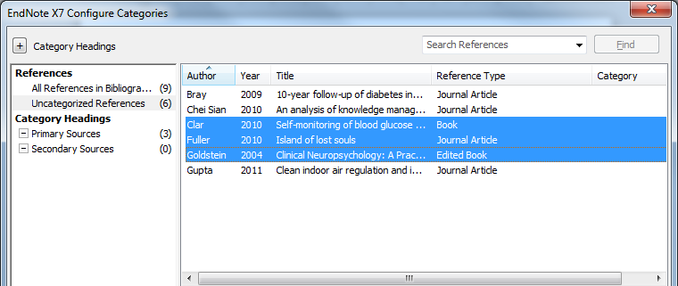

If you decide to move an item between categories, it will automatically be deleted from the first location.
You can also change the category headings and level of importance. Right -click the heading to be changed, and rename, or change priority. Choose Title for a centralised heading.
Choose Category for a left-justified heading.

To add more categories, right click in the Groups panel. . The new category can be changed to a Title if required, and Title and Category groups reordered as wished.
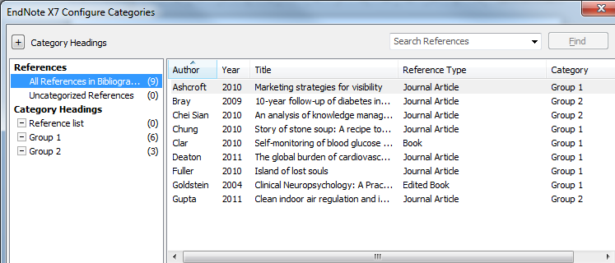

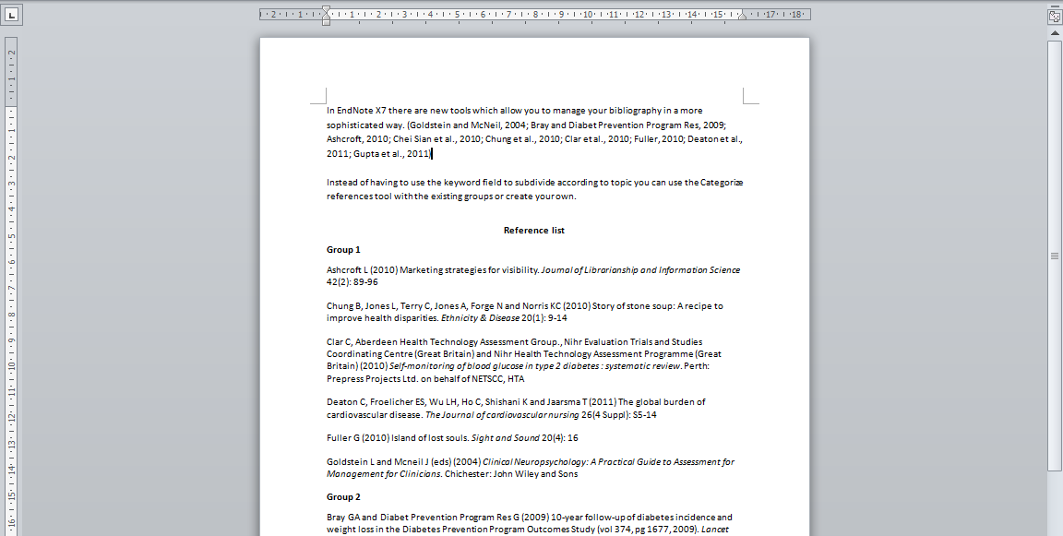

In this example, there are new categories labelled Group, and Reference List has been designated as a title.

If a single reference list is required, go to the Categorize References dropdown menu and uncheck the Group References by Custom Categories option. Custom category choices are retained for future use.

5.9 Use abbreviated journal titles
Some departments and publications require the use of abbreviated rather than full journal titles.
There are three stages to this process: first the existing journal term list must be deleted, then a list of titles and abbreviations imported, and then EndNote must be instructed to use the abbreviation field when inserting the reference.
To delete the existing Journals Term List, go to Tools Open Term Lists Journals Term List

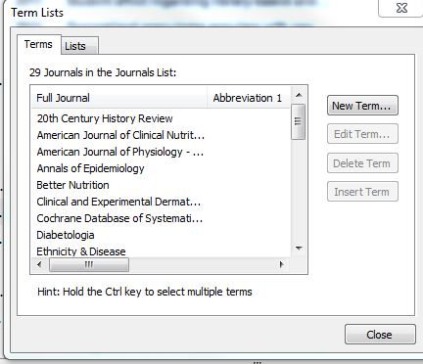

Then go to the Terms tab: this shows only the full titles, with no abbreviations. These existing titles must first be deleted.
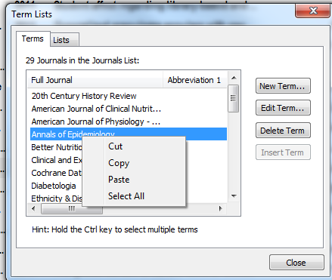

Click a single title, then right click to show editing options. Choose Select All.

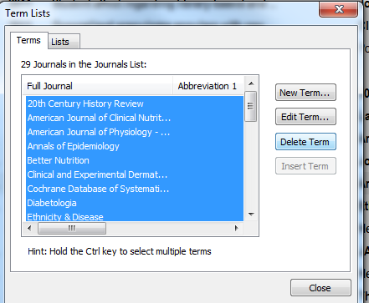

When all the journal titles are highlighted, click Delete Term.
All titles are deleted from the list.

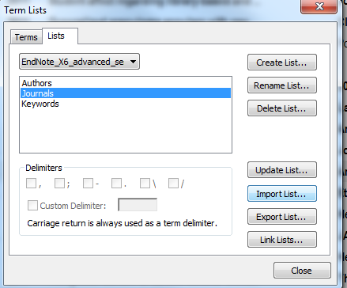

Now go to the Lists tab, and click the Import List… option.

Browse to locate the Terms List folder which is contained within the EndNote Program software on the C drive.
On university public workstations, this can be found at
My Computer OS disk (C:) Program Files (x86)
EndNote X7 Terms Lists
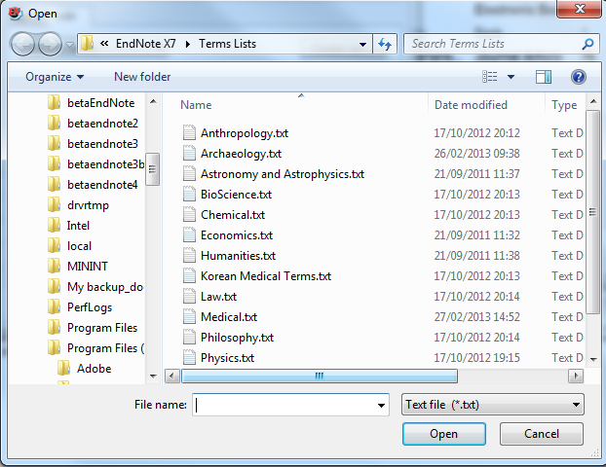

Select the Terms List for the general subject area, in this case Medicine, and click Open.

All accepted abbreviations for medical journals are then downloaded to the Journals Term List within the EndNote Library.
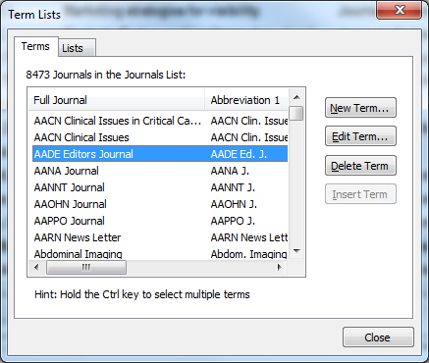

Click the Terms tab in the Term Lists window: abbreviated titles now show alongside full titles.

EndNote must be instructed to use the abbreviated titles in bibliographic references: go to Edit Output Styles Edit (Reference Style) in this case Harvard_SotonHS2013.

On the Reference Style edit window, go to Journal Names.

Choose Abbreviation 1 and save changes to the reference style in the usual way.

When this reference style is applied to the library, and relevant Word documents, the journal titles will be applied in abbreviated form.

Within the EndNote Library, the full journal title continues to appear in the individual EndNote record. The abbreviated form is shown in the Preview pane.

5.10 Create a plain text file
A Word document with EndNote citations carries hidden field codes. If the paper is to be submitted for publication, a plain copy is usually required. It is good practice to make a backup copy of the document before starting this process.

In the Bibliography toolbar section, go to Convert Citations and Bibliography and choose the Convert to Plain Text option.
Citations and bibliographic entries are retained in the chosen format, but this document no longer has any links to the EndNote library used to create it.

5.11 Restore bibliographic format
Occasionally a keying error can result in field codes {#} being displayed in the text of the document. To remove these, simply go to the Format Bibliography tab, and reapply the selected reference style to the whole document.

5.12 Combine Word documents
Large documents such as theses may originally be created as individual chapters, which will each then have their own end of document bibliography. At some stage these need to be combined into a single document, ready for submission. Use EndNote to achieve this. Various options are available:
- a reference list at the end of each chapter
- a combined reference list at the end of the complete new document
- both of the above

First, create a new Word document.
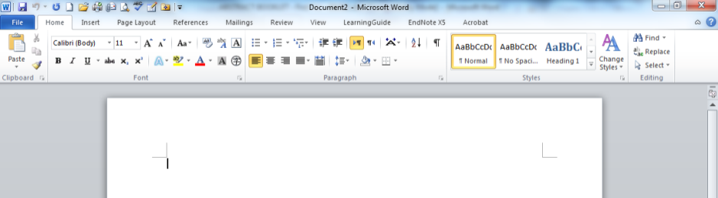

Open each chapter to be combined in turn.
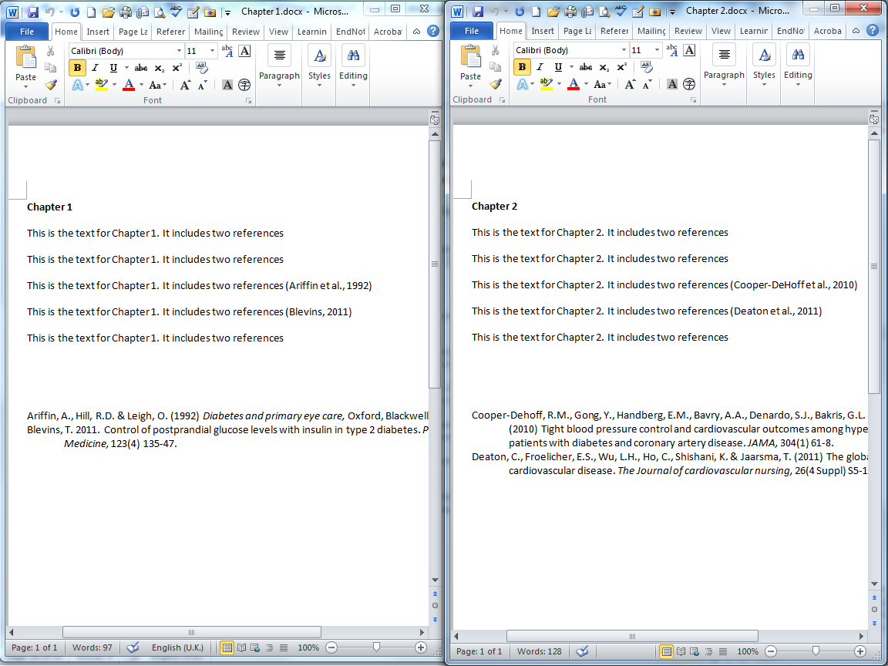

These chapters currently have separate reference lists.
For each chapter, copy and paste the text section only in to the new document. The end of text bibliography is not required: all the information to generate the new bibliography is already held in the field codes attached to each in-text citation.
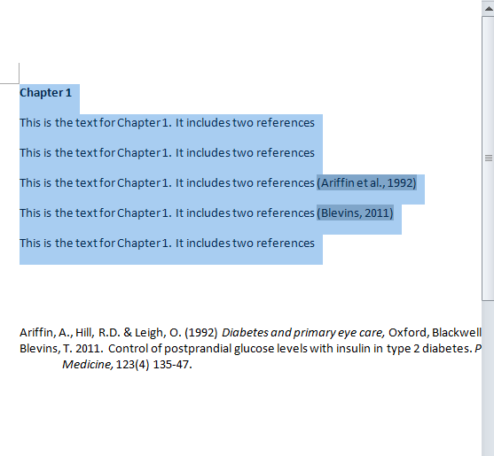

Insert a section break after each chapter: go to Page Layout Breaks Section Breaks Next Page.
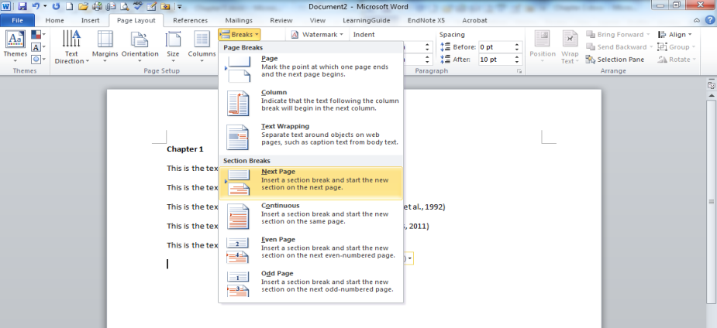

A section break should also be added after the final portion of text: these will ensure that each chapter, and the bibliography, will begin on a fresh page.
To create the new bibliography, in EndNote, go to Edit Output Styles Edit "Reference Style" (in this case Harvard Copy)
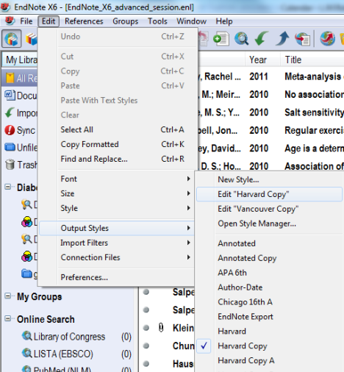

The Edit pane displays.

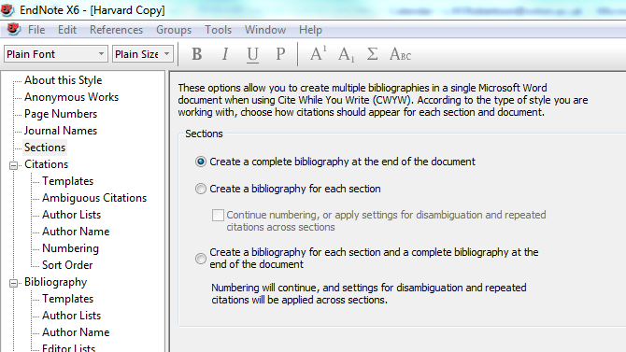

Choose the Sections tab to view options.
Make choices and save the selection to the current reference style. In this case a single bibliography will be created at the end of the document. These changes must be reselected if a different reference style is used.
In the Word document, use the small arrow in the Bibliography tab to open the Format Bibliography pane.
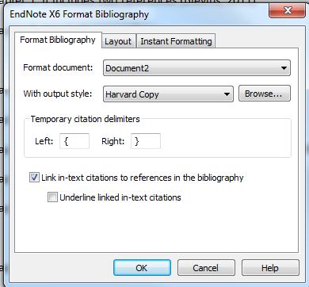

Reformat the whole document in the chosen reference style. Click OK.
A single bibliography is created at the end of the whole document.

6. Using EndNote Online
Insert citations, or manage bibliography from either toolbar

6.1 Synchronise the library

It is possible to synchronise the EndNote library with your library on EndNote Online. Most importantly, this enables you to access your references and work with them, even if you are using a computer that does not have EndNote X7 installed. You can also give others access to some or all of the references you are using.

The process must be setup from the EndNote X7 program and requires registration on the Web of Knowledge database, which hosts EndNote Online.
To set up an identity on the Web of Knowledge, choose the database from the A - Z resources list.
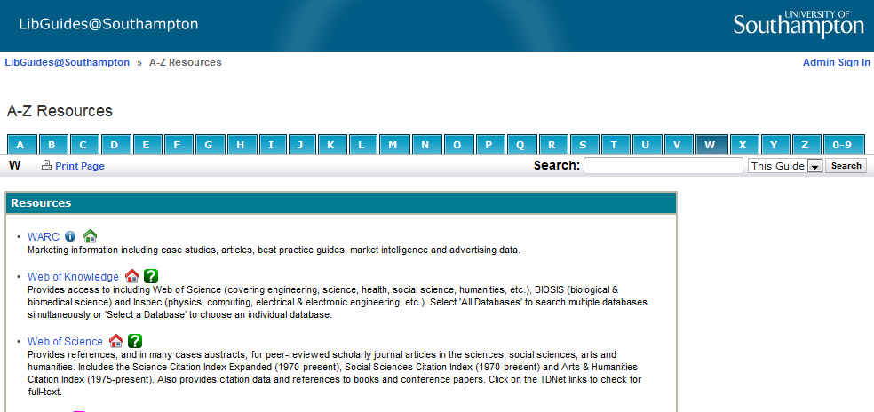

Click the orange button to open Web of Knowledge.
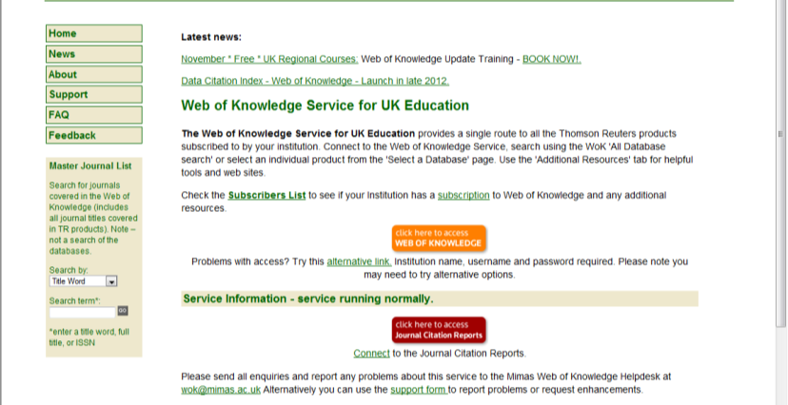

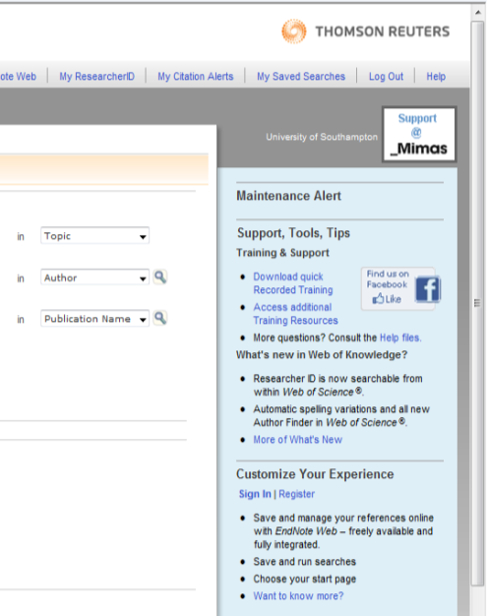
On the first occasion it is necessary

to Register on the database. Follow
the Register link.
On future occasions you can sign in
using your email address and the
password you have created (it is best
not to use your university password,
which changes every six months)

To access EndNote Online, go to the EndNote tab on the Web of Knowledge home page.

When the EndNote library has been synchronised, all references, and custom groups, will appear on the My References tab.
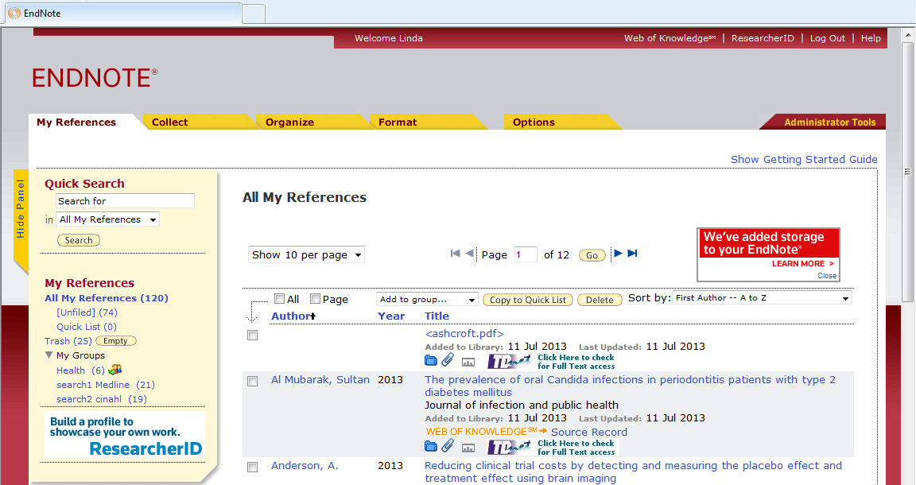

To set up synchronising, in EndNote X7, go to Edit, Preferences.

Choose the Sync option. Input the email address and password as used for Web of Knowledge, and choose whether or not to enable automatic syncing options you require. Automatic syncing will take place as a background operation every 15 minutes and when the EndNote library is closed. Click Apply. If this option is greyed out on any future visit, click OK.
Use these icons to move between the EndNote library and the Word document

To synchronise the library manually at any time, and/or to start synchronisation, click the sync icon.

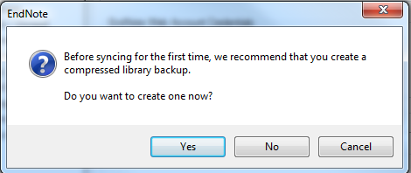
You should create a backup
library before starting sync for the
first time, but remember that this will
not be automatically updated.

The first synchronisation may take a long time, even with only a few references. Remember that Smart Groups are not synchronised.

The sync status is displayed in the left hand panel. A blue symbol indicates that synchronisation is complete, red indicates that there are conflicts to be resolved, which might happen if changes have been made to a record in both EndNote and EndNote Online since the last synchronisation.

6.2 Share the library
EndNote Online can be used to share references with others, for example in a research group.
To begin, create a Group in EndNote Online that contains all the references you wish to share.

Then go to Organize Manage My Groups, and choose Manage Sharing for the group you wish to share.
Then click on Start sharing this group.

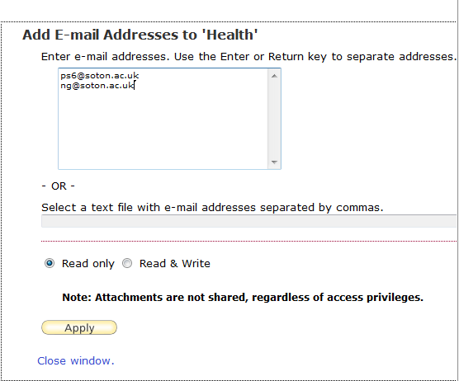

Add the email addresses of the people you wish to share your group with; they will need to have an (updated) EndNote Online account. Choose access, Read only or Read & Write, then Apply. Note that for copyright reasons, attachments are not shared.
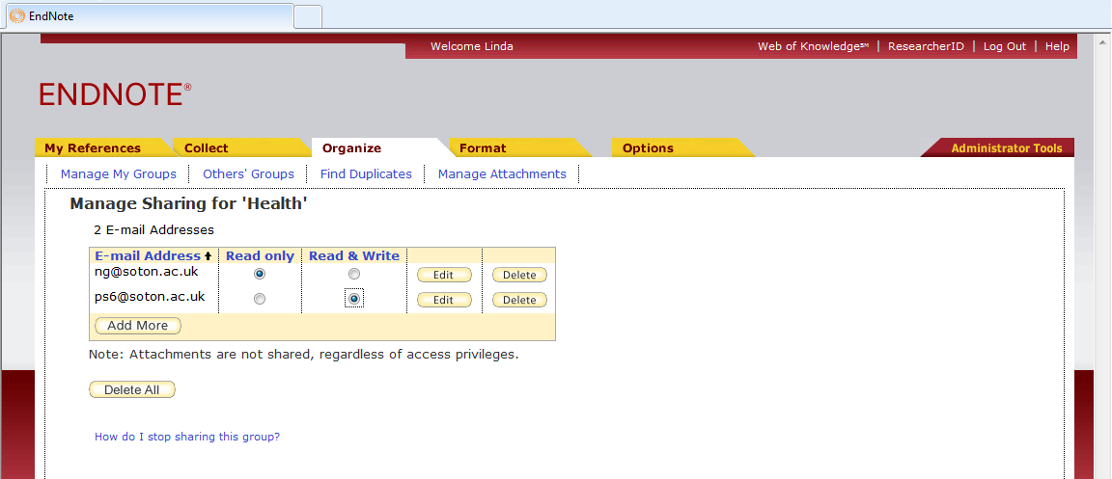

Sharing levels can be changed at any time for individual members of a group.
Click on Organize Others' Groups to access references that other people have shared with you in a similar way.

6.3 Work with Word
If you are using EndNote Online on your own computer, you will need to install the correct version of the Cite While You Write plug in. Go to Format Cite While You Write Plug-in
Follow the on-screen instructions.
Alternatively on a public workstation use the Preferences link on the EndNote tab in Word to change the Application to EndNote Online

EndNote inserts citations and creates a simultaneous bibliography at the end of the text. It is helpful to insert a page break.
In the Word document, select the point in the text to insert the reference.
Go to Insert Citations to select the required reference.
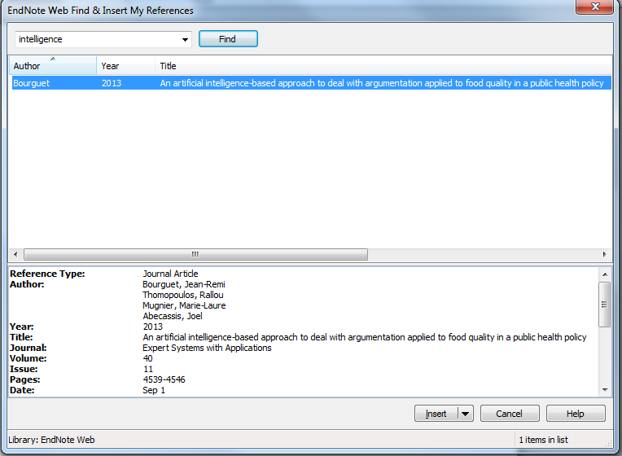

Use Author or Title keywords in the search box and click Find to show the required reference. All matching references are retrieved. Highlight the reference needed and click Insert.

The citation is inserted at the selected point in the text, and a full bibliographic record created at the end of the document.

Multiple references can be inserted at a single point in the text: locate the cursor immediately to the right of the close bracket then find the reference from the EndNote Online library as before.

The citation will be included within the brackets and the full reference at the appropriate location in the end of document bibliography. Note that the sort order for citations and bibliography is set within the referencing style.

The Reference style for the document can be changed within Word, or by using the Format tab in the Bibliography window.
Change the Bibliography layout as described in section 5.6 above.
Use the Edit Citation(s) tool as described in section 5.2 to make any changes to, or remove, citations.
All Southampton custom reference styles are available in EndNote Online.
Note that Reference Styles cannot be edited in EndNote Online.
For more information on using EndNote Online, see the Library Guide:
http://library.soton.ac.uk/endnote/online

7. Use EndNote with PowerPoint

EndNote X7 can now be used with PowerPoint, however, it is not yet a full CWYW function: the reference style must be chosen first, and the citations inserted and reference list created as separate operations.

To insert citations from an EndNote Library, use the EndNote X7 tab on the PowerPoint toolbar.

Identify the insertion point in the correct location in the PowerPoint textbox.
Use the Insert Citation icon, to search for a required record, or select the required reference in the EndNote Library first, then click on Insert Selected Citation(s).

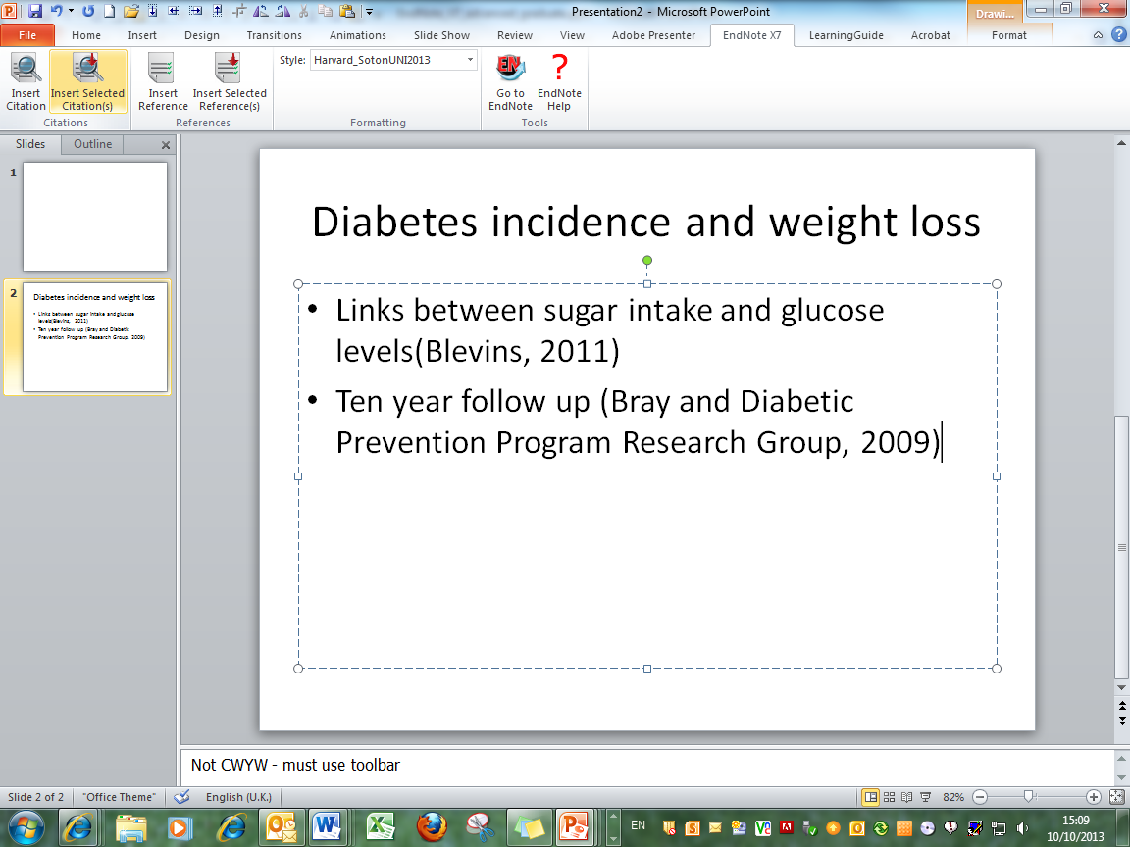

References are inserted on the slide in the Reference style chosen in the EndNote Library.
To remove a citation from a slide, simply delete it as you would ordinary text.
The Reference list should be created on a separate slide.

It is possible to use the Insert Reference tool to locate a required reference: alternatively go to the EndNote Library and select the references needed, either together or individually.

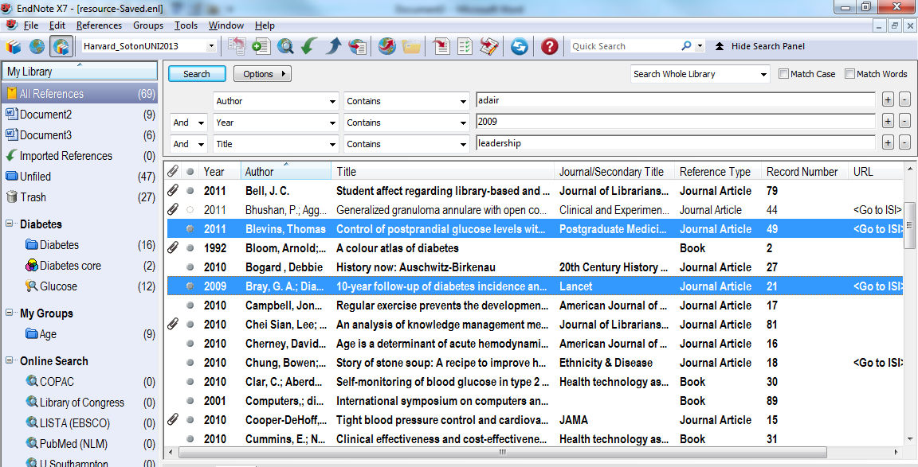

On a separate slide, click in the text box, then click the Insert Selected Reference(s) icon. The Insert Reference icon also links to all references in the EndNote library to provide a simple search function.
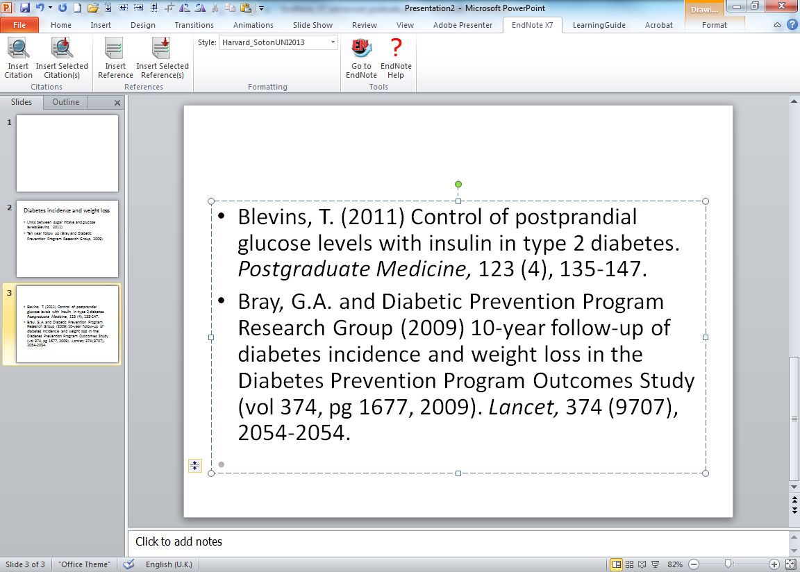

References are displayed in the style selected in the EndNote Library. To remove a reference, delete the text in the usual way. There is no electronic link between citations and references in Powerpoint.

